1. HARDWARE SPECIFICATION

|  |  |
| --- | --- |
| **COMPONENTS** | **MINIMUM REQUIREMENT** |
| PROCESSOR | PENTIUM OR AMD |
| RAM | 256MB OR HIGHER |
| HARDISK | 200MB |
| OTHER | COLOR MONITOR, KEYBROAD AND MOUSE |
|  |  |

SOFTWARE SPECIFICATION

* OPERATING SYSTEM (WINDOWS XP OR HIGHER)
* INTERNET EXPLORER/FIREFOX/GOOGLE CHROME

**A BRIEFINTRODUCTIONABOUT TOOLS AND LANGUAGES USED IN THE PROJECT.**

What is HTML?

HTML is a language for describing web pages.

* HTML stands for Hyper Text Markup Language
* HTML is not a programming language, it is a markup language
* A markup language is a set of markup tags
* HTML uses markup tags to describe web pages

HTML Tags

HTML markup tags are usually called HTML tags

* HTML tags are keywords surrounded by angle brackets like <html>
* HTML tags normally come in pairs like <b> and </b>
* The first tag in a pair is the start tag, the second tag is the end tag
* Start and end tags are also called opening tags and closing tags

HTML Documents = Web Pages

* HTML documents describe web pages
* HTML documents contain HTML tags and plain text
* HTML documents are also called web pages

The purpose of a web browser (like Internet Explorer or Firefox) is to read HTML documents and display them as web pages. The browser does not display the HTML tags, but uses the tags to interpret the content of the page:

|  |
| --- |
| <html> <body>  <h1>My First Heading</h1>  <p>My first paragraph.</p>  </body> </html> |

Example Explained

* The text between <html> and </html> describes the web page
* The text between <body> and </body> is the visible page content
* The text between <h1> and </h1> is displayed as a heading
* The text between <p> and </p> is displayed as a paragraph

HTML Headings

HTML headings are defined with the <h1> to <h6> tags.

|  |  |
| --- | --- |
| Example   |  | | --- | | <h1>This is a heading</h1> <h2>This is a heading</h2> <h3>This is a heading</h3> | |

HTML Paragraphs

HTML paragraphs are defined with the <p> tag.

|  |  |
| --- | --- |
| Example   |  | | --- | | <p>This is a paragraph.</p> <p>This is another paragraph.</p> | |

HTML Links

HTML links are defined with the <a> tag.

|  |  |
| --- | --- |
| Example   |  | | --- | | <a href="http://www.akcjobconsultancy.com">This is a link</a> | |

Note: The link address is specified in the href attribute.

HTML Images

HTML images are defined with the <img> tag.

|  |  |
| --- | --- |
| Example   |  | | --- | | <imgsrc="akc.jpg" width="104" height="142" /> | |

HTML Elements

An HTML element is everything from the start tag to the end tag:

|  |  |  |
| --- | --- | --- |
| Start tag * | Element content | End tag * |
| <p> | This is a paragraph | </p> |
| <a href="default.htm" > | This is a link | </a> |
| <br /> |  |  |

* The start tag is often called the opening tag. The end tag is often called the closing tag.

HTML Element Syntax

* An HTML element starts with a start tag / opening tag
* An HTML element ends with an end tag / closing tag
* The element content is everything between the start and the end tag
* Some HTML elements have empty content
* Empty elements are closed in the start tag
* Most HTML elements can have attributes

Nested HTML Elements

Most HTML elements can be nested (can contain other HTML elements).

HTML documents consist of nested HTML elements.

HTML Document Example

|  |
| --- |
| <html>  <body> <p>This is my first paragraph.</p> </body>  </html> |

The example above contains 3 HTML elements.

HTML Example Explained

The <p> element:

|  |
| --- |
| <p>This is my first paragraph.</p> |

The <p> element defines a paragraph in the HTML document.  
The element has a start tag <p> and an end tag </p>.  
The element content is: This is my first paragraph.

The <body> element:

|  |
| --- |
| <body> <p>This is my first paragraph.</p> </body> |

The <body> element defines the body of the HTML document.  
The element has a start tag <body> and an end tag </body>.  
The element content is another HTML element (a p element).

The <html> element:

|  |
| --- |
| <html>  <body> <p>This is my first paragraph.</p> </body>  </html> |

The <html> element defines the whole HTML document.  
The element has a start tag <html> and an end tag </html>.  
The element content is another HTML element (the body element).

Don't Forget the End Tag

Most browsers will display HTML correctly even if you forget the end tag:

|  |
| --- |
| <p>This is a paragraph <p>This is a paragraph |

The example above will work in most browsers, but don't rely on it. Forgetting the end tag can produce unexpected results or errors.

Empty HTML Elements

HTML elements with no content are called empty elements. Empty elements can be closed in the start tag.

<br> is an empty element without a closing tag (the <br> tag defines a line break).

In XHTML, XML, and future versions of HTML, all elements must be closed.

Adding a slash to the start tag, like <br />, is the proper way of closing empty elements, accepted by HTML, XHTML and XML.

Even if <br> works in all browsers, writing <br /> instead is more future proof.

HTML Line Breaks

Use the <br /> tag if you want a line break (a new line) without starting a new paragraph:

|  |  |
| --- | --- |
| Example   |  | | --- | | <p>This is<br />a para<br />graph with line breaks</p> |   [Try it yourself »](http://www.w3schools.com/html/tryit.asp?filename=tryhtml_paragraphs) |

The <br /> element is an empty HTML element. It has no end tag.

HTML Text Formatting Tags

|  |  |
| --- | --- |
| Tag | Description |
| [<b>](http://www.w3schools.com/tags/tag_font_style.asp) | Defines bold text |
| [<big>](http://www.w3schools.com/tags/tag_font_style.asp) | Defines big text |
| [<em>](http://www.w3schools.com/tags/tag_phrase_elements.asp) | Defines emphasized text |
| [<i>](http://www.w3schools.com/tags/tag_font_style.asp) | Defines italic text |
| [<small>](http://www.w3schools.com/tags/tag_font_style.asp) | Defines small text |
| [<strong>](http://www.w3schools.com/tags/tag_phrase_elements.asp) | Defines strong text |
| [<sub>](http://www.w3schools.com/tags/tag_sup.asp) | Defines subscripted text |
| [<sup>](http://www.w3schools.com/tags/tag_sup.asp) | Defines superscripted text |
| [<ins>](http://www.w3schools.com/tags/tag_ins.asp) | Defines inserted text |
| [<del>](http://www.w3schools.com/tags/tag_del.asp) | Defines deleted text |

HTML Style Example - Background Color

The background-color property defines the background color for an element:

|  |  |
| --- | --- |
| Example   |  | | --- | | <html>  <body style="background-color:yellow"> <h2 style="background-color:red">This is a heading</h2> <p style="background-color:green">This is a paragraph.</p> </body>  </html> | |

The style attribute makes the "old" bgcolor attribute obsolete.

HTML Style Example - Font, Color and Size

The font-family, color, and font-size properties defines the font, color, and size of the text in an element:

|  |  |
| --- | --- |
| Example   |  | | --- | | <html>  <body> <h1 style="font-family:verdana">A heading</h1> <p style="font-family:arial;color:red;font-size:20px;">A paragraph.</p> </body>  </html> | |

The style attribute makes the old <font> tag obsolete.

HTML Style Example - Text Alignment

The text-align property specifies the horizontal alignment of text in an element:

|  |  |
| --- | --- |
| Example   |  | | --- | | <html>  <body> <h1 style="text-align:center">This is a heading</h1> <p>The heading above is aligned to the center of this page.</p> </body>  </html> | |

HTML Hyperlinks (Links)

A hyperlink (or link) is a word, group of words, or image that you can click on to jump to a new document or a new section within the current document.

When you move the cursor over a link in a Web page, the arrow will turn into a little hand.

Links are specified in HTML using the <a> tag.

The <a> tag can be used in two ways:

1. To create a link to another document, by using the href attribute
2. To create a bookmark inside a document, by using the name attribute

HTML Link Syntax

The HTML code for a link is simple. It looks like this:

|  |
| --- |
| <a href="*url*">*Link text*</a> |

The href attribute specifies the destination of a link.

Example

|  |
| --- |
| <ahref="http://www.akcjobconsultancy.com/">Visit akc</a> |

which will display like this: Visit akcjobconsultancy

Clicking on this hyperlink will send the user to akc job consultancy' homepage.

Tip: The "Link text" doesn't have to be text. You can link from an image or any other HTML element.

HTML Links - The target Attribute

The target attribute specifies where to open the linked document.

The example below will open the linked document in a new browser window:

|  |  |
| --- | --- |
| Example   |  | | --- | | <a href="http://www.akcjobconsultancy.com/" target="_blank">Visit akc!</a> | |

HTML Links - The name Attribute

The name attribute specifies the name of an anchor.  
  
The name attribute is used to create a bookmark inside an HTML document.

Bookmarks are not displayed in any special way. They are invisible to the reader.

Example

A named anchor inside an HTML document:

|  |
| --- |
| <a name="tips">Useful Tips Section</a> |

Create a link to the "Useful Tips Section" inside the same document:

|  |
| --- |
| <a href="#tips">Visit the Useful Tips Section</a> |

Or, create a link to the "Useful Tips Section" from another page:

|  |
| --- |
| <a href="http://www.akcjobconsultancy.com/html_links.htm#tips"> Visit the Useful Tips Section</a> |

HTML The <img> Tag and the Src Attribute

In HTML, images are defined with the <img> tag.

The <img> tag is empty, which means that it contains attributes only, and has no closing tag.

To display an image on a page, you need to use the src attribute. Src stands for "source". The value of the src attribute is the URL of the image you want to display.

Syntax for defining an image:

|  |
| --- |
| <imgsrc="*url*" alt="*some_text*"/> |

The URL points to the location where the image is stored. An image named "boat.gif", located in the "images" directory on "www.akcjobconsulatancy.com" has the URL: www.akcjobconsultancy.com/images/boat.gif.

The browser displays the image where the <img> tag occurs in the document. If you put an image tag between two paragraphs, the browser shows the first paragraph, then the image, and then the second paragraph.

HTML The Alt Attribute

The required alt attribute specifies an alternate text for an image, if the image cannot be displayed.

The value of the alt attribute is an author-defined text:

|  |
| --- |
| <imgsrc="boat.gif" alt="Big Boat" /> |

The alt attribute provides alternative information for an image if a user for some reason cannot view it (because of slow connection, an error in the src attribute, or if the user uses a screen reader).

HTML Tables

Tables are defined with the <table> tag.

A table is divided into rows (with the <tr> tag), and each row is divided into data cells (with the <td> tag). td stands for "table data," and holds the content of a data cell. A <td> tag can contain text, links, images, lists, forms, other tables, etc.

Table Example

|  |
| --- |
| <table border="1"> <tr> <td>row 1, cell 1</td> <td>row 1, cell 2</td> </tr> <tr> <td>row 2, cell 1</td> <td>row 2, cell 2</td> </tr> </table> |

How the HTML code above looks in a browser:

|  |  |
| --- | --- |
| row 1, cell 1 | row 1, cell 2 |
| row 2, cell 1 | row 2, cell 2 |

HTML Tables and the Border Attribute

If you do not specify a border attribute, the table will be displayed without borders. Sometimes this can be useful, but most of the time, we want the borders to show.

To display a table with borders, specify the border attribute:

|  |
| --- |
| <table border="1"> <tr> <td>Row 1, cell 1</td> <td>Row 1, cell 2</td> </tr> </table> |

HTML Table Headers

Header information in a table are defined with the <th> tag.

The text in a th element will be bold and centered.

|  |
| --- |
| <table border="1"> <tr> <th>Header 1</th> <th>Header 2</th> </tr> <tr> <td>row 1, cell 1</td> <td>row 1, cell 2</td> </tr> <tr> <td>row 2, cell 1</td> <td>row 2, cell 2</td> </tr> </table> |

How the HTML code above looks in a browser:

|  |  |
| --- | --- |
| Header 1 | Header 2 |
| row 1, cell 1 | row 1, cell 2 |
| row 2, cell 1 | row 2, cell 2 |

HTML Unordered Lists

An unordered list starts with the <ul> tag. Each list item starts with the <li> tag.

The list items are marked with bullets (typically small black circles).

|  |
| --- |
| <ul> <li>Coffee</li> <li>Milk</li> </ul> |

How the HTML code above looks in a browser:

* Coffee
* Milk

HTML Ordered Lists

An ordered list starts with the <ol> tag. Each list item starts with the <li> tag.

The list items are marked with numbers.

|  |
| --- |
| <ol> <li>Coffee</li> <li>Milk</li> </ol> |

How the HTML code above looks in a browser:

1. Coffee
2. Milk

HTML Definition Lists

A definition list is a list of items, with a description of each item.

The <dl> tag defines a definition list.

The <dl> tag is used in conjunction with <dt> (defines the item in the list) and <dd> (describes the item in the list):

|  |
| --- |
| <dl> <dt>Coffee</dt> <dd>- black hot drink</dd> <dt>Milk</dt> <dd>- white cold drink</dd> </dl> |

How the HTML code above looks in a browser:

Coffee

- black hot drink

Milk

- white cold drink

HTML Forms

HTML forms are used to pass data to a server.

A form can contain input elements like text fields, checkboxes, radio-buttons, submit buttons and more. A form can also contain select lists, textarea, fieldset, legend, and label elements.

The <form> tag is used to create an HTML form:

|  |
| --- |
| <form> . *input elements* . </form> |

HTML Forms - The Input Element

The most important form element is the input element.

The input element is used to select user information.

An input element can vary in many ways, depending on the type attribute. An input element can be of type text field, checkbox, password, radio button, submit button, and more.

The most used input types are described below.

Text Fields

<input type="text" /> defines a one-line input field that a user can enter text into:

|  |
| --- |
| <form> First name: <input type="text" name="firstname" /><br /> Last name: <input type="text" name="lastname" /> </form> |

How the HTML code above looks in a browser:

Top of Form

First name:    
Last name: 

Bottom of Form

Note: The form itself is not visible. Also note that the default width of a text field is 20 characters.

Password Field

<input type="password" /> defines a password field:

|  |
| --- |
| <form> Password: <input type="password" name="pwd" /> </form> |

How the HTML code above looks in a browser:

Top of Form

Password: 

Bottom of Form

Note: The characters in a password field are masked (shown as asterisks or circles).

Radio Buttons

<input type="radio" /> defines a radio button. Radio buttons let a user select ONLY ONE one of a limited number of choices:

|  |
| --- |
| <form> <input type="radio" name="sex" value="male" /> Male<br /> <input type="radio" name="sex" value="female" /> Female </form> |

How the HTML code above looks in a browser:

Top of Form

 Male  
 Female

Bottom of Form

Checkboxes

<input type="checkbox" /> defines a checkbox. Checkboxes let a user select ONE or MORE options of a limited number of choices.

|  |
| --- |
| <form> <input type="checkbox" name="vehicle" value="Bike" /> I have a bike<br /> <input type="checkbox" name="vehicle" value="Car" /> I have a car  </form> |

How the HTML code above looks in a browser:

Top of Form

 I have a bike  
 I have a car

Bottom of Form

Submit Button

<input type="submit" /> defines a submit button.

A submit button is used to send form data to a server. The data is sent to the page specified in the form's action attribute. The file defined in the action attribute usually does something with the received input:

|  |
| --- |
| <form name="input" action="html_form_action.asp" method="get"> Username: <input type="text" name="user" /> <input type="submit" value="Submit" /> </form> |

How the HTML code above looks in a browser:

Top of Form

Username:  

Bottom of Form

If you type some characters in the text field above, and click the "Submit" button, the browser will send your input to a page called "html_form_action.asp". The page will show you the received input.

## Color Values

HTML colors are defined using a hexadecimal notation (HEX) for the combination of Red, Green, and Blue color values (RGB).

The lowest value that can be given to one of the light sources is 0 (in HEX: 00). The highest value is 255 (in HEX: FF).

HEX values are specified as 3 pairs of two-digit numbers, starting with a # sign.

**CSS**

Style sheets are a very powerful tool for the Web site developer. They give you the chance to be completely consistent with the look and feel of your pages, while giving you much more control over the layout and design than straight HTML ever did.

Invented in 1997, Cascading Style Sheets are just now starting to be widely used among browsers and Web developers are learning to be more comfortable with them. Those of you who use HomeSite 4.0 know that they are eventually going to take the place of tags such as <FONT>, which have been deprecated in HTML 4.0.

There are three parts to CSS: the styles, their placement, and the fact that they can cascade.

How to Use Styles

When a browser reads a style sheet, it will format the document according to it.

There are three ways of inserting a style sheet:

* External style sheet
* Internal style sheet
* Inline styles

External Style Sheet

An external style sheet is ideal when the style is applied to many pages. With an external style sheet, you can change the look of an entire Web site by changing one file. Each page must link to the style sheet using the <link> tag. The <link> tag goes inside the <head> section:

|  |
| --- |
| <head> <link rel="stylesheet" type="text/css" href="mystyle.css" /> </head> |

Internal Style Sheet

An internal style sheet can be used if one single document has a unique style. Internal styles are defined in the <head> section of an HTML page, by using the <style> tag, like this:

|  |
| --- |
| <head> <style type="text/css"> body {background-color:yellow} p {color:blue} </style> </head> |

Inline Styles

An inline style can be used if a unique style is to be applied to one single occurrence of an element.

To use inline styles, use the style attribute in the relevant tag. The style attribute can contain any CSS property. The example below shows how to change the text color and the left margin of a paragraph:

|  |
| --- |
| <p style="color:blue;margin-left:20px">This is a paragraph.</p> |

The HTML head Element

The head element is a container for all the head elements. Elements inside <head> can include scripts, instruct the browser where to find style sheets, provide meta information, and more.

The following tags can be added to the head section: <title>, <base>, <link>, <meta>, <script>, and <style>.

The HTML title Element

The <title> tag defines the title of the document.

The title element is required in all HTML/XHTML documents.

The title element:

* defines a title in the browser toolbar
* provides a title for the page when it is added to favorites
* displays a title for the page in search-engine results

A simple HTML document, with the minimum of required tags:

|  |
| --- |
| <html> <head> <title>Title of the document</title> </head>  <body> The content of the document...... </body>  </html> |

The HTML base Element

The <base> tag specifies a default address or a default target for all links on a page:

|  |
| --- |
| <head> <base href="http://www.w3schools.com/images/" /> <base target="_blank" /> </head> |

The HTML link Element

The <link> tag defines the relationship between a document and an external resource.

The <link> tag is most used to link to style sheets:

|  |
| --- |
| <head> <link rel="stylesheet" type="text/css" href="mystyle.css" /> </head> |

The HTML style Element

The <style> tag is used to define style information for an HTML document.

Inside the style element you specify how HTML elements should render in a browser:

|  |
| --- |
| <head> <style type="text/css"> body {background-color:yellow} p {color:blue} </style> </head> |

## The HTML meta Element

Metadata is information about data.

The <meta> tag provides metadata about the HTML document. Metadata will not be displayed on the page, but will be machine parsable.

Meta elements are typically used to specify page description, keywords, author of the document, last modified, and other metadata.

The <meta> tag always goes inside the head element.

The metadata can be used by browsers (how to display content or reload page), search engines (keywords), or other web services. The following meta element defines keywords for a page:

|  |
| --- |
| <meta name="keywords" content="HTML, CSS, XML" /> |

.

**DESIGNING AND CODING**

**INDEX.htm**

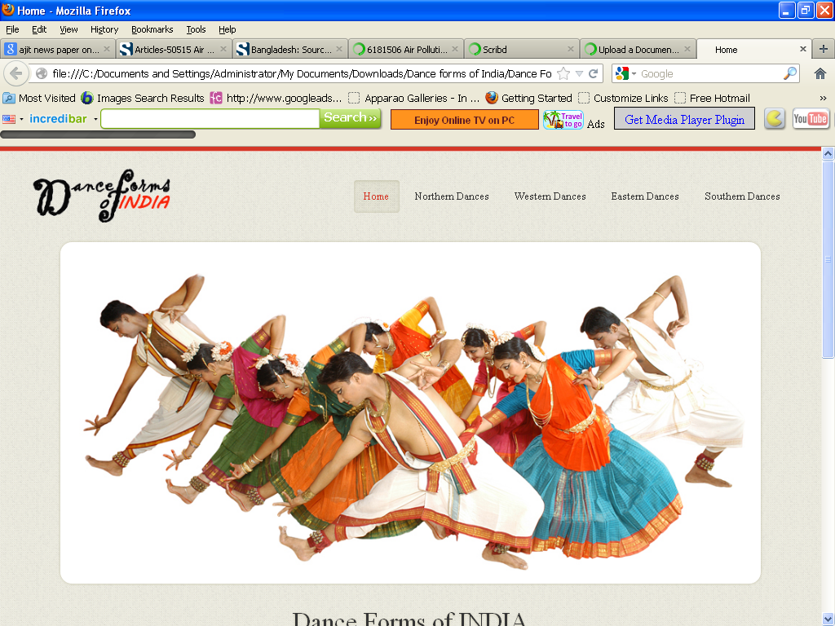

<!DOCTYPE html>

<html lang="en">

<head>

<title>Home</title>

<meta charset="utf-8">

<!--css-->

<link rel="stylesheet" href="css/reset.css" type="text/css" media="screen">

<link rel="stylesheet" href="css/style.css" type="text/css" media="screen">

<link rel="stylesheet" href="css/grid.css" type="text/css" media="screen">

<link rel="icon" href="images/favicon.ico" type="image/x-icon">

<link rel="shortcut icon" href="images/favicon.ico" type="image/x-icon" />

<link rel="stylesheet" href="css/flexslider.css" type="text/css" media="screen">

<!--js-->

<script type="text/javascript" src="js/jquery-1.7.1.min.js" ></script>

<script type="text/javascript" src="js/superfish.js"></script>

<script type="text/javascript" src="js/jquery.flexslider-min.js"></script>

<script>

jQuery(window).load(function() {

jQuery('.flexslider').flexslider({

animation: "fade",

slideshow: true,

slideshowSpeed: 7000,

animationDuration: 600,

prevText: "",

nextText: "",

controlNav: false

})

});

</script>

</head>

<body>

<!--==============================header=================================-->

<header>

<div class="line-top"></div>

<div class="main">

<div class="row-top">

<h1><a href="index.html"><img alt="" src="images/logo.gif"></a></h1>

<nav>

<ul class="sf-menu">

<li class="active"><a href="index.html">Home</a></li>

<li><a href="#">Northern Dances</a>

<ul>

<li><a href="JnK.html">Jammu n Kashmir</a></li>

<li><a href="HP.html">Himachal Pradesh </a>

<li><a href="Uttarakhand.html">Uttarakhand</a></li>

<li><a href="Haryana.html">Haryana</a></li>

<li><a href="Punjab.html">Punjab </a>

<li><a href="Rajasthan.html">Rajasthan</a></li>

<li><a href="UP.html">Uttar Pradesh</a></li>

<li><a href="Bihar.html">Bihar</a></li>

<li><a href="Jharkhand.html">Jharkhand</a></li>

<li><a href="Chhattisgarh.html">Chhattisgarh</a></li>

<li><a href="MP.html">Madhya Pradesh</a></li>

</ul>

</li>

<li><a href="#">Western Dances</a>

<ul>

<li><a href="Maharashtra.html">Maharashtra</a></li>

<li><a href="Gujarat.html">Gujarat </a>

</ul>

</li>

<li><a href="#">Eastern Dances</a>

<ul>

<li><a href="WB.html">West Bengal</a></li>

<li><a href="Orissa.html">Orissa </a>

<li><a href="Jharkhand.html">Jharkhand</a></li>

<li><a href="AP.html">Arunachal Pradesh</a></li>

<li><a href="Assam.html">Assam </a>

<li><a href="Manipur.html">Manipur</a></li>

<li><a href="Meghalaya.html">Meghalaya</a></li>

<li><a href="Mizoram.html">Mizoram</a></li>

<li><a href="Nagaland.html">Nagaland</a></li>

<li><a href="Sikkim.html">Sikkim</a></li>

<li><a href="Tripura.html">Tripura</a></li>

</ul>

</li>

<li><a href="#">Southern Dances </a>

<ul>

<li><a href="AndP.html">Andhra Pradesh</a></li>

<li><a href="Karnataka.html">Karnataka </a>

<li><a href="Kerala.html">Kerala</a></li>

<li><a href="TN.html">Tamil Nadu</a></li>

<li><a href="Assam.html">Assam </a>

<li><a href="Manipur.html">Manipur</a></li>

<li><a href="Meghalaya.html">Meghalaya</a></li>

<li><a href="Mizoram.html">Mizoram</a></li>

<li><a href="Nagaland.html">Nagaland</a></li>

<li><a href="Sikkim.html">Sikkim</a></li>

<li><a href="Tripura.html">Tripura</a></li>

</ul>

</nav>

<div class="clear"></div>

</div>

</div>

<div class="box-slider">

<div class="flexslider">

<ul class="slides">

<li> <img alt="" src="images/slide3.jpg"></li>

</ul>

</div>

</div>

<div class="box-slogan">

<h3>Dance Forms of INDIA</h3>

<p> Dance in India comprises the varied styles of dances in the country. As with other aspects of Indian culture, different forms of dances originated in different parts of India, developed according to the local traditions and also imbibed elements from other parts of the country. </p>

</div>

</header>

<!--==============================content=================================-->

<section id="content"><div class="ic"></div>

<div class="border-horiz"></div>

<div class="container_12 row-1">

<article class="grid_4 thumbnail-1">

<h3><span>Northern</span> Dances </h3>

<figure class="box-img"><img src="images/hd1.jpg " alt="" /></figure>

<p>Dance of North India too has diverse folk and classical forms. Among the well-known folk dances are the bhangra of the Punjab, the ghoomar of Rajasthan, and rouf and bhand pather of Kashmir</p>

</article>

<article class="grid_4 thumbnail-1">

<h3><span>Western</span> Dances </h3>

<figure class="box-img"><img src="images/hd2.jpg " alt="" /></figure>

<p>Western folk dances in India have emerged as very influential dance forms. Well known dance form Garba is a western dance form. Yakshagaman is a folk form of the western coast of Karnataka</p>

</article>

<article class="grid_4 thumbnail-1">

<h3><span>Eastern</span> Dances </h3>

<figure class="box-img"><img src="images/hde.jpg " alt="" /></figure>

<p>East India Dances are upshot of several relegious Inspirations, cultural expressions as well as entertainment. Few of them are Chahu, Brita, Dalkahi are folk dances of Eastern India</p>

</article>

<article class="grid_4 thumbnail-1">

<h3><span>Southern</span> Dances </h3>

<figure class="box-img"><img src="images/hds.jpg " alt="" /></figure>

<p>The South Indian culture is celebrated in the elaborate dance forms of South India - Koodiyattam, Bharatanatyam, Kuchipudi, Kathakali, Ottamthullal, Kerala Natanam, Mohiniaattam and Yakshagana.</p>

</article>

<div class="clear"></div>

</div>

</section>

<!--==============================footer=================================-->

<footer>

<div class="main">

<center> <p>Some traditions of the Indian classical dance are practiced in the whole Indian subcontinent, including Pakistan and Bangladesh, with which India shares several other cultural traits. Indian mythologies play significant part in dance forms of countries in South East Asia, an example being the performances based on Ramayana in Javanese dances.</p> </center>

</div>

</footer>

</body>

</html>

**ANDHRA PRADESH.htm**

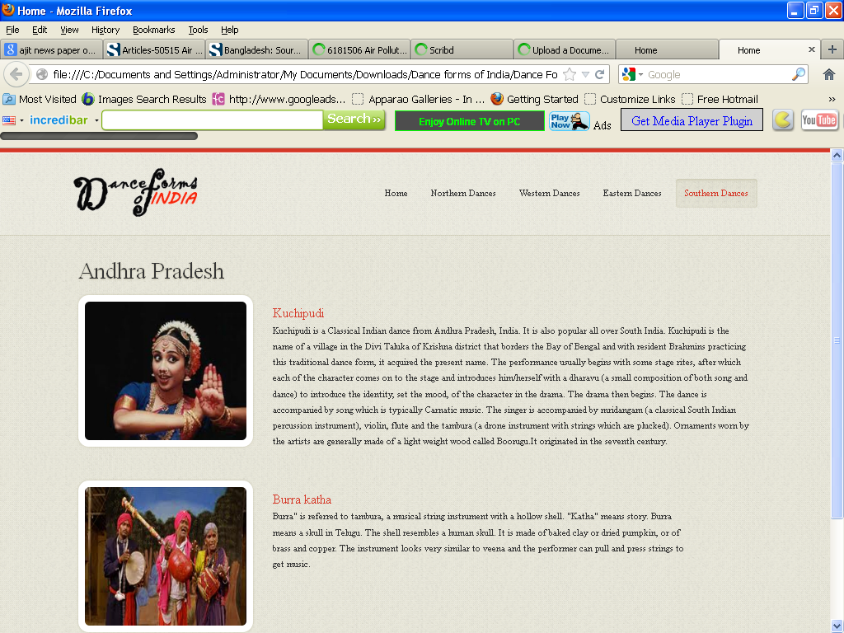

<!DOCTYPE html>

<html lang="en">

<head>

<title>Home</title>

<meta charset="utf-8">

<!--css-->

<link rel="stylesheet" href="css/reset.css" type="text/css" media="screen">

<link rel="stylesheet" href="css/style.css" type="text/css" media="screen">

<link rel="stylesheet" href="css/grid.css" type="text/css" media="screen">

<link rel="icon" href="images/favicon.ico" type="image/x-icon">

<link rel="shortcut icon" href="images/favicon.ico" type="image/x-icon" />

<link rel="stylesheet" href="css/flexslider.css" type="text/css" media="screen">

<!--js-->

<script type="text/javascript" src="js/jquery-1.7.1.min.js" ></script>

<script type="text/javascript" src="js/superfish.js"></script>

<script type="text/javascript" src="js/jquery.flexslider-min.js"></script>

<script>

jQuery(window).load(function () {

jQuery('.flexslider').flexslider({

animation: "fade",

slideshow: true,

slideshowSpeed: 7000,

animationDuration: 600,

prevText: "",

nextText: "",

controlNav: false

})

});

</script>

</head>

<body>

<!--==============================header=================================-->

<header>

<div class="line-top"></div>

<div class="main">

<div class="row-top">

<h1><a href="index.html"><img alt="" src="images/logo.gif"></a></h1>

<nav>

<ul class="sf-menu">

<li ><a href="index.html">Home</a></li>

<li><a href="#">Northern Dances</a>

<ul>

<li><a href="JnK.html">Jammu n Kashmir</a></li>

<li><a href="HP.html">Himachal Pradesh </a>

<li><a href="Uttarakhand.html">Uttarakhand</a></li>

<li><a href="Haryana.html">Haryana</a></li>

<li><a href="Punjab.html">Punjab </a>

<li><a href="Rajasthan.html">Rajasthan</a></li>

<li><a href="UP.html">Uttar Pradesh</a></li>

<li><a href="Bihar.html">Bihar</a></li>

<li><a href="Jharkhand.html">Jharkhand</a></li>

<li><a href="Chhattisgarh.html">Chhattisgarh</a></li>

<li><a href="MP.html">Madhya Pradesh</a></li>

</ul>

</li>

<li><a href="#">Western Dances</a>

<ul>

<li><a href="Maharashtra.html">Maharashtra</a></li>

<li><a href="Gujarat.html">Gujarat </a>

</ul>

</li>

<li><a href="#" >Eastern Dances</a>

<ul>

<li><a href="WB.html">West Bengal</a></li>

<li><a href="Orissa.html">Orissa </a>

<li><a href="Jharkhand.html">Jharkhand</a></li>

<li><a href="AP.html">Arunachal Pradesh</a></li>

<li><a href="Assam.html">Assam </a>

<li><a href="Manipur.html">Manipur</a></li>

<li><a href="Meghalaya.html">Meghalaya</a></li>

<li><a href="Mizoram.html">Mizoram</a></li>

<li><a href="Nagaland.html">Nagaland</a></li>

<li><a href="Sikkim.html">Sikkim</a></li>

<li><a href="Tripura.html">Tripura</a></li>

</ul>

</li>

<li class="active"><a href="#">Southern Dances </a>

<ul>

<li><a href="AndP.html">Andhra Pradesh</a></li>

<li><a href="Karnataka.html">Karnataka </a>

<li><a href="Kerala.html">Kerala</a></li>

<li><a href="TN.html">Tamil Nadu</a></li>

</ul>

</nav>

<div class="clear"></div>

</div>

</div>

</header>

<!--==============================content=================================-->

<section id="content"><div class="ic"></div>

<div class="border-horiz"></div>

<div class="container_12">

<article class="grid_8">

<h3>Andhra Pradesh</h3>

<ul class="list-recipes">

<li>

<figure class="box-img"><img src="images/AndP1.jpg " alt="" /></figure>

<div class="overflow">

<h4>Kuchipudi</h4>

<p>Kuchipudi is a Classical Indian dance from Andhra Pradesh, India. It is also popular all over South India. Kuchipudi is the name of a village in the Divi Taluka of Krishna district that borders the Bay of Bengal and with resident Brahmins practicing this traditional dance form, it acquired the present name.

The performance usually begins with some stage rites, after which each of the character comes on to the stage and introduces him/herself with a dharavu (a small composition of both song and dance) to introduce the identity, set the mood, of the character in the drama. The drama then begins. The dance is accompanied by song which is typically Carnatic music. The singer is accompanied by mridangam (a classical South Indian percussion instrument), violin, flute and the tambura (a drone instrument with strings which are plucked). Ornaments worn by the artists are generally made of a light weight wood called Boorugu.It originated in the seventh century.</p>

</div>

<div class="clear"></div>

</li>

<li>

<figure class="box-img "><img src="images/AndP2.jpg " alt="" /></figure>

<div class="overflow" style= "width:62%" >

<h4>Burra katha</h4>

<p>Burra" is referred to tambura, a musical string instrument with a hollow shell. "Katha" means story.

Burra means a skull in Telugu. The shell resembles a human skull. It is made of baked clay or dried pumpkin, or of brass and copper. The instrument looks very similar to veena and the performer can pull and press strings to get music. </p>

</div>

<div class="clear"></div>

</li>

</ul>

</article>

<div class="clear"></div>

</div>

</section>

<!--==============================footer=================================-->

<footer>

<div class="main">

<center> <p>Some traditions of the Indian classical dance are practiced in the whole Indian subcontinent, including Pakistan and Bangladesh, with which India shares several other cultural traits. Indian mythologies play significant part in dance forms of countries in South East Asia, an example being the performances based on Ramayana in Javanese dances.</p> </center>

</div>

</footer>

</body>

</html>

**Arunachal Pradesh.htm**

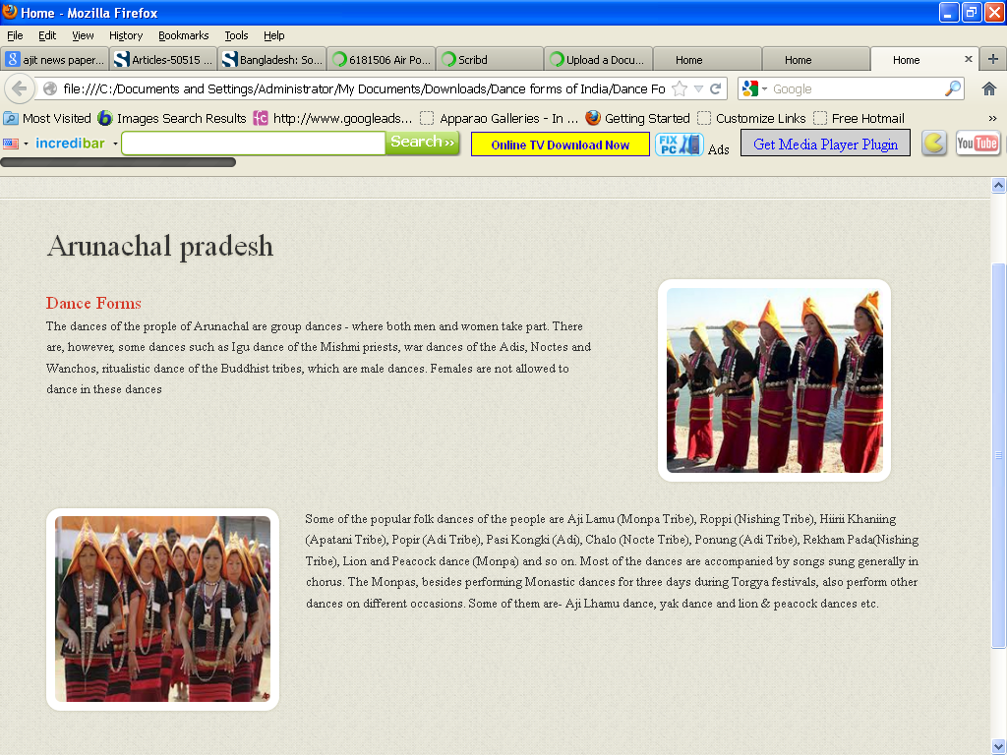

<!DOCTYPE html>

<html lang="en">

<head>

<title>Home</title>

<meta charset="utf-8">

<!--css-->

<link rel="stylesheet" href="css/reset.css" type="text/css" media="screen">

<link rel="stylesheet" href="css/style.css" type="text/css" media="screen">

<link rel="stylesheet" href="css/grid.css" type="text/css" media="screen">

<link rel="icon" href="images/favicon.ico" type="image/x-icon">

<link rel="shortcut icon" href="images/favicon.ico" type="image/x-icon" />

<link rel="stylesheet" href="css/flexslider.css" type="text/css" media="screen">

<!--js-->

<script type="text/javascript" src="js/jquery-1.7.1.min.js" ></script>

<script type="text/javascript" src="js/superfish.js"></script>

<script type="text/javascript" src="js/jquery.flexslider-min.js"></script>

<script>

jQuery(window).load(function () {

jQuery('.flexslider').flexslider({

animation: "fade",

slideshow: true,

slideshowSpeed: 7000,

animationDuration: 600,

prevText: "",

nextText: "",

controlNav: false

})

});

</script>

</head>

<body>

<!--==============================header=================================-->

<header>

<div class="line-top"></div>

<div class="main">

<div class="row-top">

<h1><a href="index.html"><img alt="" src="images/logo.gif"></a></h1>

<nav>

<ul class="sf-menu">

<li><a href="index.html">Home</a></li>

<li><a href="#">Northern Dances</a>

<ul>

<li><a href="JnK.html">Jammu n Kashmir</a></li>

<li><a href="HP.html">Himachal Pradesh </a>

<li><a href="Uttarakhand.html">Uttarakhand</a></li>

<li><a href="Haryana.html">Haryana</a></li>

<li><a href="Punjab.html">Punjab </a>

<li><a href="Rajasthan.html">Rajasthan</a></li>

<li><a href="UP.html">Uttar Pradesh</a></li>

<li><a href="Bihar.html">Bihar</a></li>

<li><a href="Jharkhand.html">Jharkhand</a></li>

<li><a href="Chhattisgarh.html">Chhattisgarh</a></li>

<li><a href="MP.html">Madhya Pradesh</a></li>

</ul>

</li>

<li><a href="#">Western Dances</a>

<ul>

<li><a href="Maharashtra.html">Maharashtra</a></li>

<li><a href="Gujarat.html">Gujarat </a>

</ul>

</li>

<li class="active"><a href="#">Eastern Dances</a>

<ul>

<li><a href="WB.html">West Bengal</a></li>

<li><a href="Orissa.html">Orissa </a>

<li><a href="Jharkhand.html">Jharkhand</a></li>

<li><a href="AP.html">Arunachal Pradesh</a></li>

<li><a href="Assam.html">Assam </a>

<li><a href="Manipur.html">Manipur</a></li>

<li><a href="Meghalaya.html">Meghalaya</a></li>

<li><a href="Mizoram.html">Mizoram</a></li>

<li><a href="Nagaland.html">Nagaland</a></li>

<li><a href="Sikkim.html">Sikkim</a></li>

<li><a href="Tripura.html">Tripura</a></li>

</ul>

</li>

<li><a href="#">Southern Dances </a>

<ul>

<li><a href="AndP.html">Andhra Pradesh</a></li>

<li><a href="Karnataka.html">Karnataka </a>

<li><a href="Kerala.html">Kerala</a></li>

<li><a href="TN.html">Tamil Nadu</a></li>

</ul>

</nav>

<div class="clear"></div>

</div>

</div>

</header>

<!--==============================content=================================-->

<section id="content"><div class="ic"></div>

<div class="border-horiz"></div>

<div class="container_12">

<article class="grid_8">

<h3>Arunachal pradesh</h3>

<ul class="list-recipes">

<li>

<div class="img-indent2"><figure class="box-img "><img src="images/AP1.jpg " alt="" /></figure></div>

<div class="overflow" style= "width:62%" >

<h4>Dance Forms</h4>

<p>The dances of the prople of Arunachal are group dances - where both men and women take part. There are, however, some dances such as Igu dance of the Mishmi priests, war dances of the Adis, Noctes and Wanchos, ritualistic dance of the Buddhist tribes, which are male dances. Females are not allowed to dance in these dances </p>

</div>

<div class="clear"></div>

</li>

<li>

<figure class="box-img"><img src="images/AP2.jpg " alt="" /></figure>

<div class="overflow">

<p>Some of the popular folk dances of the people are Aji Lamu (Monpa Tribe), Roppi (Nishing Tribe), Hiirii Khaniing (Apatani Tribe), Popir (Adi Tribe), Pasi Kongki (Adi), Chalo (Nocte Tribe), Ponung (Adi Tribe), Rekham Pada(Nishing Tribe), Lion and Peacock dance (Monpa) and so on. Most of the dances are accompanied by songs sung generally in chorus.

The Monpas, besides performing Monastic dances for three days during Torgya festivals, also perform other dances on different occasions. Some of them are- Aji Lhamu dance, yak dance and lion & peacock dances etc.</p>

</div>

<div class="clear"></div>

</li>

</ul>

</article>

<div class="clear"></div>

</div>

</section>

<!--==============================footer=================================-->

<footer>

<div class="main">

<center> <p>Some traditions of the Indian classical dance are practiced in the whole Indian subcontinent, including Pakistan and Bangladesh, with which India shares several other cultural traits. Indian mythologies play significant part in dance forms of countries in South East Asia, an example being the performances based on Ramayana in Javanese dances.</p> </center>

</div>

</footer>

</body>

</html>

**Assam.htm**

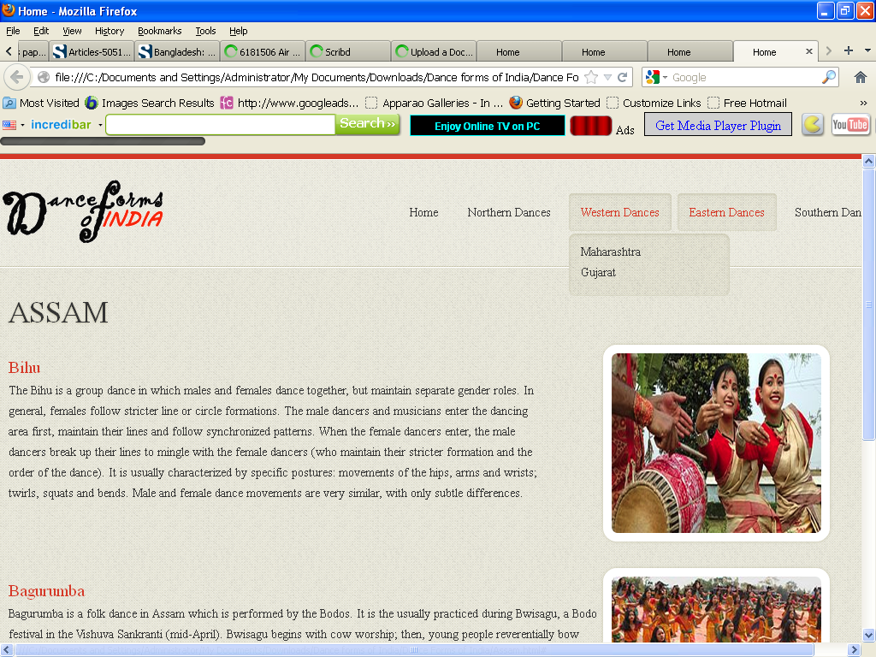

<!DOCTYPE html>

<html lang="en">

<head>

<title>Home</title>

<meta charset="utf-8">

<!--css-->

<link rel="stylesheet" href="css/reset.css" type="text/css" media="screen">

<link rel="stylesheet" href="css/style.css" type="text/css" media="screen">

<link rel="stylesheet" href="css/grid.css" type="text/css" media="screen">

<link rel="icon" href="images/favicon.ico" type="image/x-icon">

<link rel="shortcut icon" href="images/favicon.ico" type="image/x-icon" />

<link rel="stylesheet" href="css/flexslider.css" type="text/css" media="screen">

<!--js-->

<script type="text/javascript" src="js/jquery-1.7.1.min.js" ></script>

<script type="text/javascript" src="js/superfish.js"></script>

<script type="text/javascript" src="js/jquery.flexslider-min.js"></script>

<script>

jQuery(window).load(function () {

jQuery('.flexslider').flexslider({

animation: "fade",

slideshow: true,

slideshowSpeed: 7000,

animationDuration: 600,

prevText: "",

nextText: "",

controlNav: false

})

});

</script>

</head>

<body>

<!--==============================header=================================-->

<header>

<div class="line-top"></div>

<div class="main">

<div class="row-top">

<h1><a href="index.html"><img alt="" src="images/logo.gif"></a></h1>

<nav>

<ul class="sf-menu">

<li><a href="index.html">Home</a></li>

<li><a href="#">Northern Dances</a>

<ul>

<li><a href="JnK.html">Jammu n Kashmir</a></li>

<li><a href="HP.html">Himachal Pradesh </a>

<li><a href="Uttarakhand.html">Uttarakhand</a></li>

<li><a href="Haryana.html">Haryana</a></li>

<li><a href="Punjab.html">Punjab </a>

<li><a href="Rajasthan.html">Rajasthan</a></li>

<li><a href="UP.html">Uttar Pradesh</a></li>

<li><a href="Bihar.html">Bihar</a></li>

<li><a href="Jharkhand.html">Jharkhand</a></li>

<li><a href="Chhattisgarh.html">Chhattisgarh</a></li>

<li><a href="MP.html">Madhya Pradesh</a></li>

</ul>

</li>

<li><a href="#">Western Dances</a>

<ul>

<li><a href="Maharashtra.html">Maharashtra</a></li>

<li><a href="Gujarat.html">Gujarat </a>

</ul>

</li>

<li class="active"><a href="#">Eastern Dances</a>

<ul>

<li><a href="WB.html">West Bengal</a></li>

<li><a href="Orissa.html">Orissa </a>

<li><a href="Jharkhand.html">Jharkhand</a></li>

<li><a href="AP.html">Arunachal Pradesh</a></li>

<li><a href="Assam.html">Assam </a>

<li><a href="Manipur.html">Manipur</a></li>

<li><a href="Meghalaya.html">Meghalaya</a></li>

<li><a href="Mizoram.html">Mizoram</a></li>

<li><a href="Nagaland.html">Nagaland</a></li>

<li><a href="Sikkim.html">Sikkim</a></li>

<li><a href="Tripura.html">Tripura</a></li>

</ul>

</li>

<li><a href="#">Southern Dances </a>

<ul>

<li><a href="AndP.html">Andhra Pradesh</a></li>

<li><a href="Karnataka.html">Karnataka </a>

<li><a href="Kerala.html">Kerala</a></li>

<li><a href="TN.html">Tamil Nadu</a></li>

</ul>

</nav>

<div class="clear"></div>

</div>

</div>

</header>

<!--==============================content=================================-->

<section id="content"><div class="ic"></div>

<div class="border-horiz"></div>

<div class="container_12">

<article class="grid_8">

<h3>ASSAM</h3>

<ul class="list-recipes">

<li>

<div class="img-indent2"><figure class="box-img "><img src="images/Assam1.jpg " alt="" /></figure></div>

<div class="overflow" style= "width:62%" >

<h4>Bihu</h4>

<p>The Bihu is a group dance in which males and females dance together, but maintain separate gender roles. In general, females follow stricter line or circle formations. The male dancers and musicians enter the dancing area first, maintain their lines and follow synchronized patterns. When the female dancers enter, the male dancers break up their lines to mingle with the female dancers (who maintain their stricter formation and the order of the dance). It is usually characterized by specific postures: movements of the hips, arms and wrists; twirls, squats and bends. Male and female dance movements are very similar, with only subtle differences. </p>

</div>

<div class="clear"></div>

</li>

<li>

<div class="img-indent2"><figure class="box-img"><img src="images/Assam2.jpg " alt="" /></figure></div>

<div class="overflow">

<h4>Bagurumba</h4>

<p>Bagurumba is a folk dance in Assam which is performed by the Bodos. It is the usually practiced during Bwisagu, a Bodo festival in the Vishuva Sankranti (mid-April). Bwisagu begins with cow worship; then, young people reverentially bow down to their parents and elders.

After that, Bathow is worshiped by offering the deity chicken and zou (rice beer). Bodo women wearing colourful dokhna and aronai perform the Bagurumba dance (also known as the Bardwisikhla dance). It is accompanied by instruments such as the serja (a bowed instrument), sifung (flute), tharkha (split bamboo), kham or madal (long drum, made of wood and goatskin). The festival ends with a community prayer at Garjasali. This dance is performed in the Bodo-inhabited areas of Udalguri, Kokrajhar, Baksa, Chirang, Bongaigaon, Nalbari, Darrang and Sonitpur Districts.</p> </div>

<div class="clear"></div>

</li>

</ul>

</article>

<div class="clear"></div>

</div>

</section>

<!--==============================footer=================================-->

<footer>

<div class="main">

<center> <p>Some traditions of the Indian classical dance are practiced in the whole Indian subcontinent, including Pakistan and Bangladesh, with which India shares several other cultural traits. Indian mythologies play significant part in dance forms of countries in South East Asia, an example being the performances based on Ramayana in Javanese dances.</p> </center>

</div>

</footer>

</body>

</html>

**Bihar.htm**

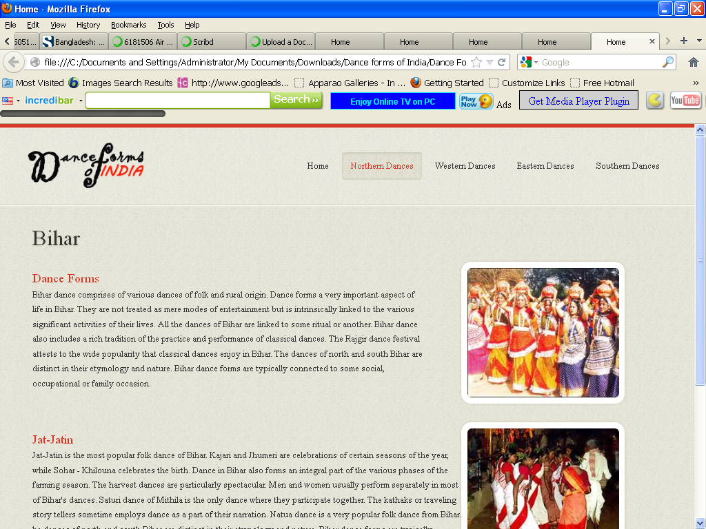

<!DOCTYPE html>

<html lang="en">

<head>

<title>Home</title>

<meta charset="utf-8">

<!--css-->

<link rel="stylesheet" href="css/reset.css" type="text/css" media="screen">

<link rel="stylesheet" href="css/style.css" type="text/css" media="screen">

<link rel="stylesheet" href="css/grid.css" type="text/css" media="screen">

<link rel="icon" href="images/favicon.ico" type="image/x-icon">

<link rel="shortcut icon" href="images/favicon.ico" type="image/x-icon" />

<link rel="stylesheet" href="css/flexslider.css" type="text/css" media="screen">

<!--js-->

<script type="text/javascript" src="js/jquery-1.7.1.min.js" ></script>

<script type="text/javascript" src="js/superfish.js"></script>

<script type="text/javascript" src="js/jquery.flexslider-min.js"></script>

<script>

jQuery(window).load(function () {

jQuery('.flexslider').flexslider({

animation: "fade",

slideshow: true,

slideshowSpeed: 7000,

animationDuration: 600,

prevText: "",

nextText: "",

controlNav: false

})

});

</script>

</head>

<body>

<!--==============================header=================================-->

<header>

<div class="line-top"></div>

<div class="main">

<div class="row-top">

<h1><a href="index.html"><img alt="" src="images/logo.gif"></a></h1>

<nav>

<ul class="sf-menu">

<li><a href="index.html">Home</a></li>

<li class="active"><a href="#">Northern Dances</a>

<ul>

<li><a href="JnK.html">Jammu n Kashmir</a></li>

<li><a href="HP.html">Himachal Pradesh </a>

<li><a href="Uttarakhand.html">Uttarakhand</a></li>

<li><a href="Haryana.html">Haryana</a></li>

<li><a href="Punjab.html">Punjab </a>

<li><a href="Rajasthan.html">Rajasthan</a></li>

<li><a href="UP.html">Uttar Pradesh</a></li>

<li><a href="Bihar.html">Bihar</a></li>

<li><a href="Jharkhand.html">Jharkhand</a></li>

<li><a href="Chhattisgarh.html">Chhattisgarh</a></li>

<li><a href="MP.html">Madhya Pradesh</a></li>

</ul>

</li>

<li><a href="#">Western Dances</a>

<ul>

<li><a href="Maharashtra.html">Maharashtra</a></li>

<li><a href="Gujarat.html">Gujarat </a>

</ul>

</li>

<li><a href="#">Eastern Dances</a>

<ul>

<li><a href="WB.html">West Bengal</a></li>

<li><a href="Orissa.html">Orissa </a>

<li><a href="Jharkhand.html">Jharkhand</a></li>

<li><a href="AP.html">Arunachal Pradesh</a></li>

<li><a href="Assam.html">Assam </a>

<li><a href="Manipur.html">Manipur</a></li>

<li><a href="Meghalaya.html">Meghalaya</a></li>

<li><a href="Mizoram.html">Mizoram</a></li>

<li><a href="Nagaland.html">Nagaland</a></li>

<li><a href="Sikkim.html">Sikkim</a></li>

<li><a href="Tripura.html">Tripura</a></li>

</ul>

</li>

<li><a href="#">Southern Dances </a>

<ul>

<li><a href="AndP.html">Andhra Pradesh</a></li>

<li><a href="Karnataka.html">Karnataka </a>

<li><a href="Kerala.html">Kerala</a></li>

<li><a href="TN.html">Tamil Nadu</a></li>

</ul>

</nav>

<div class="clear"></div>

</div>

</div>

</header>

<!--==============================content=================================-->

<section id="content"><div class="ic"></div>

<div class="border-horiz"></div>

<div class="container_12">

<article class="grid_8">

<h3>Bihar</h3>

<ul class="list-recipes">

<li>

<div class="img-indent2"><figure class="box-img "><img src="images/Bihar1.jpg " alt="" /></figure></div>

<div class="overflow" style= "width:62%" >

<h4>Dance Forms</h4>

<p>Bihar dance comprises of various dances of folk and rural origin. Dance forms a very important aspect of life in Bihar. They are not treated as mere modes of entertainment but is intrinsically linked to the various significant activities of their lives.

All the dances of Bihar are linked to some ritual or another. Bihar dance also includes a rich tradition of the practice and performance of classical dances. The Rajgir dance festival attests to the wide popularity that classical dances enjoy in Bihar.

The dances of north and south Bihar are distinct in their etymology and nature. Bihar dance forms are typically connected to some social, occupational or family occasion.

</p>

</div>

<div class="clear"></div>

</li>

<li>

<div class="img-indent2"><figure class="box-img"><img src="images/Bihar2.jpg " alt="" /></figure></div>

<div class="overflow">

<h4>Jat-Jatin</h4>

<p>Jat-Jatin is the most popular folk dance of Bihar. Kajari and Jhumeri are celebrations of certain seasons of the year, while Sohar - Khilouna celebrates the birth. Dance in Bihar also forms an integral part of the various phases of the farming season. The harvest dances are particularly spectacular. Men and women usually perform separately in most of Bihar's dances. Saturi dance of Mithila is the only dance where they participate together. The kathaks or traveling story tellers sometime employs dance as a part of their narration. Natua dance is a very popular folk dance from Bihar. he dances of north and south Bihar are distinct in their etymology and nature. Bihar dance forms are typically connected to some social, occupational or family occasion. Jat-Jatin is the most popular folk dance of Bihar. Kajari and Jhumeri are celebrations of certain seasons of the year, while Sohar - Khilouna celebrates the birth. Dance in Bihar also forms an integral part of the various phases of the farming season. The harvest dances are particularly spectacular.

</p>

</div>

<div class="clear"></div>

</li>

</ul>

</article>

<div class="clear"></div>

</div>

</section>

<!--==============================footer=================================-->

<footer>

<div class="main">

<center> <p>Some traditions of the Indian classical dance are practiced in the whole Indian subcontinent, including Pakistan and Bangladesh, with which India shares several other cultural traits. Indian mythologies play significant part in dance forms of countries in South East Asia, an example being the performances based on Ramayana in Javanese dances.</p> </center>

</div>

</footer>

</body>

</html>

**Chhatisgarh.htm**

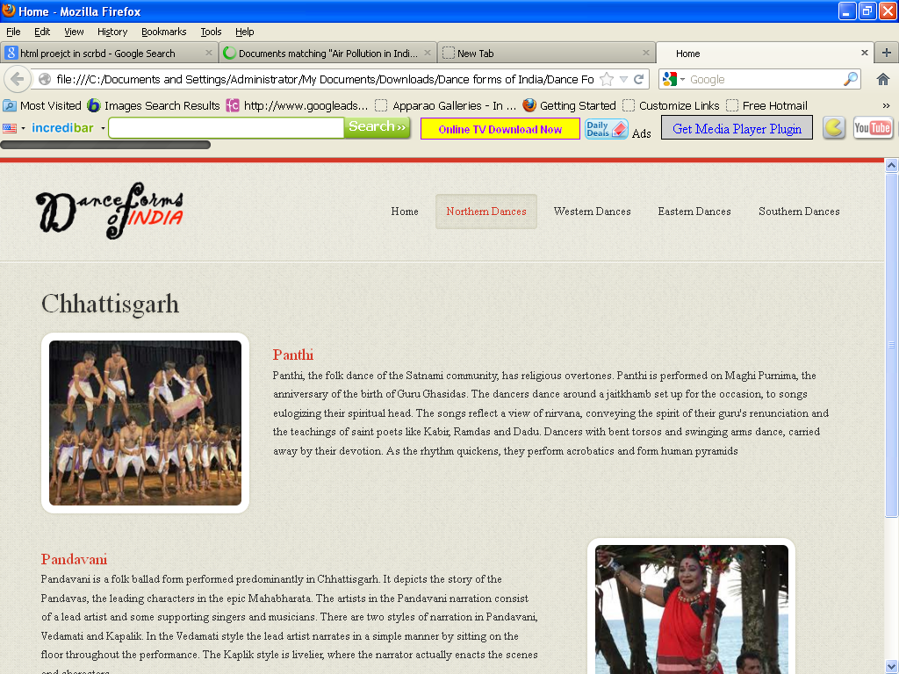

<!DOCTYPE html>

<html lang="en">

<head>

<title>Home</title>

<meta charset="utf-8">

<!--css-->

<link rel="stylesheet" href="css/reset.css" type="text/css" media="screen">

<link rel="stylesheet" href="css/style.css" type="text/css" media="screen">

<link rel="stylesheet" href="css/grid.css" type="text/css" media="screen">

<link rel="icon" href="images/favicon.ico" type="image/x-icon">

<link rel="shortcut icon" href="images/favicon.ico" type="image/x-icon" />

<link rel="stylesheet" href="css/flexslider.css" type="text/css" media="screen">

<!--js-->

<script type="text/javascript" src="js/jquery-1.7.1.min.js" ></script>

<script type="text/javascript" src="js/superfish.js"></script>

<script type="text/javascript" src="js/jquery.flexslider-min.js"></script>

<script>

jQuery(window).load(function () {

jQuery('.flexslider').flexslider({

animation: "fade",

slideshow: true,

slideshowSpeed: 7000,

animationDuration: 600,

prevText: "",

nextText: "",

controlNav: false

})

});

</script>

</head>

<body>

<!--==============================header=================================-->

<header>

<div class="line-top"></div>

<div class="main">

<div class="row-top">

<h1><a href="index.html"><img alt="" src="images/logo.gif"></a></h1>

<nav>

<ul class="sf-menu">

<li><a href="index.html">Home</a></li>

<li class="active"><a href="#">Northern Dances</a>

<ul>

<li><a href="JnK.html">Jammu n Kashmir</a></li>

<li><a href="HP.html">Himachal Pradesh </a>

<li><a href="Uttarakhand.html">Uttarakhand</a></li>

<li><a href="Haryana.html">Haryana</a></li>

<li><a href="Punjab.html">Punjab </a>

<li><a href="Rajasthan.html">Rajasthan</a></li>

<li><a href="UP.html">Uttar Pradesh</a></li>

<li><a href="Bihar.html">Bihar</a></li>

<li><a href="Jharkhand.html">Jharkhand</a></li>

<li><a href="Chhattisgarh.html">Chhattisgarh</a></li>

<li><a href="MP.html">Madhya Pradesh</a></li>

</ul>

</li>

<li><a href="#">Western Dances</a>

<ul>

<li><a href="Maharashtra.html">Maharashtra</a></li>

<li><a href="Gujarat.html">Gujarat </a>

</ul>

</li>

<li><a href="#">Eastern Dances</a>

<ul>

<li><a href="WB.html">West Bengal</a></li>

<li><a href="Orissa.html">Orissa </a>

<li><a href="Jharkhand.html">Jharkhand</a></li>

<li><a href="AP.html">Arunachal Pradesh</a></li>

<li><a href="Assam.html">Assam </a>

<li><a href="Manipur.html">Manipur</a></li>

<li><a href="Meghalaya.html">Meghalaya</a></li>

<li><a href="Mizoram.html">Mizoram</a></li>

<li><a href="Nagaland.html">Nagaland</a></li>

<li><a href="Sikkim.html">Sikkim</a></li>

<li><a href="Tripura.html">Tripura</a></li>

</ul>

</li>

<li><a href="#">Southern Dances </a>

<ul>

<li><a href="AndP.html">Andhra Pradesh</a></li>

<li><a href="Karnataka.html">Karnataka </a>

<li><a href="Kerala.html">Kerala</a></li>

<li><a href="TN.html">Tamil Nadu</a></li>

</ul>

</nav>

<div class="clear"></div>

</div>

</div>

</header>

<!--==============================content=================================-->

<section id="content"><div class="ic"></div>

<div class="border-horiz"></div>

<div class="container_12">

<article class="grid_8">

<h3>Chhattisgarh</h3>

<ul class="list-recipes">

<li>

<figure class="box-img"><img src="images/Ch1.jpg " alt="" /></figure>

<div class="overflow">

<h4>Panthi</h4>

<p>Panthi, the folk dance of the Satnami community, has religious overtones. Panthi is performed on Maghi Purnima, the anniversary of the birth of Guru Ghasidas. The dancers dance around a jaitkhamb set up for the occasion, to songs eulogizing their spiritual head. The songs reflect a view of nirvana, conveying the spirit of their guru's renunciation and the teachings of saint poets like Kabir, Ramdas and Dadu. Dancers with bent torsos and swinging arms dance, carried away by their devotion. As the rhythm quickens, they perform acrobatics and form human pyramids </p> </div>

<div class="clear"></div>

</li>

<li>

<div class="img-indent2"><figure class="box-img "><img src="images/Ch2.jpg " alt="" /></figure></div>

<div class="overflow" style= "width:62%" >

<h4>Pandavani</h4>

<p>Pandavani is a folk ballad form performed predominantly in Chhattisgarh. It depicts the story of the Pandavas, the leading characters in the epic Mahabharata. The artists in the Pandavani narration consist of a lead artist and some supporting singers and musicians. There are two styles of narration in Pandavani, Vedamati and Kapalik. In the Vedamati style the lead artist narrates in a simple manner by sitting on the floor throughout the performance. The Kaplik style is livelier, where the narrator actually enacts the scenes and characters.</p>

</div>

<div class="clear"></div>

</li>

</ul>

</article>

<div class="clear"></div>

</div>

</section>

<!--==============================footer=================================-->

<footer>

<div class="main">

<center> <p>Some traditions of the Indian classical dance are practiced in the whole Indian subcontinent, including Pakistan and Bangladesh, with which India shares several other cultural traits. Indian mythologies play significant part in dance forms of countries in South East Asia, an example being the performances based on Ramayana in Javanese dances.</p> </center>

</div>

</footer>

</body>

</html>

**Gujarat.htm**

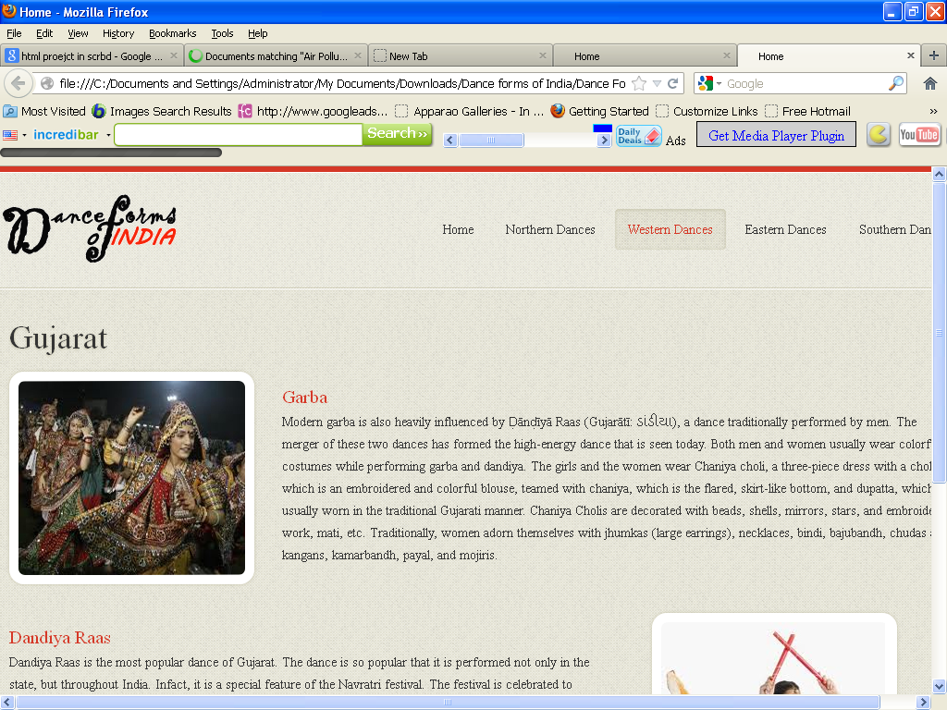

<!DOCTYPE html>

<html lang="en">

<head>

<title>Home</title>

<meta charset="utf-8">

<!--css-->

<link rel="stylesheet" href="css/reset.css" type="text/css" media="screen">

<link rel="stylesheet" href="css/style.css" type="text/css" media="screen">

<link rel="stylesheet" href="css/grid.css" type="text/css" media="screen">

<link rel="icon" href="images/favicon.ico" type="image/x-icon">

<link rel="shortcut icon" href="images/favicon.ico" type="image/x-icon" />

<link rel="stylesheet" href="css/flexslider.css" type="text/css" media="screen">

<!--js-->

<script type="text/javascript" src="js/jquery-1.7.1.min.js" ></script>

<script type="text/javascript" src="js/superfish.js"></script>

<script type="text/javascript" src="js/jquery.flexslider-min.js"></script>

<script>

jQuery(window).load(function () {

jQuery('.flexslider').flexslider({

animation: "fade",

slideshow: true,

slideshowSpeed: 7000,

animationDuration: 600,

prevText: "",

nextText: "",

controlNav: false

})

});

</script>

</head>

<body>

<!--==============================header=================================-->

<header>

<div class="line-top"></div>

<div class="main">

<div class="row-top">

<h1><a href="index.html"><img alt="" src="images/logo.gif"></a></h1>

<nav>

<ul class="sf-menu">

<li ><a href="index.html">Home</a></li>

<li><a href="#">Northern Dances</a>

<ul>

<li><a href="JnK.html">Jammu n Kashmir</a></li>

<li><a href="HP.html">Himachal Pradesh </a>

<li><a href="Uttarakhand.html">Uttarakhand</a></li>

<li><a href="Haryana.html">Haryana</a></li>

<li><a href="Punjab.html">Punjab </a>

<li><a href="Rajasthan.html">Rajasthan</a></li>

<li><a href="UP.html">Uttar Pradesh</a></li>

<li><a href="Bihar.html">Bihar</a></li>

<li><a href="Jharkhand.html">Jharkhand</a></li>

<li><a href="Chhattisgarh.html">Chhattisgarh</a></li>

<li><a href="MP.html">Madhya Pradesh</a></li>

</ul>

</li>

<li class="active" ><a href="#">Western Dances</a>

<ul>

<li><a href="Maharashtra.html">Maharashtra</a></li>

<li><a href="Gujarat.html">Gujarat </a>

</ul>

</li>

<li><a href="#">Eastern Dances</a>

<ul>

<li><a href="WB.html">West Bengal</a></li>

<li><a href="Orissa.html">Orissa </a>

<li><a href="Jharkhand.html">Jharkhand</a></li>

<li><a href="AP.html">Arunachal Pradesh</a></li>

<li><a href="Assam.html">Assam </a>

<li><a href="Manipur.html">Manipur</a></li>

<li><a href="Meghalaya.html">Meghalaya</a></li>

<li><a href="Mizoram.html">Mizoram</a></li>

<li><a href="Nagaland.html">Nagaland</a></li>

<li><a href="Sikkim.html">Sikkim</a></li>

<li><a href="Tripura.html">Tripura</a></li>

</ul>

</li>

<li><a href="#">Southern Dances </a>

<ul>

<li><a href="AndP.html">Andhra Pradesh</a></li>

<li><a href="Karnataka.html">Karnataka </a>

<li><a href="Kerala.html">Kerala</a></li>

<li><a href="TN.html">Tamil Nadu</a></li>

</ul>

</nav>

<div class="clear"></div>

</div>

</div>

</header>

<!--==============================content=================================-->

<section id="content"><div class="ic"></div>

<div class="border-horiz"></div>

<div class="container_12">

<article class="grid_8">

<h3>Gujarat</h3>

<ul class="list-recipes">

<li>

<figure class="box-img"><img src="images/gu1.jpg " alt="" /></figure>

<div class="overflow">

<h4>Garba</h4>

<p>Modern garba is also heavily influenced by Ḍānḍīyā Raas (Gujarātī: ડાંડીયા), a dance traditionally performed by men. The merger of these two dances has formed the high-energy dance that is seen today.

Both men and women usually wear colorful costumes while performing garba and dandiya. The girls and the women wear Chaniya choli, a three-piece dress with a choli, which is an embroidered and colorful blouse, teamed with chaniya, which is the flared, skirt-like bottom, and dupatta, which is usually worn in the traditional Gujarati manner. Chaniya Cholis are decorated with beads, shells, mirrors, stars, and embroidery work, mati, etc. Traditionally, women adorn themselves with jhumkas (large earrings), necklaces, bindi, bajubandh, chudas and kangans, kamarbandh, payal, and mojiris.</p>

</div>

<div class="clear"></div>

</li>

<li>

<div class="img-indent2"><figure class="box-img "><img src="images/gu2.jpg " alt="" /></figure></div>

<div class="overflow" style= "width:62%" >

<h4>Dandiya Raas</h4>

<p>Dandiya Raas is the most popular dance of Gujarat. The dance is so popular that it is performed not only in the state, but throughout India. Infact, it is a special feature of the Navratri festival. The festival is celebrated to pay homage to the nine incarnations of Mata Amb, the Mother Goddess. People observe fasts on all nine days of the festival and pay regular visits to temples. </p>

</div>

<div class="clear"></div>

</li>

</ul>

</article>

<div class="clear"></div>

</div>

</section>

<!--==============================footer=================================-->

<footer>

<div class="main">

<center> <p>Some traditions of the Indian classical dance are practiced in the whole Indian subcontinent, including Pakistan and Bangladesh, with which India shares several other cultural traits. Indian mythologies play significant part in dance forms of countries in South East Asia, an example being the performances based on Ramayana in Javanese dances.</p> </center>

</div>

</footer>

</body>

</html>

**Haryana.htm**

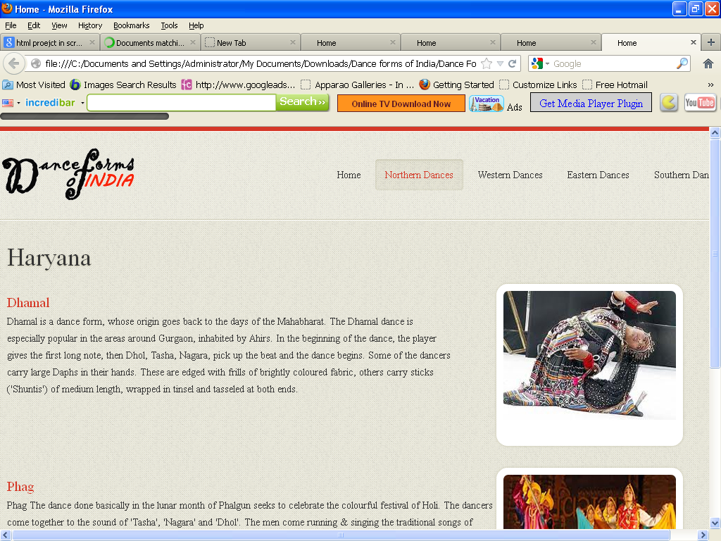

<!DOCTYPE html>

<html lang="en">

<head>

<title>Home</title>

<meta charset="utf-8">

<!--css-->

<link rel="stylesheet" href="css/reset.css" type="text/css" media="screen">

<link rel="stylesheet" href="css/style.css" type="text/css" media="screen">

<link rel="stylesheet" href="css/grid.css" type="text/css" media="screen">

<link rel="icon" href="images/favicon.ico" type="image/x-icon">

<link rel="shortcut icon" href="images/favicon.ico" type="image/x-icon" />

<link rel="stylesheet" href="css/flexslider.css" type="text/css" media="screen">

<!--js-->

<script type="text/javascript" src="js/jquery-1.7.1.min.js" ></script>

<script type="text/javascript" src="js/superfish.js"></script>

<script type="text/javascript" src="js/jquery.flexslider-min.js"></script>

<script>

jQuery(window).load(function () {

jQuery('.flexslider').flexslider({

animation: "fade",

slideshow: true,

slideshowSpeed: 7000,

animationDuration: 600,

prevText: "",

nextText: "",

controlNav: false

})

});

</script>

</head>

<body>

<!--==============================header=================================-->

<header>

<div class="line-top"></div>

<div class="main">

<div class="row-top">

<h1><a href="index.html"><img alt="" src="images/logo.gif"></a></h1>

<nav>

<ul class="sf-menu">

<li ><a href="index.html">Home</a></li>

<li class="active"><a href="#">Northern Dances</a>

<ul>

<li><a href="JnK.html">Jammu n Kashmir</a></li>

<li><a href="HP.html">Himachal Pradesh </a>

<li><a href="Uttarakhand.html">Uttarakhand</a></li>

<li><a href="Haryana.html">Haryana</a></li>

<li><a href="Punjab.html">Punjab </a>

<li><a href="Rajasthan.html">Rajasthan</a></li>

<li><a href="UP.html">Uttar Pradesh</a></li>

<li><a href="Bihar.html">Bihar</a></li>

<li><a href="Jharkhand.html">Jharkhand</a></li>

<li><a href="Chhattisgarh.html">Chhattisgarh</a></li>

<li><a href="MP.html">Madhya Pradesh</a></li>

</ul>

</li>

<li><a href="#">Western Dances</a>

<ul>

<li><a href="Maharashtra.html">Maharashtra</a></li>

<li><a href="Gujarat.html">Gujarat </a>

</ul>

</li>

<li><a href="#">Eastern Dances</a>

<ul>

<li><a href="WB.html">West Bengal</a></li>

<li><a href="Orissa.html">Orissa </a>

<li><a href="Jharkhand.html">Jharkhand</a></li>

<li><a href="AP.html">Arunachal Pradesh</a></li>

<li><a href="Assam.html">Assam </a>

<li><a href="Manipur.html">Manipur</a></li>

<li><a href="Meghalaya.html">Meghalaya</a></li>

<li><a href="Mizoram.html">Mizoram</a></li>

<li><a href="Nagaland.html">Nagaland</a></li>

<li><a href="Sikkim.html">Sikkim</a></li>

<li><a href="Tripura.html">Tripura</a></li>

</ul>

</li>

<li><a href="#">Southern Dances </a>

<ul>

<li><a href="AndP.html">Andhra Pradesh</a></li>

<li><a href="Karnataka.html">Karnataka </a>

<li><a href="Kerala.html">Kerala</a></li>

<li><a href="TN.html">Tamil Nadu</a></li>

</ul>

</nav>

<div class="clear"></div>

</div>

</div>

</header>

<!--==============================content=================================-->

<section id="content"><div class="ic"></div>

<div class="border-horiz"></div>

<div class="container_12">

<article class="grid_8">

<h3>Haryana</h3>

<ul class="list-recipes">

<li>

<div class="img-indent2"><figure class="box-img "><img src="images/Hr1.jpg " alt="" /></figure></div>

<div class="overflow" style= "width:62%" >

<h4>Dhamal</h4>

<p>

Dhamal is a dance form, whose origin goes back to the days of the Mahabharat. The Dhamal dance is especially popular in the areas around Gurgaon, inhabited by Ahirs. In the beginning of the dance, the player gives the first long note, then Dhol, Tasha, Nagara, pick up the beat and the dance begins. Some of the dancers carry large Daphs in their hands. These are edged with frills of brightly coloured fabric, others carry sticks ('Shuntis') of medium length, wrapped in tinsel and tasseled at both ends.

</p>

</div>

<div class="clear"></div>

</li>

<li>

<div class="img-indent2"><figure class="box-img"><img src="images/Hr2.jpg " alt="" /></figure></div>

<div class="overflow">

<h4>Phag</h4>

<p>Phag

The dance done basically in the lunar month of Phalgun seeks to celebrate the colourful festival of Holi. The dancers come together to the sound of 'Tasha', 'Nagara' and 'Dhol'. The men come running & singing the traditional songs of 'Phalgun', followed by women carrying 'Koraras', the knotted lengths of cloths. They run about the men hitting with the 'Koraras' while men defend themselves as best as they can with 'Shuntis'

</p>

</div>

<div class="clear"></div>

</li>

</ul>

</article>

<div class="clear"></div>

</div>

</section>

<!--==============================footer=================================-->

<footer>

<div class="main">

<center> <p>Some traditions of the Indian classical dance are practiced in the whole Indian subcontinent, including Pakistan and Bangladesh, with which India shares several other cultural traits. Indian mythologies play significant part in dance forms of countries in South East Asia, an example being the performances based on Ramayana in Javanese dances.</p> </center>

</div>

</footer>

</body>

</html>

**Himachal Pradesh.htm**

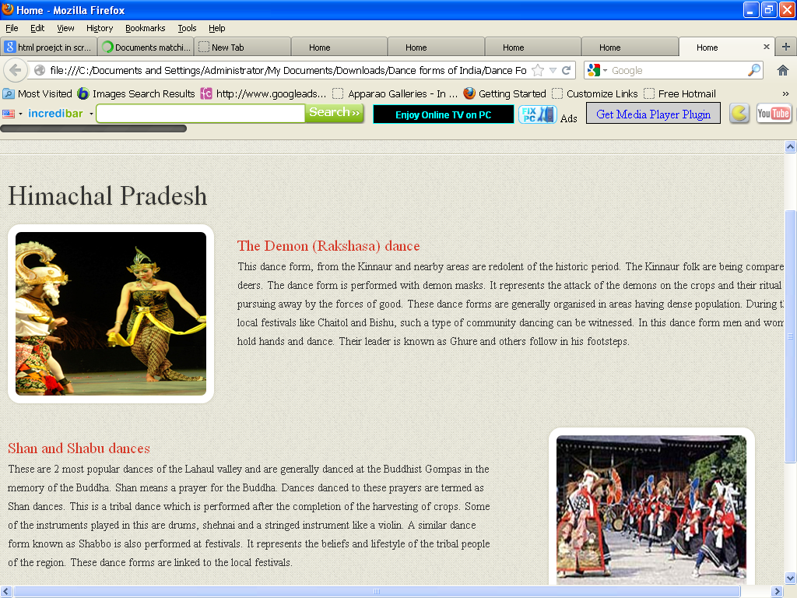

<!DOCTYPE html>

<html lang="en">

<head>

<title>Home</title>

<meta charset="utf-8">

<!--css-->

<link rel="stylesheet" href="css/reset.css" type="text/css" media="screen">

<link rel="stylesheet" href="css/style.css" type="text/css" media="screen">

<link rel="stylesheet" href="css/grid.css" type="text/css" media="screen">

<link rel="icon" href="images/favicon.ico" type="image/x-icon">

<link rel="shortcut icon" href="images/favicon.ico" type="image/x-icon" />

<link rel="stylesheet" href="css/flexslider.css" type="text/css" media="screen">

<!--js-->

<script type="text/javascript" src="js/jquery-1.7.1.min.js" ></script>

<script type="text/javascript" src="js/superfish.js"></script>

<script type="text/javascript" src="js/jquery.flexslider-min.js"></script>

<script>

jQuery(window).load(function () {

jQuery('.flexslider').flexslider({

animation: "fade",

slideshow: true,

slideshowSpeed: 7000,

animationDuration: 600,

prevText: "",

nextText: "",

controlNav: false

})

});

</script>

</head>

<body>

<!--==============================header=================================-->

<header>

<div class="line-top"></div>

<div class="main">

<div class="row-top">

<h1><a href="index.html"><img alt="" src="images/logo.gif"></a></h1>

<nav>

<ul class="sf-menu">

<li><a href="index.html">Home</a></li>

<li class="active"><a href="#">Northern Dances</a>

<ul>

<li><a href="JnK.html">Jammu n Kashmir</a></li>

<li><a href="HP.html">Himachal Pradesh </a>

<li><a href="Uttarakhand.html">Uttarakhand</a></li>

<li><a href="Haryana.html">Haryana</a></li>

<li><a href="Punjab.html">Punjab </a>

<li><a href="Rajasthan.html">Rajasthan</a></li>

<li><a href="UP.html">Uttar Pradesh</a></li>

<li><a href="Bihar.html">Bihar</a></li>

<li><a href="Jharkhand.html">Jharkhand</a></li>

<li><a href="Chhattisgarh.html">Chhattisgarh</a></li>

<li><a href="MP.html">Madhya Pradesh</a></li>

</ul>

</li>

<li><a href="#">Western Dances</a>

<ul>

<li><a href="Maharashtra.html">Maharashtra</a></li>

<li><a href="Gujarat.html">Gujarat </a>

</ul>

</li>

<li><a href="#">Eastern Dances</a>

<ul>

<li><a href="WB.html">West Bengal</a></li>

<li><a href="Orissa.html">Orissa </a>

<li><a href="Jharkhand.html">Jharkhand</a></li>

<li><a href="AP.html">Arunachal Pradesh</a></li>

<li><a href="Assam.html">Assam </a>

<li><a href="Manipur.html">Manipur</a></li>

<li><a href="Meghalaya.html">Meghalaya</a></li>

<li><a href="Mizoram.html">Mizoram</a></li>

<li><a href="Nagaland.html">Nagaland</a></li>

<li><a href="Sikkim.html">Sikkim</a></li>

<li><a href="Tripura.html">Tripura</a></li>

</ul>

</li>

<li><a href="#">Southern Dances </a>

<ul>

<li><a href="AndP.html">Andhra Pradesh</a></li>

<li><a href="Karnataka.html">Karnataka </a>

<li><a href="Kerala.html">Kerala</a></li>

<li><a href="TN.html">Tamil Nadu</a></li>

</ul>

</nav>

<div class="clear"></div>

</div>

</div>

</header>

<!--==============================content=================================-->

<section id="content"><div class="ic"></div>

<div class="border-horiz"></div>

<div class="container_12">

<article class="grid_8">

<h3>Himachal Pradesh</h3>

<ul class="list-recipes">

<li>

<figure class="box-img"><img src="images/hp1.jpg " alt="" /></figure>

<div class="overflow">

<h4>The Demon (Rakshasa) dance</h4>

<p>This dance form, from the Kinnaur and nearby areas are redolent of the historic period. The Kinnaur folk are being compared to deers. The dance form is performed with demon masks. It represents the attack of the demons on the crops and their ritual pursuing away by the forces of good. These dance forms are generally organised in areas having dense population. During their local festivals like Chaitol and Bishu, such a type of community dancing can be witnessed. In this dance form men and women hold hands and dance. Their leader is known as Ghure and others follow in his footsteps.</p>

</div>

<div class="clear"></div>

</li>

<li>

<div class="img-indent2"><figure class="box-img "><img src="images/hp2.jpg " alt="" /></figure></div>

<div class="overflow" style= "width:62%" >

<h4>Shan and Shabu dances</h4>

<p>These are 2 most popular dances of the Lahaul valley and are generally danced at the Buddhist Gompas in the memory of the Buddha. Shan means a prayer for the Buddha. Dances danced to these prayers are termed as Shan dances. This is a tribal dance which is performed after the completion of the harvesting of crops. Some of the instruments played in this are drums, shehnai and a stringed instrument like a violin.

A similar dance form known as Shabbo is also performed at festivals. It represents the beliefs and lifestyle of the tribal people of the region. These dance forms are linked to the local festivals.

</p>

</div>

<div class="clear"></div>

</li>

</ul>

</article>

<div class="clear"></div>

</div>

</section>

<!--==============================footer=================================-->

<footer>

<div class="main">

<center> <p>Some traditions of the Indian classical dance are practiced in the whole Indian subcontinent, including Pakistan and Bangladesh, with which India shares several other cultural traits. Indian mythologies play significant part in dance forms of countries in South East Asia, an example being the performances based on Ramayana in Javanese dances.</p> </center>

</div>

</footer>

</body>

</html>

**Jharkhand.htm**

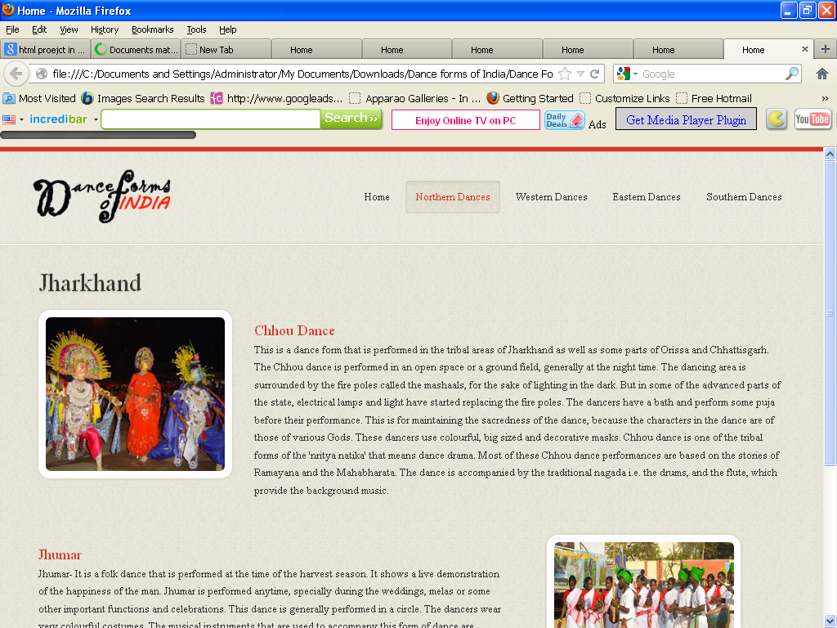

<!DOCTYPE html>

<html lang="en">

<head>

<title>Home</title>

<meta charset="utf-8">

<!--css-->

<link rel="stylesheet" href="css/reset.css" type="text/css" media="screen">

<link rel="stylesheet" href="css/style.css" type="text/css" media="screen">

<link rel="stylesheet" href="css/grid.css" type="text/css" media="screen">

<link rel="icon" href="images/favicon.ico" type="image/x-icon">

<link rel="shortcut icon" href="images/favicon.ico" type="image/x-icon" />

<link rel="stylesheet" href="css/flexslider.css" type="text/css" media="screen">

<!--js-->

<script type="text/javascript" src="js/jquery-1.7.1.min.js" ></script>

<script type="text/javascript" src="js/superfish.js"></script>

<script type="text/javascript" src="js/jquery.flexslider-min.js"></script>

<script>

jQuery(window).load(function () {

jQuery('.flexslider').flexslider({

animation: "fade",

slideshow: true,

slideshowSpeed: 7000,

animationDuration: 600,

prevText: "",

nextText: "",

controlNav: false

})

});

</script>

</head>

<body>

<!--==============================header=================================-->

<header>

<div class="line-top"></div>

<div class="main">

<div class="row-top">

<h1><a href="index.html"><img alt="" src="images/logo.gif"></a></h1>

<nav>

<ul class="sf-menu">

<li><a href="index.html">Home</a></li>

<li class="active"><a href="#">Northern Dances</a>

<ul>

<li><a href="JnK.html">Jammu n Kashmir</a></li>

<li><a href="HP.html">Himachal Pradesh </a>

<li><a href="Uttarakhand.html">Uttarakhand</a></li>

<li><a href="Haryana.html">Haryana</a></li>

<li><a href="Punjab.html">Punjab </a>

<li><a href="Rajasthan.html">Rajasthan</a></li>

<li><a href="UP.html">Uttar Pradesh</a></li>

<li><a href="Bihar.html">Bihar</a></li>

<li><a href="Jharkhand.html">Jharkhand</a></li>

<li><a href="Chhattisgarh.html">Chhattisgarh</a></li>

<li><a href="MP.html">Madhya Pradesh</a></li>

</ul>

</li>

<li><a href="#">Western Dances</a>

<ul>

<li><a href="Maharashtra.html">Maharashtra</a></li>

<li><a href="Gujarat.html">Gujarat </a>

</ul>

</li>

<li><a href="#">Eastern Dances</a>

<ul>

<li><a href="WB.html">West Bengal</a></li>

<li><a href="Orissa.html">Orissa </a>

<li><a href="Jharkhand.html">Jharkhand</a></li>

<li><a href="AP.html">Arunachal Pradesh</a></li>

<li><a href="Assam.html">Assam </a>

<li><a href="Manipur.html">Manipur</a></li>

<li><a href="Meghalaya.html">Meghalaya</a></li>

<li><a href="Mizoram.html">Mizoram</a></li>

<li><a href="Nagaland.html">Nagaland</a></li>

<li><a href="Sikkim.html">Sikkim</a></li>

<li><a href="Tripura.html">Tripura</a></li>

</ul>

</li>

<li><a href="#">Southern Dances </a>

<ul>

<li><a href="AndP.html">Andhra Pradesh</a></li>

<li><a href="Karnataka.html">Karnataka </a>

<li><a href="Kerala.html">Kerala</a></li>

<li><a href="TN.html">Tamil Nadu</a></li>

</ul>

</nav>

<div class="clear"></div>

</div>

</div>

</header>

<!--==============================content=================================-->

<section id="content"><div class="ic"></div>

<div class="border-horiz"></div>

<div class="container_12">

<article class="grid_8">

<h3>Jharkhand</h3>

<ul class="list-recipes">

<li>

<figure class="box-img"><img src="images/jh1.jpg " alt="" /></figure>

<div class="overflow">

<h4>Chhou Dance</h4>

<p>This is a dance form that is performed in the tribal areas of Jharkhand as well as some parts of Orissa and Chhattisgarh. The Chhou dance is performed in an open space or a ground field, generally at the night time. The dancing area is surrounded by the fire poles called the mashaals, for the sake of lighting in the dark. But in some of the advanced parts of the state, electrical lamps and light have started replacing the fire poles. The dancers have a bath and perform some puja before their performance. This is for maintaining the sacredness of the dance, because the characters in the dance are of those of various Gods.

These dancers use colourful, big sized and decorative masks. Chhou dance is one of the tribal forms of the 'nritya natika' that means dance drama. Most of these Chhou dance performances are based on the stories of Ramayana and the Mahabharata. The dance is accompanied by the traditional nagada i.e. the drums, and the flute, which provide the background music.

</p>

</div>

<div class="clear"></div>

</li>

<li>

<div class="img-indent2"><figure class="box-img "><img src="images/jh2.jpg " alt="" /></figure></div>

<div class="overflow" style= "width:62%" >

<h4>Jhumar</h4>

<p>Jhumar- It is a folk dance that is performed at the time of the harvest season. It shows a live demonstration of the happiness of the man.

Jhumar is performed anytime, specially during the weddings, melas or some other important functions and celebrations. This dance is generally performed in a circle. The dancers wear very colourful costumes. The musical instruments that are used to accompany this form of dance are nagara, dholak and shehnai.

</p>

</div>

<div class="clear"></div>

</li>

</ul>

</article>

<div class="clear"></div>

</div>

</section>

<!--==============================footer=================================-->

<footer>

<div class="main">

<center> <p>Some traditions of the Indian classical dance are practiced in the whole Indian subcontinent, including Pakistan and Bangladesh, with which India shares several other cultural traits. Indian mythologies play significant part in dance forms of countries in South East Asia, an example being the performances based on Ramayana in Javanese dances.</p> </center>

</div>

</footer>

</body>

</html>

**Jammu and Kashmir.htm**

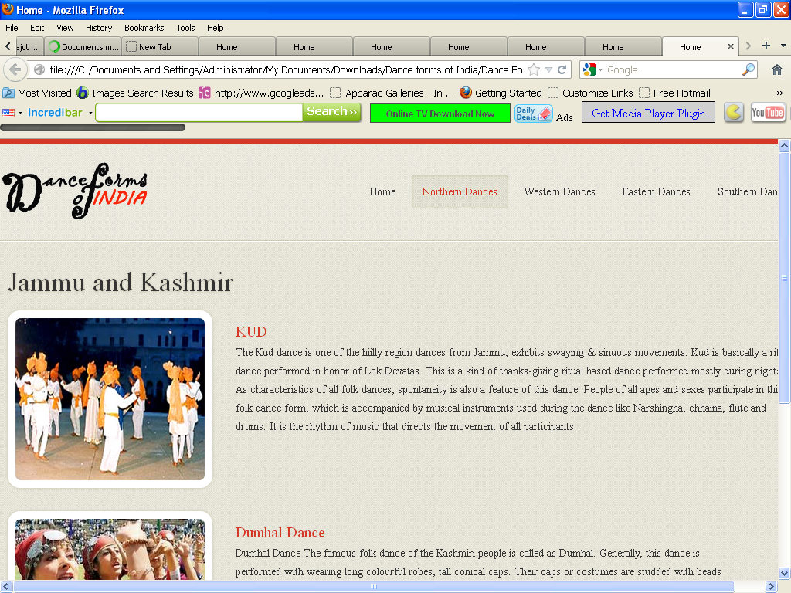

<!DOCTYPE html>

<html lang="en">

<head>

<title>Home</title>

<meta charset="utf-8">

<!--css-->

<link rel="stylesheet" href="css/reset.css" type="text/css" media="screen">

<link rel="stylesheet" href="css/style.css" type="text/css" media="screen">

<link rel="stylesheet" href="css/grid.css" type="text/css" media="screen">

<link rel="icon" href="images/favicon.ico" type="image/x-icon">

<link rel="shortcut icon" href="images/favicon.ico" type="image/x-icon" />

<link rel="stylesheet" href="css/flexslider.css" type="text/css" media="screen">

<!--js-->

<script type="text/javascript" src="js/jquery-1.7.1.min.js" ></script>

<script type="text/javascript" src="js/superfish.js"></script>

<script type="text/javascript" src="js/jquery.flexslider-min.js"></script>

<script>

jQuery(window).load(function () {

jQuery('.flexslider').flexslider({

animation: "fade",

slideshow: true,

slideshowSpeed: 7000,

animationDuration: 600,

prevText: "",

nextText: "",

controlNav: false

})

});

</script>

</head>

<body>

<!--==============================header=================================-->

<header>

<div class="line-top"></div>

<div class="main">

<div class="row-top">

<h1><a href="index.html"><img alt="" src="images/logo.gif"></a></h1>

<nav>

<ul class="sf-menu">

<li ><a href="index.html">Home</a></li>

<li class="active"><a href="#">Northern Dances</a>

<ul>

<li><a href="JnK.html">Jammu n Kashmir</a></li>

<li><a href="HP.html">Himachal Pradesh </a>

<li><a href="Uttarakhand.html">Uttarakhand</a></li>

<li><a href="Haryana.html">Haryana</a></li>

<li><a href="Punjab.html">Punjab </a>

<li><a href="Rajasthan.html">Rajasthan</a></li>

<li><a href="UP.html">Uttar Pradesh</a></li>

<li><a href="Bihar.html">Bihar</a></li>

<li><a href="Jharkhand.html">Jharkhand</a></li>

<li><a href="Chhattisgarh.html">Chhattisgarh</a></li>

<li><a href="MP.html">Madhya Pradesh</a></li>

</ul>

</li>

<li><a href="#">Western Dances</a>

<ul>

<li><a href="Maharashtra.html">Maharashtra</a></li>

<li><a href="Gujarat.html">Gujarat </a>

</ul>

</li>

<li><a href="#">Eastern Dances</a>

<ul>

<li><a href="WB.html">West Bengal</a></li>

<li><a href="Orissa.html">Orissa </a>

<li><a href="Jharkhand.html">Jharkhand</a></li>

<li><a href="AP.html">Arunachal Pradesh</a></li>

<li><a href="Assam.html">Assam </a>

<li><a href="Manipur.html">Manipur</a></li>

<li><a href="Meghalaya.html">Meghalaya</a></li>

<li><a href="Mizoram.html">Mizoram</a></li>

<li><a href="Nagaland.html">Nagaland</a></li>

<li><a href="Sikkim.html">Sikkim</a></li>

<li><a href="Tripura.html">Tripura</a></li>

</ul>

</li>

<li><a href="#">Southern Dances </a>

<ul>

<li><a href="AndP.html">Andhra Pradesh</a></li>

<li><a href="Karnataka.html">Karnataka </a>

<li><a href="Kerala.html">Kerala</a></li>

<li><a href="TN.html">Tamil Nadu</a></li>

</ul>

</nav>

<div class="clear"></div>

</div>

</div>

</header>

<!--==============================content=================================-->

<section id="content"><div class="ic"></div>

<div class="border-horiz"></div>

<div class="container_12">

<article class="grid_8">

<h3>Jammu and Kashmir</h3>

<ul class="list-recipes">

<li>

<figure class="box-img"><img src="images/JK1.jpg " alt="" /></figure>

<div class="overflow">

<h4>KUD</h4>

<p>

The Kud dance is one of the hiilly region dances from Jammu, exhibits swaying & sinuous movements. Kud is basically a ritual dance performed in honor of Lok Devatas. This is a kind of thanks-giving ritual based dance performed mostly during nights. As characteristics of all folk dances, spontaneity is also a feature of this dance. People of all ages and sexes participate in this folk dance form, which is accompanied by musical instruments used during the dance like Narshingha, chhaina, flute and drums. It is the rhythm of music that directs the movement of all participants.

</p>

</div>

<div class="clear"></div>

</li>

<li>

<figure class="box-img "><img src="images/JK2.jpg " alt="" /></figure>

<div class="overflow" style= "width:62%" >

<h4>Dumhal Dance</h4>

<p>

Dumhal Dance The famous folk dance of the Kashmiri people is called as Dumhal. Generally, this dance is performed with wearing long colourful robes, tall conical caps. Their caps or costumes are studded with beads and shells. Only the men folk of the Wattal are privileged to perform this dance on specific occasions.

With dancing, the performers sing beautiful songs in chorus. Drums are used to assist the music in the dance. The vocal singing of the participants is tuned with music. The group of performers moves in a ritual manner and dig a banner into the ground on set occasions. Usually, the dance begins with men dancing around this banner. Dumhal is performed on set occasions and at set locations. </p>

</div>

<div class="clear"></div>

</li>

</ul>

</article>

<div class="clear"></div>

</div>

</section>

<!--==============================footer=================================-->

<footer>

<div class="main">

<center> <p>Some traditions of the Indian classical dance are practiced in the whole Indian subcontinent, including Pakistan and Bangladesh, with which India shares several other cultural traits. Indian mythologies play significant part in dance forms of countries in South East Asia, an example being the performances based on Ramayana in Javanese dances.</p> </center>

</div>

</footer>

</body>

</html>

**Karnataka.htm**

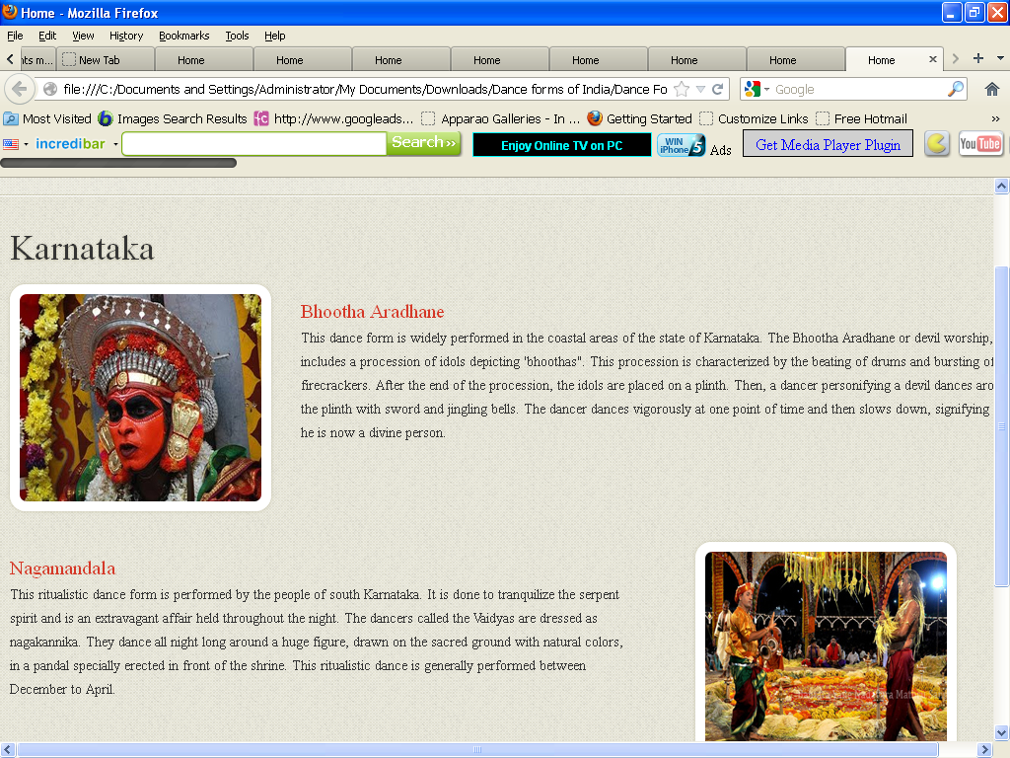

<!DOCTYPE html>

<html lang="en">

<head>

<title>Home</title>

<meta charset="utf-8">

<!--css-->

<link rel="stylesheet" href="css/reset.css" type="text/css" media="screen">

<link rel="stylesheet" href="css/style.css" type="text/css" media="screen">

<link rel="stylesheet" href="css/grid.css" type="text/css" media="screen">

<link rel="icon" href="images/favicon.ico" type="image/x-icon">

<link rel="shortcut icon" href="images/favicon.ico" type="image/x-icon" />

<link rel="stylesheet" href="css/flexslider.css" type="text/css" media="screen">

<!--js-->

<script type="text/javascript" src="js/jquery-1.7.1.min.js" ></script>

<script type="text/javascript" src="js/superfish.js"></script>

<script type="text/javascript" src="js/jquery.flexslider-min.js"></script>

<script>

jQuery(window).load(function () {

jQuery('.flexslider').flexslider({

animation: "fade",

slideshow: true,

slideshowSpeed: 7000,

animationDuration: 600,

prevText: "",

nextText: "",

controlNav: false

})

});

</script>

</head>

<body>

<!--==============================header=================================-->

<header>

<div class="line-top"></div>

<div class="main">

<div class="row-top">

<h1><a href="index.html"><img alt="" src="images/logo.gif"></a></h1>

<nav>

<ul class="sf-menu">

<li><a href="index.html">Home</a></li>

<li><a href="#">Northern Dances</a>

<ul>

<li><a href="JnK.html">Jammu n Kashmir</a></li>

<li><a href="HP.html">Himachal Pradesh </a>

<li><a href="Uttarakhand.html">Uttarakhand</a></li>

<li><a href="Haryana.html">Haryana</a></li>

<li><a href="Punjab.html">Punjab </a>

<li><a href="Rajasthan.html">Rajasthan</a></li>

<li><a href="UP.html">Uttar Pradesh</a></li>

<li><a href="Bihar.html">Bihar</a></li>

<li><a href="Jharkhand.html">Jharkhand</a></li>

<li><a href="Chhattisgarh.html">Chhattisgarh</a></li>

<li><a href="MP.html">Madhya Pradesh</a></li>

</ul>

</li>

<li><a href="#">Western Dances</a>

<ul>

<li><a href="Maharashtra.html">Maharashtra</a></li>

<li><a href="Gujarat.html">Gujarat </a>

</ul>

</li>

<li><a href="#" >Eastern Dances</a>

<ul>

<li><a href="WB.html">West Bengal</a></li>

<li><a href="Orissa.html">Orissa </a>

<li><a href="Jharkhand.html">Jharkhand</a></li>

<li><a href="AP.html">Arunachal Pradesh</a></li>

<li><a href="Assam.html">Assam </a>

<li><a href="Manipur.html">Manipur</a></li>

<li><a href="Meghalaya.html">Meghalaya</a></li>

<li><a href="Mizoram.html">Mizoram</a></li>

<li><a href="Nagaland.html">Nagaland</a></li>

<li><a href="Sikkim.html">Sikkim</a></li>

<li><a href="Tripura.html">Tripura</a></li>

</ul>

</li>

<li class="active"><a href="#">Southern Dances </a>

<ul>

<li><a href="AndP.html">Andhra Pradesh</a></li>

<li><a href="Karnataka.html">Karnataka </a>

<li><a href="Kerala.html">Kerala</a></li>

<li><a href="TN.html">Tamil Nadu</a></li>

</ul>

</nav>

<div class="clear"></div>

</div>

</div>

</header>

<!--==============================content=================================-->

<section id="content"><div class="ic"></div>

<div class="border-horiz"></div>

<div class="container_12">

<article class="grid_8">

<h3>Karnataka</h3>

<ul class="list-recipes">

<li>

<figure class="box-img"><img src="images/kr1.jpg " alt="" /></figure>

<div class="overflow">

<h4>Bhootha Aradhane</h4>

<p>This dance form is widely performed in the coastal areas of the state of Karnataka. The Bhootha Aradhane or devil worship, includes a procession of idols depicting 'bhoothas". This procession is characterized by the beating of drums and bursting of firecrackers. After the end of the procession, the idols are placed on a plinth. Then, a dancer personifying a devil dances around the plinth with sword and jingling bells. The dancer dances vigorously at one point of time and then slows down, signifying that he is now a divine person. </p>

</div>

<div class="clear"></div>

</li>

<li>

<div class="img-indent2"><figure class="box-img "><img src="images/kr2.jpg " alt="" /></figure></div>

<div class="overflow" style= "width:62%" >

<h4>Nagamandala</h4>

<p>This ritualistic dance form is performed by the people of south Karnataka. It is done to tranquilize the serpent spirit and is an extravagant affair held throughout the night. The dancers called the Vaidyas are dressed as nagakannika. They dance all night long around a huge figure, drawn on the sacred ground with natural colors, in a pandal specially erected in front of the shrine. This ritualistic dance is generally performed between December to April.</p>

</div>

<div class="clear"></div>

</li>

</ul>

</article>

<div class="clear"></div>

</div>

</section>

<!--==============================footer=================================-->

<footer>

<div class="main">

<center> <p>Some traditions of the Indian classical dance are practiced in the whole Indian subcontinent, including Pakistan and Bangladesh, with which India shares several other cultural traits. Indian mythologies play significant part in dance forms of countries in South East Asia, an example being the performances based on Ramayana in Javanese dances.</p> </center>

</div>

</footer>

</body>

</html>

**Kerala.htm**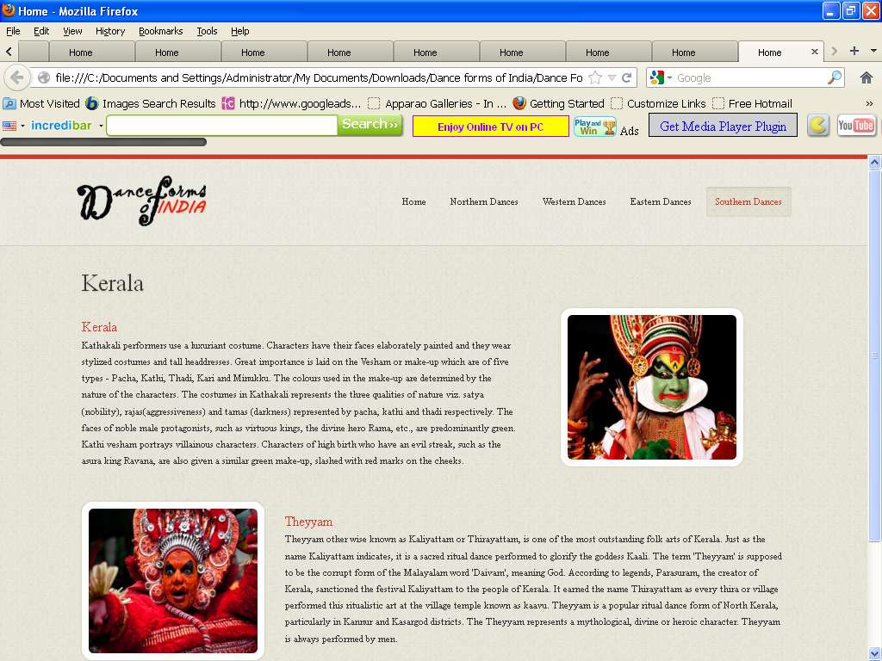

<!DOCTYPE html>

<html lang="en">

<head>

<title>Home</title>

<meta charset="utf-8">

<!--css-->

<link rel="stylesheet" href="css/reset.css" type="text/css" media="screen">

<link rel="stylesheet" href="css/style.css" type="text/css" media="screen">

<link rel="stylesheet" href="css/grid.css" type="text/css" media="screen">

<link rel="icon" href="images/favicon.ico" type="image/x-icon">

<link rel="shortcut icon" href="images/favicon.ico" type="image/x-icon" />

<link rel="stylesheet" href="css/flexslider.css" type="text/css" media="screen">

<!--js-->

<script type="text/javascript" src="js/jquery-1.7.1.min.js" ></script>

<script type="text/javascript" src="js/superfish.js"></script>

<script type="text/javascript" src="js/jquery.flexslider-min.js"></script>

<script>

jQuery(window).load(function () {

jQuery('.flexslider').flexslider({

animation: "fade",

slideshow: true,

slideshowSpeed: 7000,

animationDuration: 600,

prevText: "",

nextText: "",

controlNav: false

})

});

</script>

</head>

<body>

<!--==============================header=================================-->

<header>

<div class="line-top"></div>

<div class="main">

<div class="row-top">

<h1><a href="index.html"><img alt="" src="images/logo.gif"></a></h1>

<nav>

<ul class="sf-menu">

<li><a href="index.html">Home</a></li>

<li><a href="#">Northern Dances</a>

<ul>

<li><a href="JnK.html">Jammu n Kashmir</a></li>

<li><a href="HP.html">Himachal Pradesh </a>

<li><a href="Uttarakhand.html">Uttarakhand</a></li>

<li><a href="Haryana.html">Haryana</a></li>

<li><a href="Punjab.html">Punjab </a>

<li><a href="Rajasthan.html">Rajasthan</a></li>

<li><a href="UP.html">Uttar Pradesh</a></li>

<li><a href="Bihar.html">Bihar</a></li>

<li><a href="Jharkhand.html">Jharkhand</a></li>

<li><a href="Chhattisgarh.html">Chhattisgarh</a></li>

<li><a href="MP.html">Madhya Pradesh</a></li>

</ul>

</li>

<li><a href="#">Western Dances</a>

<ul>

<li><a href="Maharashtra.html">Maharashtra</a></li>

<li><a href="Gujarat.html">Gujarat </a>

</ul>

</li>

<li><a href="#">Eastern Dances</a>

<ul>

<li><a href="WB.html">West Bengal</a></li>

<li><a href="Orissa.html">Orissa </a>

<li><a href="Jharkhand.html">Jharkhand</a></li>

<li><a href="AP.html">Arunachal Pradesh</a></li>

<li><a href="Assam.html">Assam </a>

<li><a href="Manipur.html">Manipur</a></li>

<li><a href="Meghalaya.html">Meghalaya</a></li>

<li><a href="Mizoram.html">Mizoram</a></li>

<li><a href="Nagaland.html">Nagaland</a></li>

<li><a href="Sikkim.html">Sikkim</a></li>

<li><a href="Tripura.html">Tripura</a></li>

</ul>

</li>

<li class="active"><a href="#">Southern Dances </a>

<ul>

<li><a href="AndP.html">Andhra Pradesh</a></li>

<li><a href="Karnataka.html">Karnataka </a>

<li><a href="Kerala.html">Kerala</a></li>

<li><a href="TN.html">Tamil Nadu</a></li>

</ul>

</nav>

<div class="clear"></div>

</div>

</div>

</header>

<!--==============================content=================================-->

<section id="content"><div class="ic"></div>

<div class="border-horiz"></div>

<div class="container_12">

<article class="grid_8">

<h3>Kerala</h3>

<ul class="list-recipes">

<li>

<div class="img-indent2"><figure class="box-img "><img src="images/ke1.jpg " alt="" /></figure></div>

<div class="overflow" style= "width:62%" >

<h4>Kerala</h4>

<p>

Kathakali performers use a luxuriant costume. Characters have their faces elaborately painted and they wear stylized costumes and tall headdresses. Great importance is laid on the Vesham or make-up which are of five types - Pacha, Kathi, Thadi, Kari and Minukku. The colours used in the make-up are determined by the nature of the characters. The costumes in Kathakali represents the three qualities of nature viz. satya (nobility), rajas(aggressiveness) and tamas (darkness) represented by pacha, kathi and thadi respectively.

The faces of noble male protagonists, such as virtuous kings, the divine hero Rama, etc., are predominantly green.

Kathi vesham portrays villainous characters. Characters of high birth who have an evil streak, such as the asura king Ravana, are also given a similar green make-up, slashed with red marks on the cheeks.

</p>

</div>

<div class="clear"></div>

</li>

<li>

<figure class="box-img"><img src="images/ke2.jpg " alt="" /></figure>

<div class="overflow">

<h4>Theyyam </h4>

<p>Theyyam other wise known as Kaliyattam or Thirayattam, is one of the most outstanding folk arts of Kerala. Just as the name Kaliyattam indicates, it is a sacred ritual dance performed to glorify the goddess Kaali. The term 'Theyyam' is supposed to be the corrupt form of the Malayalam word 'Daivam', meaning God. According to legends, Parasuram, the creator of Kerala, sanctioned the festival Kaliyattam to the people of Kerala. It earned the name Thirayattam as every thira or village performed this ritualistic art at the village temple known as kaavu.

Theyyam is a popular ritual dance form of North Kerala, particularly in Kannur and Kasargod districts. The Theyyam represents a mythological, divine or heroic character. Theyyam is always performed by men.

</p>

</div>

<div class="clear"></div>

</li>

</ul>

</article>

<div class="clear"></div>

</div>

</section>

<!--==============================footer=================================-->

<footer>

<div class="main">

<center> <p>Some traditions of the Indian classical dance are practiced in the whole Indian subcontinent, including Pakistan and Bangladesh, with which India shares several other cultural traits. Indian mythologies play significant part in dance forms of countries in South East Asia, an example being the performances based on Ramayana in Javanese dances.</p> </center>

</div>

</footer>

</body>

</html>

**Maharashtra.htm**

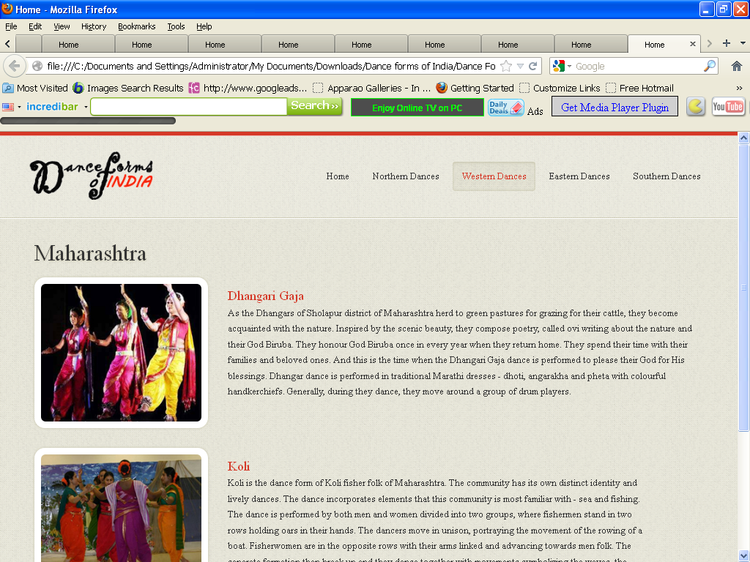

<!DOCTYPE html>

<html lang="en">

<head>

<title>Home</title>

<meta charset="utf-8">

<!--css-->

<link rel="stylesheet" href="css/reset.css" type="text/css" media="screen">

<link rel="stylesheet" href="css/style.css" type="text/css" media="screen">

<link rel="stylesheet" href="css/grid.css" type="text/css" media="screen">

<link rel="icon" href="images/favicon.ico" type="image/x-icon">

<link rel="shortcut icon" href="images/favicon.ico" type="image/x-icon" />

<link rel="stylesheet" href="css/flexslider.css" type="text/css" media="screen">

<!--js-->

<script type="text/javascript" src="js/jquery-1.7.1.min.js" ></script>

<script type="text/javascript" src="js/superfish.js"></script>

<script type="text/javascript" src="js/jquery.flexslider-min.js"></script>

<script>

jQuery(window).load(function () {

jQuery('.flexslider').flexslider({

animation: "fade",

slideshow: true,

slideshowSpeed: 7000,

animationDuration: 600,

prevText: "",

nextText: "",

controlNav: false

})

});

</script>

</head>

<body>

<!--==============================header=================================-->

<header>

<div class="line-top"></div>

<div class="main">

<div class="row-top">

<h1><a href="index.html"><img alt="" src="images/logo.gif"></a></h1>

<nav>

<ul class="sf-menu">

<li><a href="index.html">Home</a></li>

<li><a href="#">Northern Dances</a>

<ul>

<li><a href="JnK.html">Jammu n Kashmir</a></li>

<li><a href="HP.html">Himachal Pradesh </a>

<li><a href="Uttarakhand.html">Uttarakhand</a></li>

<li><a href="Haryana.html">Haryana</a></li>

<li><a href="Punjab.html">Punjab </a>

<li><a href="Rajasthan.html">Rajasthan</a></li>

<li><a href="UP.html">Uttar Pradesh</a></li>

<li><a href="Bihar.html">Bihar</a></li>

<li><a href="Jharkhand.html">Jharkhand</a></li>

<li><a href="Chhattisgarh.html">Chhattisgarh</a></li>

<li><a href="MP.html">Madhya Pradesh</a></li>

</ul>

</li>

<li class= "active" ><a href="#">Western Dances</a>

<ul>

<li><a href="Maharashtra.html">Maharashtra</a></li>

<li><a href="Gujarat.html">Gujarat </a>

</ul>

</li>

<li><a href="#">Eastern Dances</a>

<ul>

<li><a href="WB.html">West Bengal</a></li>

<li><a href="Orissa.html">Orissa </a>

<li><a href="Jharkhand.html">Jharkhand</a></li>

<li><a href="AP.html">Arunachal Pradesh</a></li>

<li><a href="Assam.html">Assam </a>

<li><a href="Manipur.html">Manipur</a></li>

<li><a href="Meghalaya.html">Meghalaya</a></li>

<li><a href="Mizoram.html">Mizoram</a></li>

<li><a href="Nagaland.html">Nagaland</a></li>

<li><a href="Sikkim.html">Sikkim</a></li>

<li><a href="Tripura.html">Tripura</a></li>

</ul>

</li>

<li><a href="#">Southern Dances </a>

<ul>

<li><a href="AndP.html">Andhra Pradesh</a></li>

<li><a href="Karnataka.html">Karnataka </a>

<li><a href="Kerala.html">Kerala</a></li>

<li><a href="TN.html">Tamil Nadu</a></li>

</ul>

</nav>

<div class="clear"></div>

</div>

</div>

</header>

<!--==============================content=================================-->

<section id="content"><div class="ic"></div>

<div class="border-horiz"></div>

<div class="container_12">

<article class="grid_8">

<h3>Maharashtra </h3>

<ul class="list-recipes">

<li>

<figure class="box-img"><img src="images/mh1.jpg " alt="" /></figure>

<div class="overflow">

<h4>Dhangari Gaja</h4>

<p>As the Dhangars of Sholapur district of Maharashtra herd to green pastures for grazing for their cattle, they become acquainted with the nature. Inspired by the scenic beauty, they compose poetry, called ovi writing about the nature and their God Biruba.

They honour God Biruba once in every year when they return home. They spend their time with their families and beloved ones. And this is the time when the Dhangari Gaja dance is performed to please their God for His blessings.

Dhangar dance is performed in traditional Marathi dresses - dhoti, angarakha and pheta with colourful handkerchiefs. Generally, during they dance, they move around a group of drum players.

</p>

</div>

<div class="clear"></div>

</li>

<li>

<figure class="box-img "><img src="images/MH2.jpg " alt="" /></figure>

<div class="overflow" style= "width:62%" >

<h4>Koli</h4>

<p>Koli is the dance form of Koli fisher folk of Maharashtra. The community has its own distinct identity and lively dances. The dance incorporates elements that this community is most familiar with - sea and fishing. The dance is performed by both men and women divided into two groups, where fishermen stand in two rows holding oars in their hands. The dancers move in unison, portraying the movement of the rowing of a boat. Fisherwomen are in the opposite rows with their arms linked and advancing towards men folk. The separate formation then break up and they dance together with movements symbolizing the waves, the breakers and rowing from cliff to cliff and casting of nets to catch the fish. </p>

</div>

<div class="clear"></div>

</li>

</ul>

</article>

<div class="clear"></div>

</div>

</section>

<!--==============================footer=================================-->

<footer>

<div class="main">

<center> <p>Some traditions of the Indian classical dance are practiced in the whole Indian subcontinent, including Pakistan and Bangladesh, with which India shares several other cultural traits. Indian mythologies play significant part in dance forms of countries in South East Asia, an example being the performances based on Ramayana in Javanese dances.</p> </center>

</div>

</footer>

</body>

</html>

**Manipur.htm**

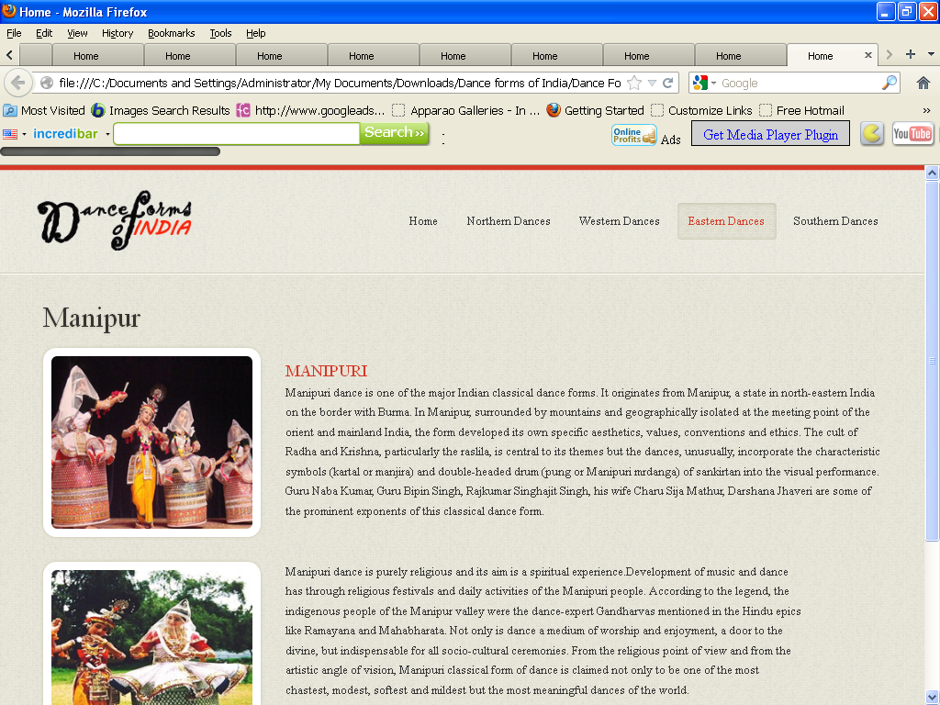

<!DOCTYPE html>

<html lang="en">

<head>

<title>Home</title>

<meta charset="utf-8">

<!--css-->

<link rel="stylesheet" href="css/reset.css" type="text/css" media="screen">

<link rel="stylesheet" href="css/style.css" type="text/css" media="screen">

<link rel="stylesheet" href="css/grid.css" type="text/css" media="screen">

<link rel="icon" href="images/favicon.ico" type="image/x-icon">

<link rel="shortcut icon" href="images/favicon.ico" type="image/x-icon" />

<link rel="stylesheet" href="css/flexslider.css" type="text/css" media="screen">

<!--js-->

<script type="text/javascript" src="js/jquery-1.7.1.min.js" ></script>

<script type="text/javascript" src="js/superfish.js"></script>

<script type="text/javascript" src="js/jquery.flexslider-min.js"></script>

<script>

jQuery(window).load(function () {

jQuery('.flexslider').flexslider({

animation: "fade",

slideshow: true,

slideshowSpeed: 7000,

animationDuration: 600,

prevText: "",

nextText: "",

controlNav: false

})

});

</script>

</head>

<body>

<!--==============================header=================================-->

<header>

<div class="line-top"></div>

<div class="main">

<div class="row-top">

<h1><a href="index.html"><img alt="" src="images/logo.gif"></a></h1>

<nav>

<ul class="sf-menu">

<li ><a href="index.html">Home</a></li>

<li><a href="#">Northern Dances</a>

<ul>

<li><a href="JnK.html">Jammu n Kashmir</a></li>

<li><a href="HP.html">Himachal Pradesh </a>

<li><a href="Uttarakhand.html">Uttarakhand</a></li>

<li><a href="Haryana.html">Haryana</a></li>

<li><a href="Punjab.html">Punjab </a>

<li><a href="Rajasthan.html">Rajasthan</a></li>

<li><a href="UP.html">Uttar Pradesh</a></li>

<li><a href="Bihar.html">Bihar</a></li>

<li><a href="Jharkhand.html">Jharkhand</a></li>

<li><a href="Chhattisgarh.html">Chhattisgarh</a></li>

<li><a href="MP.html">Madhya Pradesh</a></li>

</ul>

</li>

<li><a href="#">Western Dances</a>

<ul>

<li><a href="Maharashtra.html">Maharashtra</a></li>

<li><a href="Gujarat.html">Gujarat </a>

</ul>

</li>

<li class="active"><a href="#" >Eastern Dances</a>

<ul>

<li><a href="WB.html">West Bengal</a></li>

<li><a href="Orissa.html">Orissa </a>

<li><a href="Jharkhand.html">Jharkhand</a></li>

<li><a href="AP.html">Arunachal Pradesh</a></li>

<li><a href="Assam.html">Assam </a>

<li><a href="Manipur.html">Manipur</a></li>

<li><a href="Meghalaya.html">Meghalaya</a></li>

<li><a href="Mizoram.html">Mizoram</a></li>

<li><a href="Nagaland.html">Nagaland</a></li>

<li><a href="Sikkim.html">Sikkim</a></li>

<li><a href="Tripura.html">Tripura</a></li>

</ul>

</li>

<li><a href="#">Southern Dances </a>

<ul>

<li><a href="AndP.html">Andhra Pradesh</a></li>

<li><a href="Karnataka.html">Karnataka </a>

<li><a href="Kerala.html">Kerala</a></li>

<li><a href="TN.html">Tamil Nadu</a></li>

<li><a href="Assam.html">Assam </a>

</ul>

</nav>

<div class="clear"></div>

</div>

</div>

</header>

<!--==============================content=================================-->

<section id="content"><div class="ic"></div>

<div class="border-horiz"></div>

<div class="container_12">

<article class="grid_8">

<h3>Manipur</h3>

<ul class="list-recipes">

<li>

<figure class="box-img"><img src="images/mn1.jpg " alt="" /></figure>

<div class="overflow">

<h4>MANIPURI</h4>

<p>Manipuri dance is one of the major Indian classical dance forms. It originates from Manipur, a state in north-eastern India on the border with Burma. In Manipur, surrounded by mountains and geographically isolated at the meeting point of the orient and mainland India, the form developed its own specific aesthetics, values, conventions and ethics. The cult of Radha and Krishna, particularly the raslila, is central to its themes but the dances, unusually, incorporate the characteristic symbols (kartal or manjira) and double-headed drum (pung or Manipuri mrdanga) of sankirtan into the visual performance. Guru Naba Kumar, Guru Bipin Singh, Rajkumar Singhajit Singh, his wife Charu Sija Mathur, Darshana Jhaveri are some of the prominent exponents of this classical dance form.

</p>

</div>

<div class="clear"></div>

</li>

<li>

<figure class="box-img "><img src="images/mn2.jpg " alt="" /></figure>

<div class="overflow" style= "width:62%" >

<p>

Manipuri dance is purely religious and its aim is a spiritual experience.Development of music and dance has through religious festivals and daily activities of the Manipuri people. According to the legend, the indigenous people of the Manipur valley were the dance-expert Gandharvas mentioned in the Hindu epics like Ramayana and Mahabharata. Not only is dance a medium of worship and enjoyment, a door to the divine, but indispensable for all socio-cultural ceremonies. From the religious point of view and from the artistic angle of vision, Manipuri classical form of dance is claimed not only to be one of the most chastest, modest, softest and mildest but the most meaningful dances of the world.</p>

</div>

<div class="clear"></div>

</li>

</ul>

</article>

<div class="clear"></div>

</div>

</section>

<!--==============================footer=================================-->

<footer>

<div class="main">

<center> <p>Some traditions of the Indian classical dance are practiced in the whole Indian subcontinent, including Pakistan and Bangladesh, with which India shares several other cultural traits. Indian mythologies play significant part in dance forms of countries in South East Asia, an example being the performances based on Ramayana in Javanese dances.</p> </center>

</div>

</footer>

</body>

</html>

**Meghalaya.htm**

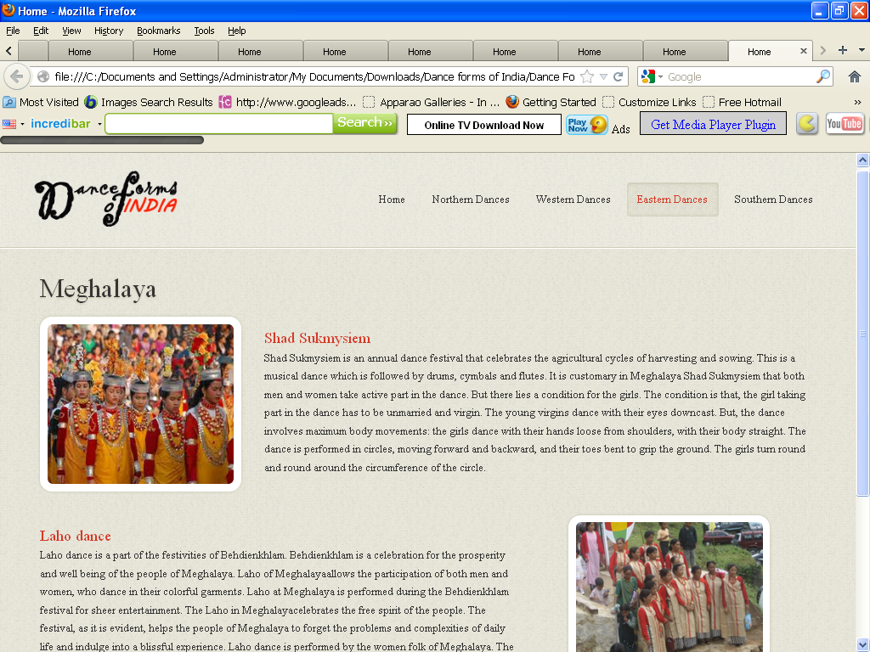

<!DOCTYPE html>

<html lang="en">

<head>

<title>Home</title>

<meta charset="utf-8">

<!--css-->

<link rel="stylesheet" href="css/reset.css" type="text/css" media="screen">

<link rel="stylesheet" href="css/style.css" type="text/css" media="screen">

<link rel="stylesheet" href="css/grid.css" type="text/css" media="screen">

<link rel="icon" href="images/favicon.ico" type="image/x-icon">

<link rel="shortcut icon" href="images/favicon.ico" type="image/x-icon" />

<link rel="stylesheet" href="css/flexslider.css" type="text/css" media="screen">

<!--js-->

<script type="text/javascript" src="js/jquery-1.7.1.min.js" ></script>

<script type="text/javascript" src="js/superfish.js"></script>

<script type="text/javascript" src="js/jquery.flexslider-min.js"></script>

<script>

jQuery(window).load(function () {

jQuery('.flexslider').flexslider({

animation: "fade",

slideshow: true,

slideshowSpeed: 7000,

animationDuration: 600,

prevText: "",

nextText: "",

controlNav: false

})

});

</script>

</head>

<body>

<!--==============================header=================================-->

<header>

<div class="line-top"></div>

<div class="main">

<div class="row-top">

<h1><a href="index.html"><img alt="" src="images/logo.gif"></a></h1>

<nav>

<ul class="sf-menu">

<li><a href="index.html">Home</a></li>

<li><a href="#">Northern Dances</a>

<ul>

<li><a href="JnK.html">Jammu n Kashmir</a></li>

<li><a href="HP.html">Himachal Pradesh </a>

<li><a href="Uttarakhand.html">Uttarakhand</a></li>

<li><a href="Haryana.html">Haryana</a></li>

<li><a href="Punjab.html">Punjab </a>

<li><a href="Rajasthan.html">Rajasthan</a></li>

<li><a href="UP.html">Uttar Pradesh</a></li>

<li><a href="Bihar.html">Bihar</a></li>

<li><a href="Jharkhand.html">Jharkhand</a></li>

<li><a href="Chhattisgarh.html">Chhattisgarh</a></li>

<li><a href="MP.html">Madhya Pradesh</a></li>

</ul>

</li>

<li><a href="#">Western Dances</a>

<ul>

<li><a href="Maharashtra.html">Maharashtra</a></li>

<li><a href="Gujarat.html">Gujarat </a>

</ul>

</li>

<li class="active"><a href="#" >Eastern Dances</a>

<ul>

<li><a href="WB.html">West Bengal</a></li>

<li><a href="Orissa.html">Orissa </a>

<li><a href="Jharkhand.html">Jharkhand</a></li>

<li><a href="AP.html">Arunachal Pradesh</a></li>

<li><a href="Assam.html">Assam </a>

<li><a href="Manipur.html">Manipur</a></li>

<li><a href="Meghalaya.html">Meghalaya</a></li>

<li><a href="Mizoram.html">Mizoram</a></li>

<li><a href="Nagaland.html">Nagaland</a></li>

<li><a href="Sikkim.html">Sikkim</a></li>

<li><a href="Tripura.html">Tripura</a></li>

</ul>

</li>

<li><a href="#">Southern Dances </a>

<ul>

<li><a href="AndP.html">Andhra Pradesh</a></li>

<li><a href="Karnataka.html">Karnataka </a>

<li><a href="Kerala.html">Kerala</a></li>

<li><a href="TN.html">Tamil Nadu</a></li>

<li><a href="Assam.html">Assam </a>

</ul>

</nav>

<div class="clear"></div>

</div>

</div>

</header>

<!--==============================content=================================-->

<section id="content"><div class="ic"></div>

<div class="border-horiz"></div>

<div class="container_12">

<article class="grid_8">

<h3>Meghalaya</h3>

<ul class="list-recipes">

<li>

<figure class="box-img"><img src="images/mg1.jpg " alt="" /></figure>

<div class="overflow">

<h4>Shad Sukmysiem</h4>

<p>Shad Sukmysiem is an annual dance festival that celebrates the agricultural cycles of harvesting and sowing. This is a musical dance which is followed by drums, cymbals and flutes.

It is customary in Meghalaya Shad Sukmysiem that both men and women take active part in the dance. But there lies a condition for the girls. The condition is that, the girl taking part in the dance has to be unmarried and virgin. The young virgins dance with their eyes downcast. But, the dance involves maximum body movements: the girls dance with their hands loose from shoulders, with their body straight. The dance is performed in circles, moving forward and backward, and their toes bent to grip the ground. The girls turn round and round around the circumference of the circle.

</p>

</div>

<div class="clear"></div>

</li>

<li>

<div class="img-indent2"><figure class="box-img "><img src="images/mg2.jpg " alt="" /></figure></div>

<div class="overflow" style= "width:62%" >

<h4>Laho dance</h4>

<p>Laho dance is a part of the festivities of Behdienkhlam. Behdienkhlam is a celebration for the prosperity and well being of the people of Meghalaya. Laho of Meghalayaallows the participation of both men and women, who dance in their colorful garments.

Laho at Meghalaya is performed during the Behdienkhlam festival for sheer entertainment. The Laho in Meghalayacelebrates the free spirit of the people. The festival, as it is evident, helps the people of Meghalaya to forget the problems and complexities of daily life and indulge into a blissful experience.

Laho dance is performed by the women folk of Meghalaya. The female dancers dance with young men on both sides; the dancers link their arms and sway their bodies back and forth.

</p>

</div>

<div class="clear"></div>

</li>

</ul>

</article>

<div class="clear"></div>

</div>

</section>

<!--==============================footer=================================-->

<footer>

<div class="main">

<center> <p>Some traditions of the Indian classical dance are practiced in the whole Indian subcontinent, including Pakistan and Bangladesh, with which India shares several other cultural traits. Indian mythologies play significant part in dance forms of countries in South East Asia, an example being the performances based on Ramayana in Javanese dances.</p> </center>

</div>

</footer>

</body>

</html>

**Mizoram.htm**

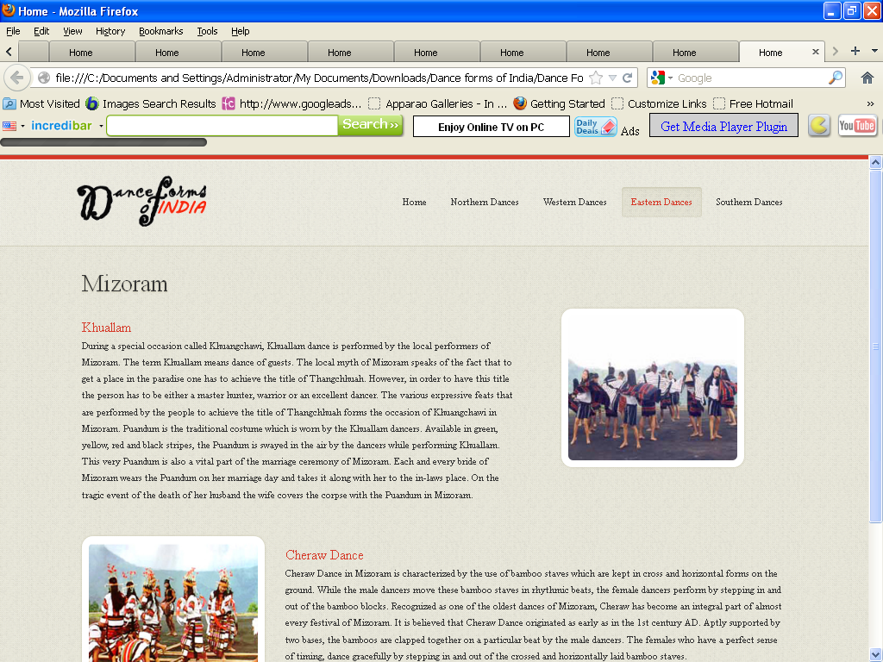

**<**!DOCTYPE html>

<html lang="en">

<head>

<title>Home</title>

<meta charset="utf-8">

<!--css-->

<link rel="stylesheet" href="css/reset.css" type="text/css" media="screen">

<link rel="stylesheet" href="css/style.css" type="text/css" media="screen">

<link rel="stylesheet" href="css/grid.css" type="text/css" media="screen">

<link rel="icon" href="images/favicon.ico" type="image/x-icon">

<link rel="shortcut icon" href="images/favicon.ico" type="image/x-icon" />

<link rel="stylesheet" href="css/flexslider.css" type="text/css" media="screen">

<!--js-->

<script type="text/javascript" src="js/jquery-1.7.1.min.js" ></script>

<script type="text/javascript" src="js/superfish.js"></script>

<script type="text/javascript" src="js/jquery.flexslider-min.js"></script>

<script>

jQuery(window).load(function () {

jQuery('.flexslider').flexslider({

animation: "fade",

slideshow: true,

slideshowSpeed: 7000,

animationDuration: 600,

prevText: "",

nextText: "",

controlNav: false

})

});

</script>

</head>

<body>

<!--==============================header=================================-->

<header>

<div class="line-top"></div>

<div class="main">

<div class="row-top">

<h1><a href="index.html"><img alt="" src="images/logo.gif"></a></h1>

<nav>

<ul class="sf-menu">

<li><a href="index.html">Home</a></li>

<li><a href="#">Northern Dances</a>

<ul>

<li><a href="JnK.html">Jammu n Kashmir</a></li>

<li><a href="HP.html">Himachal Pradesh </a>

<li><a href="Uttarakhand.html">Uttarakhand</a></li>

<li><a href="Haryana.html">Haryana</a></li>

<li><a href="Punjab.html">Punjab </a>

<li><a href="Rajasthan.html">Rajasthan</a></li>

<li><a href="UP.html">Uttar Pradesh</a></li>

<li><a href="Bihar.html">Bihar</a></li>

<li><a href="Jharkhand.html">Jharkhand</a></li>

<li><a href="Chhattisgarh.html">Chhattisgarh</a></li>

<li><a href="MP.html">Madhya Pradesh</a></li>

</ul>

</li>

<li><a href="#">Western Dances</a>

<ul>

<li><a href="Maharashtra.html">Maharashtra</a></li>

<li><a href="Gujarat.html">Gujarat </a>

</ul>

</li>

<li class="active"><a href="#">Eastern Dances</a>

<ul>

<li><a href="WB.html">West Bengal</a></li>

<li><a href="Orissa.html">Orissa </a>

<li><a href="Jharkhand.html">Jharkhand</a></li>

<li><a href="AP.html">Arunachal Pradesh</a></li>

<li><a href="Assam.html">Assam </a>

<li><a href="Manipur.html">Manipur</a></li>

<li><a href="Meghalaya.html">Meghalaya</a></li>

<li><a href="Mizoram.html">Mizoram</a></li>

<li><a href="Nagaland.html">Nagaland</a></li>

<li><a href="Sikkim.html">Sikkim</a></li>

<li><a href="Tripura.html">Tripura</a></li>

</ul>

</li>

<li><a href="#">Southern Dances </a>

<ul>

<li><a href="AndP.html">Andhra Pradesh</a></li>

<li><a href="Karnataka.html">Karnataka </a>

<li><a href="Kerala.html">Kerala</a></li>

<li><a href="TN.html">Tamil Nadu</a></li>

<li><a href="Assam.html">Assam </a>

</ul>

</nav>

<div class="clear"></div>

</div>

</div>

</header>

<!--==============================content=================================-->

<section id="content"><div class="ic"></div>

<div class="border-horiz"></div>

<div class="container_12">

<article class="grid_8">

<h3>Mizoram </h3>

<ul class="list-recipes">

<li>

<div class="img-indent2"><figure class="box-img "><img src="images/miz1.jpg " alt="" /></figure></div>

<div class="overflow" style= "width:62%" >

<h4>Khuallam</h4>

<p>During a special occasion called Khuangchawi, Khuallam dance is performed by the local performers of Mizoram. The term Khuallam means dance of guests. The local myth of Mizoram speaks of the fact that to get a place in the paradise one has to achieve the title of Thangchhuah. However, in order to have this title the person has to be either a master hunter, warrior or an excellent dancer. The various expressive feats that are performed by the people to achieve the title of Thangchhuah forms the occasion of Khuangchawi in Mizoram.

Puandum is the traditional costume which is worn by the Khuallam dancers. Available in green, yellow, red and black stripes, the Puandum is swayed in the air by the dancers while performing Khuallam. This very Puandum is also a vital part of the marriage ceremony of Mizoram. Each and every bride of Mizoram wears the Puandum on her marriage day and takes it along with her to the in-laws place. On the tragic event of the death of her husband the wife covers the corpse with the Puandum in Mizoram.

</p>

</div>

<div class="clear"></div>

</li>

<li>

<figure class="box-img"><img src="images/miz2.jpg " alt="" /></figure>

<div class="overflow">

<h4>Cheraw Dance </h4>

<p>Cheraw Dance in Mizoram is characterized by the use of bamboo staves which are kept in cross and horizontal forms on the ground. While the male dancers move these bamboo staves in rhythmic beats, the female dancers perform by stepping in and out of the bamboo blocks. Recognized as one of the oldest dances of Mizoram, Cheraw has become an integral part of almost every festival of Mizoram.

It is believed that Cheraw Dance originated as early as in the 1st century AD. Aptly supported by two bases, the bamboos are clapped together on a particular beat by the male dancers. The females who have a perfect sense of timing, dance gracefully by stepping in and out of the crossed and horizontally laid bamboo staves.

</p>

</div>

<div class="clear"></div>

</li>

</ul>

</article>

<div class="clear"></div>

</div>

</section>

<!--==============================footer=================================-->

<footer>

<div class="main">

<center> <p>Some traditions of the Indian classical dance are practiced in the whole Indian subcontinent, including Pakistan and Bangladesh, with which India shares several other cultural traits. Indian mythologies play significant part in dance forms of countries in South East Asia, an example being the performances based on Ramayana in Javanese dances.</p> </center>

</div>

</footer>

</body>

</html>

**Madhyapardesh.htm**

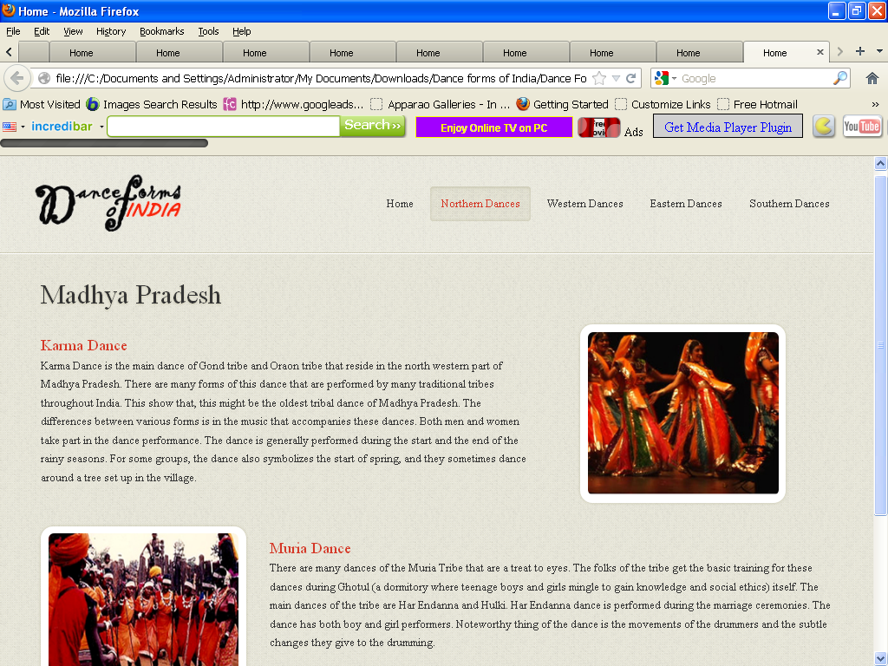

<!DOCTYPE html>

<html lang="en">

<head>

<title>Home</title>

<meta charset="utf-8">

<!--css-->

<link rel="stylesheet" href="css/reset.css" type="text/css" media="screen">

<link rel="stylesheet" href="css/style.css" type="text/css" media="screen">

<link rel="stylesheet" href="css/grid.css" type="text/css" media="screen">

<link rel="icon" href="images/favicon.ico" type="image/x-icon">

<link rel="shortcut icon" href="images/favicon.ico" type="image/x-icon" />

<link rel="stylesheet" href="css/flexslider.css" type="text/css" media="screen">

<!--js-->

<script type="text/javascript" src="js/jquery-1.7.1.min.js" ></script>

<script type="text/javascript" src="js/superfish.js"></script>

<script type="text/javascript" src="js/jquery.flexslider-min.js"></script>

<script>

jQuery(window).load(function () {

jQuery('.flexslider').flexslider({

animation: "fade",

slideshow: true,

slideshowSpeed: 7000,

animationDuration: 600,

prevText: "",

nextText: "",

controlNav: false

})

});

</script>

</head>

<body>

<!--==============================header=================================-->

<header>

<div class="line-top"></div>

<div class="main">

<div class="row-top">

<h1><a href="index.html"><img alt="" src="images/logo.gif"></a></h1>

<nav>

<ul class="sf-menu">

<li><a href="index.html">Home</a></li>

<li class="active"><a href="#">Northern Dances</a>

<ul>

<li><a href="JnK.html">Jammu n Kashmir</a></li>

<li><a href="HP.html">Himachal Pradesh </a>

<li><a href="Uttarakhand.html">Uttarakhand</a></li>

<li><a href="Haryana.html">Haryana</a></li>

<li><a href="Punjab.html">Punjab </a>

<li><a href="Rajasthan.html">Rajasthan</a></li>

<li><a href="UP.html">Uttar Pradesh</a></li>

<li><a href="Bihar.html">Bihar</a></li>

<li><a href="Jharkhand.html">Jharkhand</a></li>

<li><a href="Chhattisgarh.html">Chhattisgarh</a></li>

<li><a href="MP.html">Madhya Pradesh</a></li>

</ul>

</li>

<li><a href="#">Western Dances</a>

<ul>

<li><a href="Maharashtra.html">Maharashtra</a></li>

<li><a href="Gujarat.html">Gujarat </a>

</ul>

</li>

<li><a href="#">Eastern Dances</a>

<ul>

<li><a href="WB.html">West Bengal</a></li>

<li><a href="Orissa.html">Orissa </a>

<li><a href="Jharkhand.html">Jharkhand</a></li>

<li><a href="AP.html">Arunachal Pradesh</a></li>

<li><a href="Assam.html">Assam </a>

<li><a href="Manipur.html">Manipur</a></li>

<li><a href="Meghalaya.html">Meghalaya</a></li>

<li><a href="Mizoram.html">Mizoram</a></li>

<li><a href="Nagaland.html">Nagaland</a></li>

<li><a href="Sikkim.html">Sikkim</a></li>

<li><a href="Tripura.html">Tripura</a></li>

</ul>

</li>

<li><a href="#">Southern Dances </a>

<ul>

<li><a href="AndP.html">Andhra Pradesh</a></li>

<li><a href="Karnataka.html">Karnataka </a>

<li><a href="Kerala.html">Kerala</a></li>

<li><a href="TN.html">Tamil Nadu</a></li>

</ul>

</nav>

<div class="clear"></div>

</div>

</div>

</header>

<!--==============================content=================================-->

<section id="content"><div class="ic"></div>

<div class="border-horiz"></div>

<div class="container_12">

<article class="grid_8">

<h3>Madhya Pradesh</h3>

<ul class="list-recipes">

<li>

<div class="img-indent2"><figure class="box-img "><img src="images/mp1.jpg " alt="" /></figure></div>

<div class="overflow" style= "width:62%" >

<h4>Karma Dance</h4>

<p>

Karma Dance is the main dance of Gond tribe and Oraon tribe that reside in the north western part of Madhya Pradesh. There are many forms of this dance that are performed by many traditional tribes throughout India. This show that, this might be the oldest tribal dance of Madhya Pradesh. The differences between various forms is in the music that accompanies these dances. Both men and women take part in the dance performance. The dance is generally performed during the start and the end of the rainy seasons. For some groups, the dance also symbolizes the start of spring, and they sometimes dance around a tree set up in the village.

</p>

</div>

<div class="clear"></div>

</li>

<li>

<figure class="box-img"><img src="images/mp2.jpg " alt="" /></figure>

<div class="overflow">

<h4>Muria Dance</h4>

<p>

There are many dances of the Muria Tribe that are a treat to eyes. The folks of the tribe get the basic training for these dances during Ghotul (a dormitory where teenage boys and girls mingle to gain knowledge and social ethics) itself. The main dances of the tribe are Har Endanna and Hulki. Har Endanna dance is performed during the marriage ceremonies. The dance has both boy and girl performers. Noteworthy thing of the dance is the movements of the drummers and the subtle changes they give to the drumming.

</p>

</div>

<div class="clear"></div>

</li>

</ul>

</article>

<div class="clear"></div>

</div>

</section>

<!--==============================footer=================================-->

<footer>

<div class="main">

<center> <p>Some traditions of the Indian classical dance are practiced in the whole Indian subcontinent, including Pakistan and Bangladesh, with which India shares several other cultural traits. Indian mythologies play significant part in dance forms of countries in South East Asia, an example being the performances based on Ramayana in Javanese dances.</p> </center>

</div>

</footer>

</body>

</html>

**Nagaland.htm**

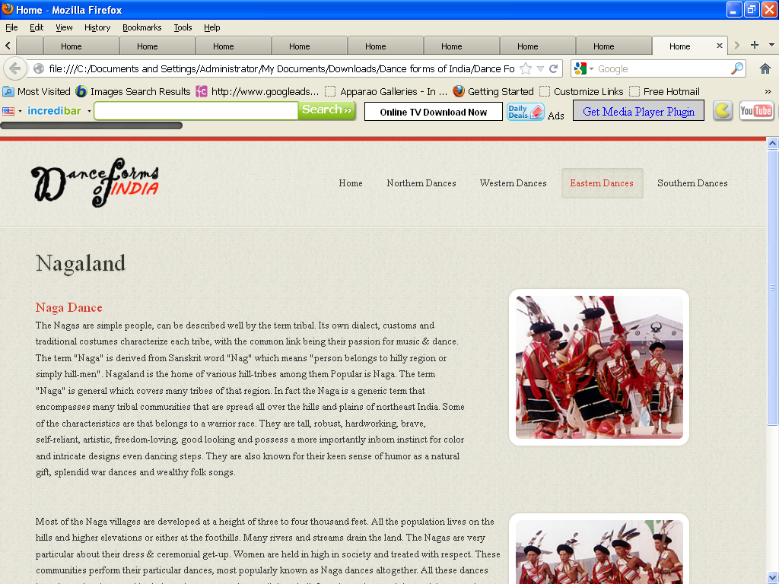

<!DOCTYPE html>

<html lang="en">

<head>

<title>Home</title>

<meta charset="utf-8">

<!--css-->

<link rel="stylesheet" href="css/reset.css" type="text/css" media="screen">

<link rel="stylesheet" href="css/style.css" type="text/css" media="screen">

<link rel="stylesheet" href="css/grid.css" type="text/css" media="screen">

<link rel="icon" href="images/favicon.ico" type="image/x-icon">

<link rel="shortcut icon" href="images/favicon.ico" type="image/x-icon" />

<link rel="stylesheet" href="css/flexslider.css" type="text/css" media="screen">

<!--js-->

<script type="text/javascript" src="js/jquery-1.7.1.min.js" ></script>

<script type="text/javascript" src="js/superfish.js"></script>

<script type="text/javascript" src="js/jquery.flexslider-min.js"></script>

<script>

jQuery(window).load(function () {

jQuery('.flexslider').flexslider({

animation: "fade",

slideshow: true,

slideshowSpeed: 7000,

animationDuration: 600,

prevText: "",

nextText: "",

controlNav: false

})

});

</script>

</head>

<body>

<!--==============================header=================================-->

<header>

<div class="line-top"></div>

<div class="main">

<div class="row-top">

<h1><a href="index.html"><img alt="" src="images/logo.gif"></a></h1>

<nav>

<ul class="sf-menu">

<li><a href="index.html">Home</a></li>

<li><a href="#">Northern Dances</a>

<ul>

<li><a href="JnK.html">Jammu n Kashmir</a></li>

<li><a href="HP.html">Himachal Pradesh </a>

<li><a href="Uttarakhand.html">Uttarakhand</a></li>

<li><a href="Haryana.html">Haryana</a></li>

<li><a href="Punjab.html">Punjab </a>

<li><a href="Rajasthan.html">Rajasthan</a></li>

<li><a href="UP.html">Uttar Pradesh</a></li>

<li><a href="Bihar.html">Bihar</a></li>

<li><a href="Jharkhand.html">Jharkhand</a></li>

<li><a href="Chhattisgarh.html">Chhattisgarh</a></li>

<li><a href="MP.html">Madhya Pradesh</a></li>

</ul>

</li>

<li><a href="#">Western Dances</a>

<ul>

<li><a href="Maharashtra.html">Maharashtra</a></li>

<li><a href="Gujarat.html">Gujarat </a>

</ul>

</li>

<li class="active"><a href="#">Eastern Dances</a>

<ul>

<li><a href="WB.html">West Bengal</a></li>

<li><a href="Orissa.html">Orissa </a>

<li><a href="Jharkhand.html">Jharkhand</a></li>

<li><a href="AP.html">Arunachal Pradesh</a></li>

<li><a href="Assam.html">Assam </a>

<li><a href="Manipur.html">Manipur</a></li>

<li><a href="Meghalaya.html">Meghalaya</a></li>

<li><a href="Mizoram.html">Mizoram</a></li>

<li><a href="Nagaland.html">Nagaland</a></li>

<li><a href="Sikkim.html">Sikkim</a></li>

<li><a href="Tripura.html">Tripura</a></li>

</ul>

</li>

<li><a href="#">Southern Dances </a>

<ul>

<li><a href="AndP.html">Andhra Pradesh</a></li>

<li><a href="Karnataka.html">Karnataka </a>

<li><a href="Kerala.html">Kerala</a></li>

<li><a href="TN.html">Tamil Nadu</a></li>

</ul>

</nav>

<div class="clear"></div>

</div>

</div>

</header>

<!--==============================content=================================-->

<section id="content"><div class="ic"></div>

<div class="border-horiz"></div>

<div class="container_12">

<article class="grid_8">

<h3>Nagaland</h3>

<ul class="list-recipes">

<li>

<div class="img-indent2"><figure class="box-img "><img src="images/ng1.jpg " alt="" /></figure></div>

<div class="overflow" style= "width:62%" >

<h4>Naga Dance</h4>

<p>The Nagas are simple people, can be described well by the term tribal. Its own dialect, customs and traditional costumes characterize each tribe, with the common link being their passion for music & dance. The term "Naga" is derived from Sanskrit word "Nag" which means "person belongs to hilly region or simply hill-men". Nagaland is the home of various hill-tribes among them Popular is Naga.

The term "Naga" is general which covers many tribes of that region. In fact the Naga is a generic term that encompasses many tribal communities that are spread all over the hills and plains of northeast India. Some of the characteristics are that belongs to a warrior race. They are tall, robust, hardworking, brave, self-reliant, artistic, freedom-loving, good looking and possess a more importantly inborn instinct for color and intricate designs even dancing steps. They are also known for their keen sense of humor as a natural gift, splendid war dances and wealthy folk songs.

</p>

</div>

<div class="clear"></div>

</li>

<li>

<div class="img-indent2"><figure class="box-img"><img src="images/ng2.jpg " alt="" /></figure></div>

<div class="overflow">

<p>Most of the Naga villages are developed at a height of three to four thousand feet. All the population lives on the hills and higher elevations or either at the foothills. Many rivers and streams drain the land. The Nagas are very particular about their dress & ceremonial get-up. Women are held in high in society and treated with respect.

These communities perform their particular dances, most popularly known as Naga dances altogether. All these dances have been deeply rooted in their environ, occupations, religious beliefs and practices and the social patters that prevails .The cultural activities of the Nagas especially the dances reflect folds or aspects of their life-style in their rhythmic movements and body language. Their dances are numerous and as rich as varied. Most of these dances are war-like and martial in its approach.</p>

</div>

<div class="clear"></div>

</li>

</ul>

</article>

<div class="clear"></div>

</div>

</section>

<!--==============================footer=================================-->

<footer>

<div class="main">

<center> <p>Some traditions of the Indian classical dance are practiced in the whole Indian subcontinent, including Pakistan and Bangladesh, with which India shares several other cultural traits. Indian mythologies play significant part in dance forms of countries in South East Asia, an example being the performances based on Ramayana in Javanese dances.</p> </center>

</div>

</footer>

</body>

</html>

**Orissa.htm**

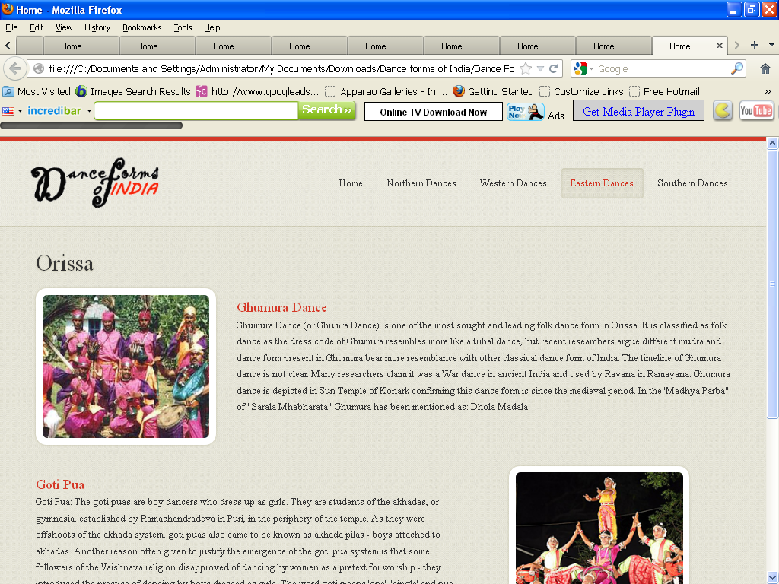

<!DOCTYPE html>

<html lang="en">

<head>

<title>Home</title>

<meta charset="utf-8">

<!--css-->

<link rel="stylesheet" href="css/reset.css" type="text/css" media="screen">

<link rel="stylesheet" href="css/style.css" type="text/css" media="screen">

<link rel="stylesheet" href="css/grid.css" type="text/css" media="screen">

<link rel="icon" href="images/favicon.ico" type="image/x-icon">

<link rel="shortcut icon" href="images/favicon.ico" type="image/x-icon" />

<link rel="stylesheet" href="css/flexslider.css" type="text/css" media="screen">

<!--js-->

<script type="text/javascript" src="js/jquery-1.7.1.min.js" ></script>

<script type="text/javascript" src="js/superfish.js"></script>

<script type="text/javascript" src="js/jquery.flexslider-min.js"></script>

<script>

jQuery(window).load(function () {

jQuery('.flexslider').flexslider({

animation: "fade",

slideshow: true,

slideshowSpeed: 7000,

animationDuration: 600,

prevText: "",

nextText: "",

controlNav: false

})

});

</script>

</head>

<body>

<!--==============================header=================================-->

<header>

<div class="line-top"></div>

<div class="main">

<div class="row-top">

<h1><a href="index.html"><img alt="" src="images/logo.gif"></a></h1>

<nav>

<ul class="sf-menu">

<li><a href="index.html">Home</a></li>

<li><a href="#">Northern Dances</a>

<ul>

<li><a href="JnK.html">Jammu n Kashmir</a></li>

<li><a href="HP.html">Himachal Pradesh </a>

<li><a href="Uttarakhand.html">Uttarakhand</a></li>

<li><a href="Haryana.html">Haryana</a></li>

<li><a href="Punjab.html">Punjab </a>

<li><a href="Rajasthan.html">Rajasthan</a></li>

<li><a href="UP.html">Uttar Pradesh</a></li>

<li><a href="Bihar.html">Bihar</a></li>

<li><a href="Jharkhand.html">Jharkhand</a></li>

<li><a href="Chhattisgarh.html">Chhattisgarh</a></li>

<li><a href="MP.html">Madhya Pradesh</a></li>

</ul>

</li>

<li><a href="#">Western Dances</a>

<ul>

<li><a href="Maharashtra.html">Maharashtra</a></li>

<li><a href="Gujarat.html">Gujarat </a>

</ul>

</li>

<li class="active"><a href="#" >Eastern Dances</a>

<ul>

<li><a href="WB.html">West Bengal</a></li>

<li><a href="Orissa.html">Orissa </a>

<li><a href="Jharkhand.html">Jharkhand</a></li>

<li><a href="AP.html">Arunachal Pradesh</a></li>

<li><a href="Assam.html">Assam </a>

<li><a href="Manipur.html">Manipur</a></li>

<li><a href="Meghalaya.html">Meghalaya</a></li>

<li><a href="Mizoram.html">Mizoram</a></li>

<li><a href="Nagaland.html">Nagaland</a></li>

<li><a href="Sikkim.html">Sikkim</a></li>

<li><a href="Tripura.html">Tripura</a></li>

</ul>

</li>

<li><a href="#">Southern Dances </a>

<ul>

<li><a href="AndP.html">Andhra Pradesh</a></li>

<li><a href="Karnataka.html">Karnataka </a>

<li><a href="Kerala.html">Kerala</a></li>

<li><a href="TN.html">Tamil Nadu</a></li>

</ul>

</nav>

<div class="clear"></div>

</div>

</div>

</header>

<!--==============================content=================================-->

<section id="content"><div class="ic"></div>

<div class="border-horiz"></div>

<div class="container_12">

<article class="grid_8">

<h3>Orissa</h3>

<ul class="list-recipes">

<li>

<figure class="box-img"><img src="images/or1.jpg " alt="" /></figure>

<div class="overflow">

<h4>Ghumura Dance</h4>

<p>Ghumura Dance (or Ghumra Dance) is one of the most sought and leading folk dance form in Orissa. It is classified as folk dance as the dress code of Ghumura resembles more like a tribal dance, but recent researchers argue different mudra and dance form present in Ghumura bear more resemblance with other classical dance form of India. The timeline of Ghumura dance is not clear. Many researchers claim it was a War dance in ancient India and used by Ravana in Ramayana. Ghumura dance is depicted in Sun Temple of Konark confirming this dance form is since the medieval period. In the 'Madhya Parba" of "Sarala Mhabharata" Ghumura has been mentioned as: Dhola Madala </p>

</div>

<div class="clear"></div>

</li>

<li>

<div class="img-indent2"><figure class="box-img "><img src="images/or2.jpg " alt="" /></figure></div>

<div class="overflow" style= "width:62%" >

<h4>Goti Pua</h4>

<p>Goti Pua: The goti puas are boy dancers who dress up as girls. They are students of the akhadas, or gymnasia, established by Ramachandradeva in Puri, in the periphery of the temple. As they were offshoots of the akhada system, goti puas also came to be known as akhada pilas - boys attached to akhadas. Another reason often given to justify the emergence of the goti pua system is that some followers of the Vaishnava religion disapproved of dancing by women as a pretext for worship - they introduced the practice of dancing by boys dressed as girls. The word goti means 'one', 'single' and pua, 'boy', but the goti puas always dance in pairs. Boys are recruited about the age of six and continue to perform till they are 14, then become teachers of the dance or join drama parties. Goti puas are now part of professional teams, known as dals, each headed by a guru. The boys are trained for about two years, during which, after having imbibed the basic technique, they learn items of dance, ornamental and expressional. </p>

</div>

<div class="clear"></div>

</li>

</ul>

</article>

<div class="clear"></div>

</div>

</section>

<!--==============================footer=================================-->

<footer>

<div class="main">

<center> <p>Some traditions of the Indian classical dance are practiced in the whole Indian subcontinent, including Pakistan and Bangladesh, with which India shares several other cultural traits. Indian mythologies play significant part in dance forms of countries in South East Asia, an example being the performances based on Ramayana in Javanese dances.</p> </center>

</div>

</footer>

</body>

</html>

**Punjab.htm**

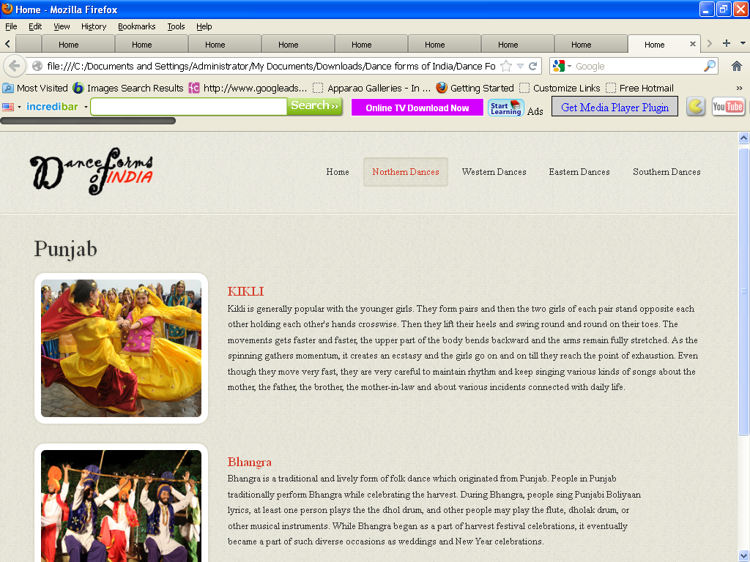

<!DOCTYPE html>

<html lang="en">

<head>

<title>Home</title>

<meta charset="utf-8">

<!--css-->

<link rel="stylesheet" href="css/reset.css" type="text/css" media="screen">

<link rel="stylesheet" href="css/style.css" type="text/css" media="screen">

<link rel="stylesheet" href="css/grid.css" type="text/css" media="screen">

<link rel="icon" href="images/favicon.ico" type="image/x-icon">

<link rel="shortcut icon" href="images/favicon.ico" type="image/x-icon" />

<link rel="stylesheet" href="css/flexslider.css" type="text/css" media="screen">

<!--js-->

<script type="text/javascript" src="js/jquery-1.7.1.min.js" ></script>

<script type="text/javascript" src="js/superfish.js"></script>

<script type="text/javascript" src="js/jquery.flexslider-min.js"></script>

<script>

jQuery(window).load(function () {

jQuery('.flexslider').flexslider({

animation: "fade",

slideshow: true,

slideshowSpeed: 7000,

animationDuration: 600,

prevText: "",

nextText: "",

controlNav: false

})

});

</script>

</head>

<body>

<!--==============================header=================================-->

<header>

<div class="line-top"></div>

<div class="main">

<div class="row-top">

<h1><a href="index.html"><img alt="" src="images/logo.gif"></a></h1>

<nav>

<ul class="sf-menu">

<li ><a href="index.html">Home</a></li>

<li class="active"><a href="#">Northern Dances</a>

<ul>

<li><a href="JnK.html">Jammu n Kashmir</a></li>

<li><a href="HP.html">Himachal Pradesh </a>

<li><a href="Uttarakhand.html">Uttarakhand</a></li>

<li><a href="Haryana.html">Haryana</a></li>

<li><a href="Punjab.html">Punjab </a>

<li><a href="Rajasthan.html">Rajasthan</a></li>

<li><a href="UP.html">Uttar Pradesh</a></li>

<li><a href="Bihar.html">Bihar</a></li>

<li><a href="Jharkhand.html">Jharkhand</a></li>

<li><a href="Chhattisgarh.html">Chhattisgarh</a></li>

<li><a href="MP.html">Madhya Pradesh</a></li>

</ul>

</li>

<li><a href="#">Western Dances</a>

<ul>

<li><a href="Maharashtra.html">Maharashtra</a></li>

<li><a href="Gujarat.html">Gujarat </a>

</ul>

</li>

<li><a href="#">Eastern Dances</a>

<ul>

<li><a href="WB.html">West Bengal</a></li>

<li><a href="Orissa.html">Orissa </a>

<li><a href="Jharkhand.html">Jharkhand</a></li>

<li><a href="AP.html">Arunachal Pradesh</a></li>

<li><a href="Assam.html">Assam </a>

<li><a href="Manipur.html">Manipur</a></li>

<li><a href="Meghalaya.html">Meghalaya</a></li>

<li><a href="Mizoram.html">Mizoram</a></li>

<li><a href="Nagaland.html">Nagaland</a></li>

<li><a href="Sikkim.html">Sikkim</a></li>

<li><a href="Tripura.html">Tripura</a></li>

</ul>

</li>

<li><a href="#">Southern Dances </a>

<ul>

<li><a href="AndP.html">Andhra Pradesh</a></li>

<li><a href="Karnataka.html">Karnataka </a>

<li><a href="Kerala.html">Kerala</a></li>

<li><a href="TN.html">Tamil Nadu</a></li>

</ul>

</nav>

<div class="clear"></div>

</div>

</div>

</header>

<!--==============================content=================================-->

<section id="content"><div class="ic"></div>

<div class="border-horiz"></div>

<div class="container_12">

<article class="grid_8">

<h3>Punjab</h3>

<ul class="list-recipes">

<li>

<figure class="box-img"><img src="images/pb1.jpg " alt="" /></figure>

<div class="overflow">

<h4>KIKLI</h4>

<p>

Kikli is generally popular with the younger girls. They form pairs and then the two girls of each pair stand opposite each other holding each other's hands crosswise. Then they lift their heels and swing round and round on their toes. The movements gets faster and faster, the upper part of the body bends backward and the arms remain fully stretched. As the spinning gathers momentum, it creates an ecstasy and the girls go on and on till they reach the point of exhaustion. Even though they move very fast, they are very careful to maintain rhythm and keep singing various kinds of songs about the mother, the father, the brother, the mother-in-law and about various incidents connected with daily life.

</p>

</div>

<div class="clear"></div>

</li>

<li>

<figure class="box-img "><img src="images/pb2.jpg " alt="" /></figure>

<div class="overflow" style= "width:62%" >

<h4>Bhangra </h4>

<p>

Bhangra is a traditional and lively form of folk dance which originated from Punjab. People in Punjab traditionally perform Bhangra while celebrating the harvest. During Bhangra, people sing Punjabi Boliyaan lyrics, at least one person plays the the dhol drum, and other people may play the flute, dholak drum, or other musical instruments. While Bhangra began as a part of harvest festival celebrations, it eventually became a part of such diverse occasions as weddings and New Year celebrations.

</p>

</div>

<div class="clear"></div>

</li>

</ul>

</article>

<div class="clear"></div>

</div>

</section>

<!--==============================footer=================================-->

<footer>

<div class="main">

<center> <p>Some traditions of the Indian classical dance are practiced in the whole Indian subcontinent, including Pakistan and Bangladesh, with which India shares several other cultural traits. Indian mythologies play significant part in dance forms of countries in South East Asia, an example being the performances based on Ramayana in Javanese dances.</p> </center>

</div>

</footer>

</body>

</html>

**Rajasthan.htm**

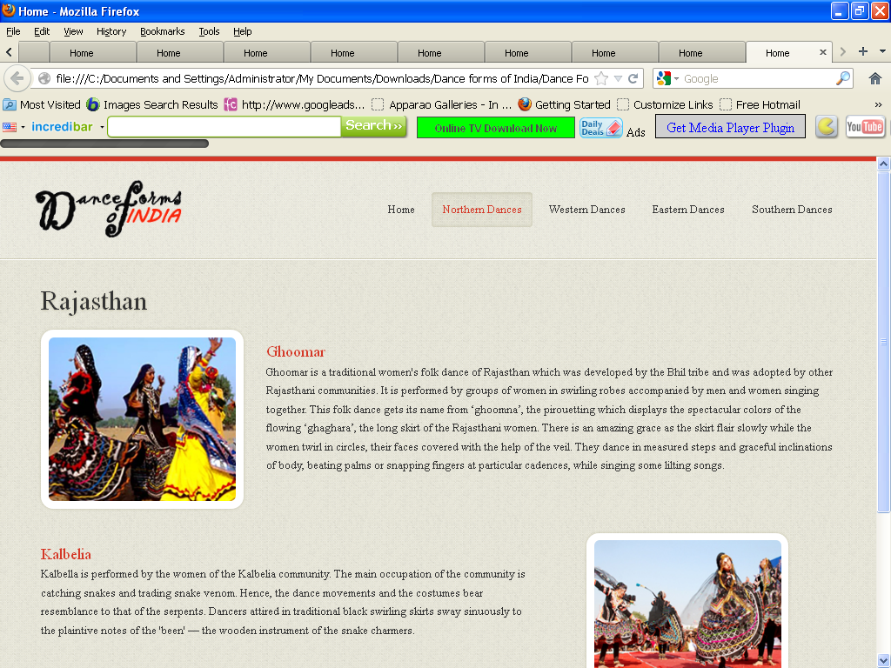

<!DOCTYPE html>

<html lang="en">

<head>

<title>Home</title>

<meta charset="utf-8">

<!--css-->

<link rel="stylesheet" href="css/reset.css" type="text/css" media="screen">

<link rel="stylesheet" href="css/style.css" type="text/css" media="screen">

<link rel="stylesheet" href="css/grid.css" type="text/css" media="screen">

<link rel="icon" href="images/favicon.ico" type="image/x-icon">

<link rel="shortcut icon" href="images/favicon.ico" type="image/x-icon" />

<link rel="stylesheet" href="css/flexslider.css" type="text/css" media="screen">

<!--js-->

<script type="text/javascript" src="js/jquery-1.7.1.min.js" ></script>

<script type="text/javascript" src="js/superfish.js"></script>

<script type="text/javascript" src="js/jquery.flexslider-min.js"></script>

<script>

jQuery(window).load(function () {

jQuery('.flexslider').flexslider({

animation: "fade",

slideshow: true,

slideshowSpeed: 7000,

animationDuration: 600,

prevText: "",

nextText: "",

controlNav: false

})

});

</script>

</head>

<body>

<!--==============================header=================================-->

<header>

<div class="line-top"></div>

<div class="main">

<div class="row-top">

<h1><a href="index.html"><img alt="" src="images/logo.gif"></a></h1>

<nav>

<ul class="sf-menu">

<li><a href="index.html">Home</a></li>

<li class="active"><a href="#">Northern Dances</a>

<ul>

<li><a href="JnK.html">Jammu n Kashmir</a></li>

<li><a href="HP.html">Himachal Pradesh </a>

<li><a href="Uttarakhand.html">Uttarakhand</a></li>

<li><a href="Haryana.html">Haryana</a></li>

<li><a href="Punjab.html">Punjab </a>

<li><a href="Rajasthan.html">Rajasthan</a></li>

<li><a href="UP.html">Uttar Pradesh</a></li>

<li><a href="Bihar.html">Bihar</a></li>

<li><a href="Jharkhand.html">Jharkhand</a></li>

<li><a href="Chhattisgarh.html">Chhattisgarh</a></li>

<li><a href="MP.html">Madhya Pradesh</a></li>

</ul>

</li>

<li><a href="#">Western Dances</a>

<ul>

<li><a href="Maharashtra.html">Maharashtra</a></li>

<li><a href="Gujarat.html">Gujarat </a>

</ul>

</li>

<li><a href="#">Eastern Dances</a>

<ul>

<li><a href="WB.html">West Bengal</a></li>

<li><a href="Orissa.html">Orissa </a>

<li><a href="Jharkhand.html">Jharkhand</a></li>

<li><a href="AP.html">Arunachal Pradesh</a></li>

<li><a href="Assam.html">Assam </a>

<li><a href="Manipur.html">Manipur</a></li>

<li><a href="Meghalaya.html">Meghalaya</a></li>

<li><a href="Mizoram.html">Mizoram</a></li>

<li><a href="Nagaland.html">Nagaland</a></li>

<li><a href="Sikkim.html">Sikkim</a></li>

<li><a href="Tripura.html">Tripura</a></li>

</ul>

</li>

<li><a href="#">Southern Dances </a>

<ul>

<li><a href="AndP.html">Andhra Pradesh</a></li>

<li><a href="Karnataka.html">Karnataka </a>

<li><a href="Kerala.html">Kerala</a></li>

<li><a href="TN.html">Tamil Nadu</a></li>

</ul>

</nav>

<div class="clear"></div>

</div>

</div>

</header>

<!--==============================content=================================-->

<section id="content"><div class="ic"></div>

<div class="border-horiz"></div>

<div class="container_12">

<article class="grid_8">

<h3>Rajasthan </h3>

<ul class="list-recipes">

<li>

<figure class="box-img"><img src="images/rj1.jpg " alt="" /></figure>

<div class="overflow">

<h4>Ghoomar</h4>

<p>

Ghoomar is a traditional women's folk dance of Rajasthan which was developed by the Bhil tribe and was adopted by other Rajasthani communities. It is performed by groups of women in swirling robes accompanied by men and women singing together. This folk dance gets its name from ‘ghoomna’, the pirouetting which displays the spectacular colors of the flowing ‘ghaghara’, the long skirt of the Rajasthani women. There is an amazing grace as the skirt flair slowly while the women twirl in circles, their faces covered with the help of the veil. They dance in measured steps and graceful inclinations of body, beating palms or snapping fingers at particular cadences, while singing some lilting songs.

</p>

</div>

<div class="clear"></div>

</li>

<li>

<div class="img-indent2"><figure class="box-img "><img src="images/rj2.jpg " alt="" /></figure></div>

<div class="overflow" style= "width:62%" >

<h4>Kalbelia</h4>

<p>

Kalbella is performed by the women of the Kalbelia community. The main occupation of the community is catching snakes and trading snake venom. Hence, the dance movements and the costumes bear resemblance to that of the serpents. Dancers attired in traditional black swirling skirts sway sinuously to the plaintive notes of the 'been' — the wooden instrument of the snake charmers. </p>

</div>

<div class="clear"></div>

</li>

</ul>

</article>

<div class="clear"></div>

</div>

</section>

<!--==============================footer=================================-->

<footer>

<div class="main">

<center> <p>Some traditions of the Indian classical dance are practiced in the whole Indian subcontinent, including Pakistan and Bangladesh, with which India shares several other cultural traits. Indian mythologies play significant part in dance forms of countries in South East Asia, an example being the performances based on Ramayana in Javanese dances.</p> </center>

</div>

</footer>

</body>

</html>

**Sikkim.htm**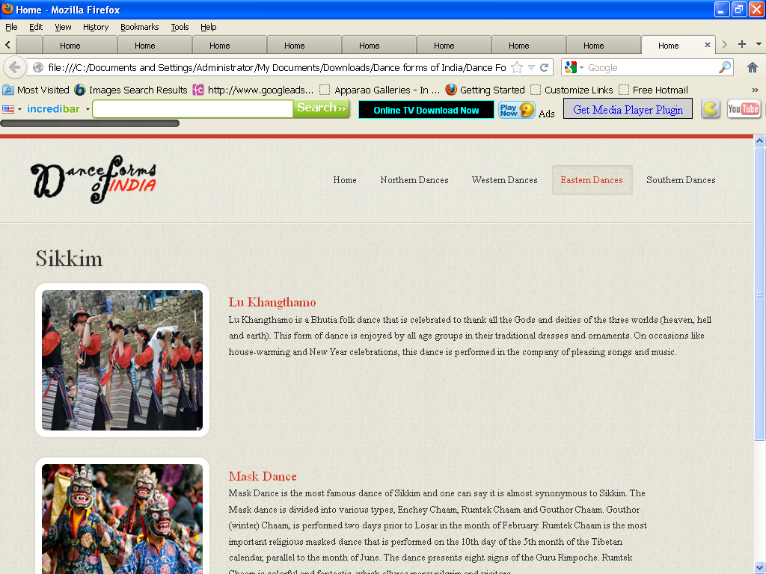

<!DOCTYPE html>

<html lang="en">

<head>

<title>Home</title>

<meta charset="utf-8">

<!--css-->

<link rel="stylesheet" href="css/reset.css" type="text/css" media="screen">

<link rel="stylesheet" href="css/style.css" type="text/css" media="screen">

<link rel="stylesheet" href="css/grid.css" type="text/css" media="screen">

<link rel="icon" href="images/favicon.ico" type="image/x-icon">

<link rel="shortcut icon" href="images/favicon.ico" type="image/x-icon" />

<link rel="stylesheet" href="css/flexslider.css" type="text/css" media="screen">

<!--js-->

<script type="text/javascript" src="js/jquery-1.7.1.min.js" ></script>

<script type="text/javascript" src="js/superfish.js"></script>

<script type="text/javascript" src="js/jquery.flexslider-min.js"></script>

<script>

jQuery(window).load(function () {

jQuery('.flexslider').flexslider({

animation: "fade",

slideshow: true,

slideshowSpeed: 7000,

animationDuration: 600,

prevText: "",

nextText: "",

controlNav: false

})

});

</script>

</head>

<body>

<!--==============================header=================================-->

<header>

<div class="line-top"></div>

<div class="main">

<div class="row-top">

<h1><a href="index.html"><img alt="" src="images/logo.gif"></a></h1>

<nav>

<ul class="sf-menu">

<li ><a href="index.html">Home</a></li>

<li><a href="#">Northern Dances</a>

<ul>

<li><a href="JnK.html">Jammu n Kashmir</a></li>

<li><a href="HP.html">Himachal Pradesh </a>

<li><a href="Uttarakhand.html">Uttarakhand</a></li>

<li><a href="Haryana.html">Haryana</a></li>

<li><a href="Punjab.html">Punjab </a>

<li><a href="Rajasthan.html">Rajasthan</a></li>

<li><a href="UP.html">Uttar Pradesh</a></li>

<li><a href="Bihar.html">Bihar</a></li>

<li><a href="Jharkhand.html">Jharkhand</a></li>

<li><a href="Chhattisgarh.html">Chhattisgarh</a></li>

<li><a href="MP.html">Madhya Pradesh</a></li>

</ul>

</li>

<li><a href="#">Western Dances</a>

<ul>

<li><a href="Maharashtra.html">Maharashtra</a></li>

<li><a href="Gujarat.html">Gujarat </a>

</ul>

</li>

<li class="active"><a href="#" >Eastern Dances</a>

<ul>

<li><a href="WB.html">West Bengal</a></li>

<li><a href="Orissa.html">Orissa </a>

<li><a href="Jharkhand.html">Jharkhand</a></li>

<li><a href="AP.html">Arunachal Pradesh</a></li>

<li><a href="Assam.html">Assam </a>

<li><a href="Manipur.html">Manipur</a></li>

<li><a href="Meghalaya.html">Meghalaya</a></li>

<li><a href="Mizoram.html">Mizoram</a></li>

<li><a href="Nagaland.html">Nagaland</a></li>

<li><a href="Sikkim.html">Sikkim</a></li>

<li><a href="Tripura.html">Tripura</a></li>

</ul>

</li>

<li><a href="#">Southern Dances </a>

<ul>

<li><a href="AndP.html">Andhra Pradesh</a></li>

<li><a href="Karnataka.html">Karnataka </a>

<li><a href="Kerala.html">Kerala</a></li>

<li><a href="TN.html">Tamil Nadu</a></li>

</ul>

</nav>

<div class="clear"></div>

</div>

</div>

</header>

<!--==============================content=================================-->

<section id="content"><div class="ic"></div>

<div class="border-horiz"></div>

<div class="container_12">

<article class="grid_8">

<h3>Sikkim </h3>

<ul class="list-recipes">

<li>

<figure class="box-img"><img src="images/sk1.jpg " alt="" /></figure>

<div class="overflow">

<h4>

Lu Khangthamo</h4>

<p>

Lu Khangthamo is a Bhutia folk dance that is celebrated to thank all the Gods and deities of the three worlds (heaven, hell and earth). This form of dance is enjoyed by all age groups in their traditional dresses and ornaments. On occasions like house-warming and New Year celebrations, this dance is performed in the company of pleasing songs and music.

</p>

</div>

<div class="clear"></div>

</li>

<li>

<figure class="box-img "><img src="images/sk2.jpg " alt="" /></figure>

<div class="overflow" style= "width:62%" >

<h4>Mask Dance</h4>

<p>

Mask Dance is the most famous dance of Sikkim and one can say it is almost synonymous to Sikkim. The Mask dance is divided into various types, Enchey Chaam, Rumtek Chaam and Gouthor Chaam. Gouthor (winter) Chaam, is performed two days prior to Losar in the month of February. Rumtek Chaam is the most important religious masked dance that is performed on the 10th day of the 5th month of the Tibetan calendar, parallel to the month of June. The dance presents eight signs of the Guru Rimpoche. Rumtek Chaam is colorful and fantastic, which allures many pilgrim and visitors </p>

</div>

<div class="clear"></div>

</li>

</ul>

</article>

<div class="clear"></div>

</div>

</section>

<!--==============================footer=================================-->

<footer>

<div class="main">

<center> <p>Some traditions of the Indian classical dance are practiced in the whole Indian subcontinent, including Pakistan and Bangladesh, with which India shares several other cultural traits. Indian mythologies play significant part in dance forms of countries in South East Asia, an example being the performances based on Ramayana in Javanese dances.</p> </center>

</div>

</footer>

</body>

</html>

**Tamilnadu.htm**

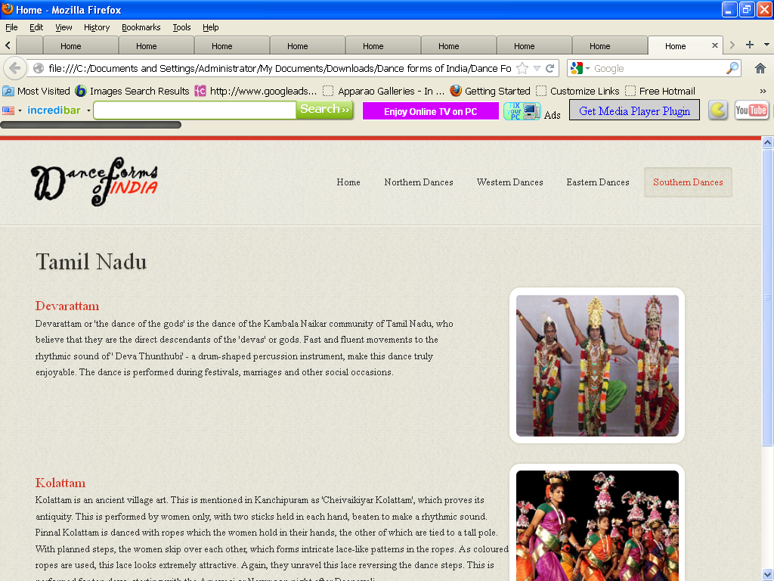

<!DOCTYPE html>

<html lang="en">

<head>

<title>Home</title>

<meta charset="utf-8">

<!--css-->

<link rel="stylesheet" href="css/reset.css" type="text/css" media="screen">

<link rel="stylesheet" href="css/style.css" type="text/css" media="screen">

<link rel="stylesheet" href="css/grid.css" type="text/css" media="screen">

<link rel="icon" href="images/favicon.ico" type="image/x-icon">

<link rel="shortcut icon" href="images/favicon.ico" type="image/x-icon" />

<link rel="stylesheet" href="css/flexslider.css" type="text/css" media="screen">

<!--js-->

<script type="text/javascript" src="js/jquery-1.7.1.min.js" ></script>

<script type="text/javascript" src="js/superfish.js"></script>

<script type="text/javascript" src="js/jquery.flexslider-min.js"></script>

<script>

jQuery(window).load(function () {

jQuery('.flexslider').flexslider({

animation: "fade",

slideshow: true,

slideshowSpeed: 7000,

animationDuration: 600,

prevText: "",

nextText: "",

controlNav: false

})

});

</script>

</head>

<body>

<!--==============================header=================================-->

<header>

<div class="line-top"></div>

<div class="main">

<div class="row-top">

<h1><a href="index.html"><img alt="" src="images/logo.gif"></a></h1>

<nav>

<ul class="sf-menu">

<li><a href="index.html">Home</a></li>

<li><a href="#">Northern Dances</a>

<ul>

<li><a href="JnK.html">Jammu n Kashmir</a></li>

<li><a href="HP.html">Himachal Pradesh </a>

<li><a href="Uttarakhand.html">Uttarakhand</a></li>

<li><a href="Haryana.html">Haryana</a></li>

<li><a href="Punjab.html">Punjab </a>

<li><a href="Rajasthan.html">Rajasthan</a></li>

<li><a href="UP.html">Uttar Pradesh</a></li>

<li><a href="Bihar.html">Bihar</a></li>

<li><a href="Jharkhand.html">Jharkhand</a></li>

<li><a href="Chhattisgarh.html">Chhattisgarh</a></li>

<li><a href="MP.html">Madhya Pradesh</a></li>

</ul>

</li>

<li><a href="#">Western Dances</a>

<ul>

<li><a href="Maharashtra.html">Maharashtra</a></li>

<li><a href="Gujarat.html">Gujarat </a>

</ul>

</li>

<li><a href="#">Eastern Dances</a>

<ul>

<li><a href="WB.html">West Bengal</a></li>

<li><a href="Orissa.html">Orissa </a>

<li><a href="Jharkhand.html">Jharkhand</a></li>

<li><a href="AP.html">Arunachal Pradesh</a></li>

<li><a href="Assam.html">Assam </a>

<li><a href="Manipur.html">Manipur</a></li>

<li><a href="Meghalaya.html">Meghalaya</a></li>

<li><a href="Mizoram.html">Mizoram</a></li>

<li><a href="Nagaland.html">Nagaland</a></li>

<li><a href="Sikkim.html">Sikkim</a></li>

<li><a href="Tripura.html">Tripura</a></li>

</ul>

</li>

<li class="active"><a href="#">Southern Dances </a>

<ul>

<li><a href="AndP.html">Andhra Pradesh</a></li>

<li><a href="Karnataka.html">Karnataka </a>

<li><a href="Kerala.html">Kerala</a></li>

<li><a href="TN.html">Tamil Nadu</a></li>

</ul>

</nav>

<div class="clear"></div>

</div>

</div>

</header>

<!--==============================content=================================-->

<section id="content"><div class="ic"></div>

<div class="border-horiz"></div>

<div class="container_12">

<article class="grid_8">

<h3>Tamil Nadu</h3>

<ul class="list-recipes">

<li>

<div class="img-indent2"><figure class="box-img "><img src="images/tn1.jpg " alt="" /></figure></div>

<div class="overflow" style= "width:62%" >

<h4>Devarattam</h4>

<p>

Devarattam or 'the dance of the gods' is the dance of the Kambala Naikar community of Tamil Nadu, who believe that they are the direct descendants of the 'devas' or gods. Fast and fluent movements to the rhythmic sound of ' Deva Thunthubi' - a drum-shaped percussion instrument, make this dance truly enjoyable. The dance is performed during festivals, marriages and other social occasions.

</p>

</div>

<div class="clear"></div>

</li>

<li>

<div class="img-indent2"><figure class="box-img"><img src="images/tn2.jpg " alt="" /></figure></div>

<div class="overflow">

<h4>Kolattam</h4>

<p>

Kolattam is an ancient village art. This is mentioned in Kanchipuram as 'Cheivaikiyar Kolattam', which proves its antiquity. This is performed by women only, with two sticks held in each hand, beaten to make a rhythmic sound. Pinnal Kolattam is danced with ropes which the women hold in their hands, the other of which are tied to a tall pole. With planned steps, the women skip over each other, which forms intricate lace-like patterns in the ropes. As coloured ropes are used, this lace looks extremely attractive. Again, they unravel this lace reversing the dance steps. This is performed for ten days, starting with the Amavasi or Newmoon night after Deepavali.</p>

</div>

<div class="clear"></div>

</li>

</ul>

</article>

<div class="clear"></div>

</div>

</section>

<!--==============================footer=================================-->

<footer>

<div class="main">

<center> <p>Some traditions of the Indian classical dance are practiced in the whole Indian subcontinent, including Pakistan and Bangladesh, with which India shares several other cultural traits. Indian mythologies play significant part in dance forms of countries in South East Asia, an example being the performances based on Ramayana in Javanese dances.</p> </center>

</div>

</footer>

</body>

</html>

**Tripura.htm**

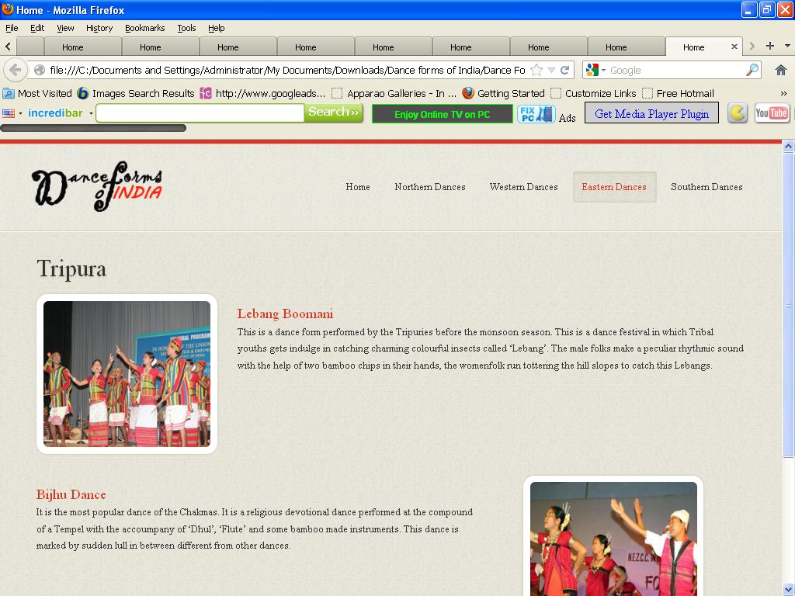

<!DOCTYPE html>

<html lang="en">

<head>

<title>Home</title>

<meta charset="utf-8">

<!--css-->

<link rel="stylesheet" href="css/reset.css" type="text/css" media="screen">

<link rel="stylesheet" href="css/style.css" type="text/css" media="screen">

<link rel="stylesheet" href="css/grid.css" type="text/css" media="screen">

<link rel="icon" href="images/favicon.ico" type="image/x-icon">

<link rel="shortcut icon" href="images/favicon.ico" type="image/x-icon" />

<link rel="stylesheet" href="css/flexslider.css" type="text/css" media="screen">

<!--js-->

<script type="text/javascript" src="js/jquery-1.7.1.min.js" ></script>

<script type="text/javascript" src="js/superfish.js"></script>

<script type="text/javascript" src="js/jquery.flexslider-min.js"></script>

<script>

jQuery(window).load(function () {

jQuery('.flexslider').flexslider({

animation: "fade",

slideshow: true,

slideshowSpeed: 7000,

animationDuration: 600,

prevText: "",

nextText: "",

controlNav: false

})

});

</script>

</head>

<body>

<!--==============================header=================================-->

<header>

<div class="line-top"></div>

<div class="main">

<div class="row-top">

<h1><a href="index.html"><img alt="" src="images/logo.gif"></a></h1>

<nav>

<ul class="sf-menu">

<li><a href="index.html">Home</a></li>

<li><a href="#">Northern Dances</a>

<ul>

<li><a href="JnK.html">Jammu n Kashmir</a></li>

<li><a href="HP.html">Himachal Pradesh </a>

<li><a href="Uttarakhand.html">Uttarakhand</a></li>

<li><a href="Haryana.html">Haryana</a></li>

<li><a href="Punjab.html">Punjab </a>

<li><a href="Rajasthan.html">Rajasthan</a></li>

<li><a href="UP.html">Uttar Pradesh</a></li>

<li><a href="Bihar.html">Bihar</a></li>

<li><a href="Jharkhand.html">Jharkhand</a></li>

<li><a href="Chhattisgarh.html">Chhattisgarh</a></li>

<li><a href="MP.html">Madhya Pradesh</a></li>

</ul>

</li>

<li><a href="#">Western Dances</a>

<ul>

<li><a href="Maharashtra.html">Maharashtra</a></li>

<li><a href="Gujarat.html">Gujarat </a>

</ul>

</li>

<li class="active"><a href="#" >Eastern Dances</a>

<ul>

<li><a href="WB.html">West Bengal</a></li>

<li><a href="Orissa.html">Orissa </a>

<li><a href="Jharkhand.html">Jharkhand</a></li>

<li><a href="AP.html">Arunachal Pradesh</a></li>

<li><a href="Assam.html">Assam </a>

<li><a href="Manipur.html">Manipur</a></li>

<li><a href="Meghalaya.html">Meghalaya</a></li>

<li><a href="Mizoram.html">Mizoram</a></li>

<li><a href="Nagaland.html">Nagaland</a></li>

<li><a href="Sikkim.html">Sikkim</a></li>

<li><a href="Tripura.html">Tripura</a></li>

</ul>

</li>

<li><a href="#">Southern Dances </a>

<ul>

<li><a href="AndP.html">Andhra Pradesh</a></li>

<li><a href="Karnataka.html">Karnataka </a>

<li><a href="Kerala.html">Kerala</a></li>

<li><a href="TN.html">Tamil Nadu</a></li>

</ul>

</nav>

<div class="clear"></div>

</div>

</div>

</header>

<!--==============================content=================================-->

<section id="content"><div class="ic"></div>

<div class="border-horiz"></div>

<div class="container_12">

<article class="grid_8">

<h3>Tripura</h3>

<ul class="list-recipes">

<li>

<figure class="box-img"><img src="images/tr1.jpg " alt="" /></figure>

<div class="overflow">

<h4>Lebang Boomani</h4>

<p>

This is a dance form performed by the Tripuries before the monsoon season. This is a dance festival in which Tribal youths gets indulge in catching charming colourful insects called ‘Lebang’. The male folks make a peculiar rhythmic sound with the help of two bamboo chips in their hands, the womenfolk run tottering the hill slopes to catch this Lebangs.

</p>

</div>

<div class="clear"></div>

</li>

<li>

<div class="img-indent2"><figure class="box-img "><img src="images/tr2.jpg " alt="" /></figure></div>

<div class="overflow" style= "width:62%" >

<h4>Bijhu Dance</h4>

<p>It is the most popular dance of the Chakmas. It is a religious devotional dance performed at the compound of a Tempel with the accoumpany of ‘Dhul’, ‘Flute’ and some bamboo made instruments. This dance is marked by sudden lull in between different from other dances.</p>

</div>

<div class="clear"></div>

</li>

</ul>

</article>

<div class="clear"></div>

</div>

</section>

<!--==============================footer=================================-->

<footer>

<div class="main">

<center> <p>Some traditions of the Indian classical dance are practiced in the whole Indian subcontinent, including Pakistan and Bangladesh, with which India shares several other cultural traits. Indian mythologies play significant part in dance forms of countries in South East Asia, an example being the performances based on Ramayana in Javanese dances.</p> </center>

</div>

</footer>

</body>

</html>

**UttarPtadesh.htm**

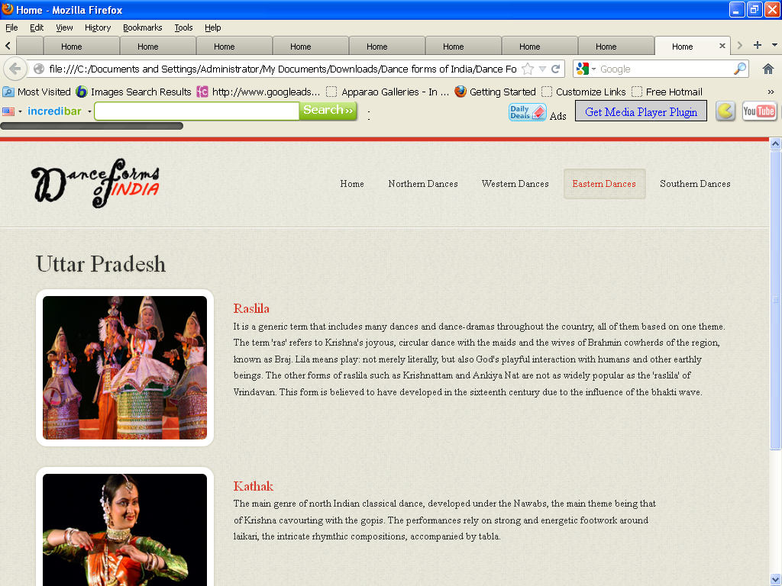

<!DOCTYPE html>

<html lang="en">

<head>

<title>Home</title>

<meta charset="utf-8">

<!--css-->

<link rel="stylesheet" href="css/reset.css" type="text/css" media="screen">

<link rel="stylesheet" href="css/style.css" type="text/css" media="screen">

<link rel="stylesheet" href="css/grid.css" type="text/css" media="screen">

<link rel="icon" href="images/favicon.ico" type="image/x-icon">

<link rel="shortcut icon" href="images/favicon.ico" type="image/x-icon" />

<link rel="stylesheet" href="css/flexslider.css" type="text/css" media="screen">

<!--js-->

<script type="text/javascript" src="js/jquery-1.7.1.min.js" ></script>

<script type="text/javascript" src="js/superfish.js"></script>

<script type="text/javascript" src="js/jquery.flexslider-min.js"></script>

<script>

jQuery(window).load(function () {

jQuery('.flexslider').flexslider({

animation: "fade",

slideshow: true,

slideshowSpeed: 7000,

animationDuration: 600,

prevText: "",

nextText: "",

controlNav: false

})

});

</script>

</head>

<body>

<!--==============================header=================================-->

<header>

<div class="line-top"></div>

<div class="main">

<div class="row-top">

<h1><a href="index.html"><img alt="" src="images/logo.gif"></a></h1>

<nav>

<ul class="sf-menu">

<li ><a href="index.html">Home</a></li>

<li><a href="#">Northern Dances</a>

<ul>

<li><a href="JnK.html">Jammu n Kashmir</a></li>

<li><a href="HP.html">Himachal Pradesh </a>

<li><a href="Uttarakhand.html">Uttarakhand</a></li>

<li><a href="Haryana.html">Haryana</a></li>

<li><a href="Punjab.html">Punjab </a>

<li><a href="Rajasthan.html">Rajasthan</a></li>

<li><a href="UP.html">Uttar Pradesh</a></li>

<li><a href="Bihar.html">Bihar</a></li>

<li><a href="Jharkhand.html">Jharkhand</a></li>

<li><a href="Chhattisgarh.html">Chhattisgarh</a></li>

<li><a href="MP.html">Madhya Pradesh</a></li>

</ul>

</li>

<li><a href="#">Western Dances</a>

<ul>

<li><a href="Maharashtra.html">Maharashtra</a></li>

<li><a href="Gujarat.html">Gujarat </a>

</ul>

</li>

<li class="active"><a href="#" >Eastern Dances</a>

<ul>

<li><a href="WB.html">West Bengal</a></li>

<li><a href="Orissa.html">Orissa </a>

<li><a href="Jharkhand.html">Jharkhand</a></li>

<li><a href="AP.html">Arunachal Pradesh</a></li>

<li><a href="Assam.html">Assam </a>

<li><a href="Manipur.html">Manipur</a></li>

<li><a href="Meghalaya.html">Meghalaya</a></li>

<li><a href="Mizoram.html">Mizoram</a></li>

<li><a href="Nagaland.html">Nagaland</a></li>

<li><a href="Sikkim.html">Sikkim</a></li>

<li><a href="Tripura.html">Tripura</a></li>

</ul>

</li>

<li><a href="#">Southern Dances </a>

<ul>

<li><a href="AndP.html">Andhra Pradesh</a></li>

<li><a href="Karnataka.html">Karnataka </a>

<li><a href="Kerala.html">Kerala</a></li>

<li><a href="TN.html">Tamil Nadu</a></li>

</ul>

</nav>

<div class="clear"></div>

</div>

</div>

</header>

<!--==============================content=================================-->

<section id="content"><div class="ic"></div>

<div class="border-horiz"></div>

<div class="container_12">

<article class="grid_8">

<h3>Uttar Pradesh</h3>

<ul class="list-recipes">

<li>

<figure class="box-img"><img src="images/up2.jpg " alt="" /></figure>

<div class="overflow">

<h4>Raslila</h4>

<p>It is a generic term that includes many dances and dance-dramas throughout the country, all of them based on one theme. The term 'ras' refers to Krishna's joyous, circular dance with the maids and the wives of Brahmin cowherds of the region, known as Braj. Lila means play: not merely literally, but also God's playful interaction with humans and other earthly beings. The other forms of raslila such as Krishnattam and Ankiya Nat are not as widely popular as the 'raslila' of Vrindavan. This form is believed to have developed in the sixteenth century due to the influence of the bhakti wave.</p>

</div>

<div class="clear"></div>

</li>

<li>

<figure class="box-img "><img src="images/up1.jpg " alt="" /></figure>

<div class="overflow" style= "width:62%" >

<h4>

Kathak</h4>

<p>

The main genre of north Indian classical dance, developed under the Nawabs, the main theme being that of Krishna cavourting with the gopis. The performances rely on strong and energetic footwork around laikari, the intricate rhymthic compositions, accompanied by tabla.

</p>

</div>

<div class="clear"></div>

</li>

</ul>

</article>

<div class="clear"></div>

</div>

</section>

<!--==============================footer=================================-->

<footer>

<div class="main">

<center> <p>Some traditions of the Indian classical dance are practiced in the whole Indian subcontinent, including Pakistan and Bangladesh, with which India shares several other cultural traits. Indian mythologies play significant part in dance forms of countries in South East Asia, an example being the performances based on Ramayana in Javanese dances.</p> </center>

</div>

</footer>

</body>

</html>

**Uttrakhand.htm**

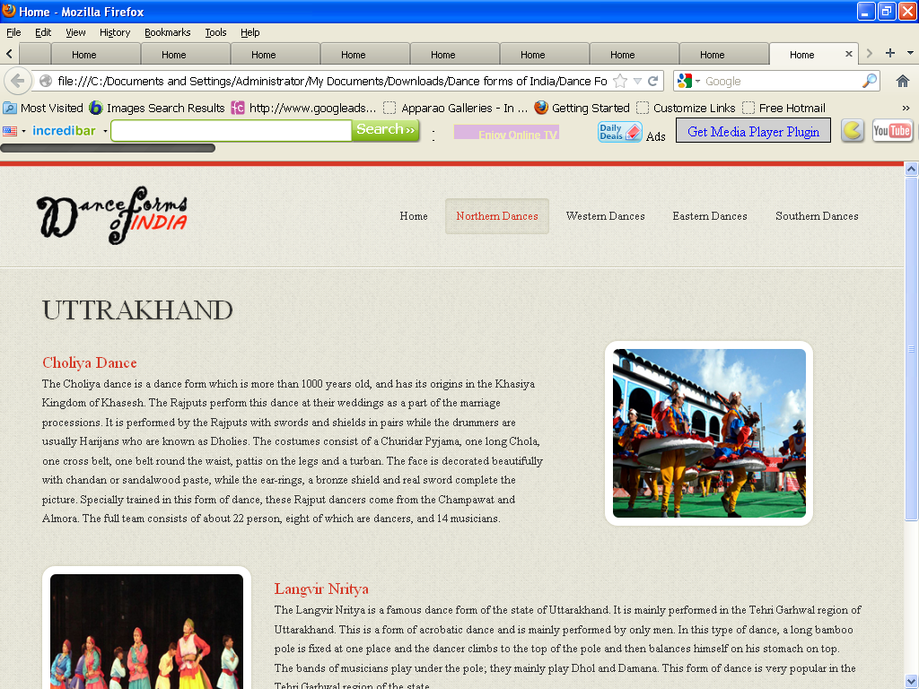<!DOCTYPE html>

<html lang="en">

<head>

<title>Home</title>

<meta charset="utf-8">

<!--css-->

<link rel="stylesheet" href="css/reset.css" type="text/css" media="screen">

<link rel="stylesheet" href="css/style.css" type="text/css" media="screen">

<link rel="stylesheet" href="css/grid.css" type="text/css" media="screen">

<link rel="icon" href="images/favicon.ico" type="image/x-icon">

<link rel="shortcut icon" href="images/favicon.ico" type="image/x-icon" />

<link rel="stylesheet" href="css/flexslider.css" type="text/css" media="screen">

<!--js-->

<script type="text/javascript" src="js/jquery-1.7.1.min.js" ></script>

<script type="text/javascript" src="js/superfish.js"></script>

<script type="text/javascript" src="js/jquery.flexslider-min.js"></script>

<script>

jQuery(window).load(function () {

jQuery('.flexslider').flexslider({

animation: "fade",

slideshow: true,

slideshowSpeed: 7000,

animationDuration: 600,

prevText: "",

nextText: "",

controlNav: false

})

});

</script>

</head>

<body>

<!--==============================header=================================-->

<header>

<div class="line-top"></div>

<div class="main">

<div class="row-top">

<h1><a href="index.html"><img alt="" src="images/logo.gif"></a></h1>

<nav>

<ul class="sf-menu">

<li ><a href="index.html">Home</a></li>

<li class="active"><a href="#">Northern Dances</a>

<ul>

<li><a href="JnK.html">Jammu n Kashmir</a></li>

<li><a href="HP.html">Himachal Pradesh </a>

<li><a href="Uttarakhand.html">Uttarakhand</a></li>

<li><a href="Haryana.html">Haryana</a></li>

<li><a href="Punjab.html">Punjab </a>

<li><a href="Rajasthan.html">Rajasthan</a></li>

<li><a href="UP.html">Uttar Pradesh</a></li>

<li><a href="Bihar.html">Bihar</a></li>

<li><a href="Jharkhand.html">Jharkhand</a></li>

<li><a href="Chhattisgarh.html">Chhattisgarh</a></li>

<li><a href="MP.html">Madhya Pradesh</a></li>

</ul>

</li>

<li><a href="#">Western Dances</a>

<ul>

<li><a href="Maharashtra.html">Maharashtra</a></li>

<li><a href="Gujarat.html">Gujarat </a>

</ul>

</li>

<li><a href="#">Eastern Dances</a>

<ul>

<li><a href="WB.html">West Bengal</a></li>

<li><a href="Orissa.html">Orissa </a>

<li><a href="Jharkhand.html">Jharkhand</a></li>

<li><a href="AP.html">Arunachal Pradesh</a></li>

<li><a href="Assam.html">Assam </a>

<li><a href="Manipur.html">Manipur</a></li>

<li><a href="Meghalaya.html">Meghalaya</a></li>

<li><a href="Mizoram.html">Mizoram</a></li>

<li><a href="Nagaland.html">Nagaland</a></li>

<li><a href="Sikkim.html">Sikkim</a></li>

<li><a href="Tripura.html">Tripura</a></li>

</ul>

</li>

<li><a href="#">Southern Dances </a>

<ul>

<li><a href="AndP.html">Andhra Pradesh</a></li>

<li><a href="Karnataka.html">Karnataka </a>

<li><a href="Kerala.html">Kerala</a></li>

<li><a href="TN.html">Tamil Nadu</a></li>

</ul>

</nav>

<div class="clear"></div>

</div>

</div>

</header>

<!--==============================content=================================-->

<section id="content"><div class="ic"></div>

<div class="border-horiz"></div>

<div class="container_12">

<article class="grid_8">

<h3>UTTRAKHAND</h3>

<ul class="list-recipes">

<li>

<div class="img-indent2"><figure class="box-img "><img src="images/ut.jpg " alt="" /></figure></div>

<div class="overflow" style= "width:62%" >

<h4>Choliya Dance</h4>

<p>The Choliya dance is a dance form which is more than 1000 years old, and has its origins in the Khasiya Kingdom of Khasesh. The Rajputs perform this dance at their weddings as a part of the marriage processions. It is performed by the Rajputs with swords and shields in pairs while the drummers are usually Harijans who are known as Dholies.

The costumes consist of a Churidar Pyjama, one long Chola, one cross belt, one belt round the waist, pattis on the legs and a turban. The face is decorated beautifully with chandan or sandalwood paste, while the ear-rings, a bronze shield and real sword complete the picture. Specially trained in this form of dance, these Rajput dancers come from the Champawat and Almora. The full team consists of about 22 person, eight of which are dancers, and 14 musicians.

</p>

</div>

<div class="clear"></div>

</li>

<li>

<figure class="box-img"><img src="images/ut2.jpg " alt="" /></figure>

<div class="overflow">

<h4>Langvir Nritya</h4>

<p>The Langvir Nritya is a famous dance form of the state of Uttarakhand. It is mainly performed in the Tehri Garhwal region of Uttarakhand.

This is a form of acrobatic dance and is mainly performed by only men. In this type of dance, a long bamboo pole is fixed at one place and the dancer climbs to the top of the pole and then balances himself on his stomach on top.

The bands of musicians play under the pole; they mainly play Dhol and Damana. This form of dance is very popular in the Tehri Garhwal region of the state.

</p>

</div>

<div class="clear"></div>

</li>

</ul>

</article>

<div class="clear"></div>

</div>

</section>

<!--==============================footer=================================-->

<footer>

<div class="main">

<center> <p>Some traditions of the Indian classical dance are practiced in the whole Indian subcontinent, including Pakistan and Bangladesh, with which India shares several other cultural traits. Indian mythologies play significant part in dance forms of countries in South East Asia, an example being the performances based on Ramayana in Javanese dances.</p> </center>

</div>

</footer>

</body>

</html>

**Westbengal.htm**

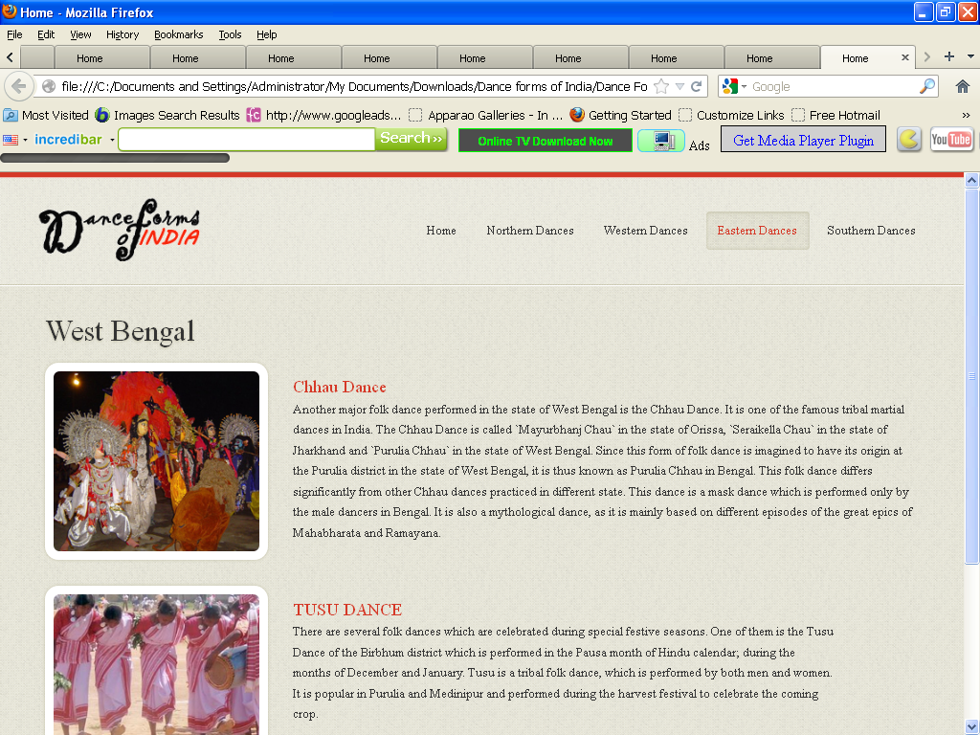

<!DOCTYPE html>

<html lang="en">

<head>

<title>Home</title>

<meta charset="utf-8">

<!--css-->

<link rel="stylesheet" href="css/reset.css" type="text/css" media="screen">

<link rel="stylesheet" href="css/style.css" type="text/css" media="screen">

<link rel="stylesheet" href="css/grid.css" type="text/css" media="screen">

<link rel="icon" href="images/favicon.ico" type="image/x-icon">

<link rel="shortcut icon" href="images/favicon.ico" type="image/x-icon" />

<link rel="stylesheet" href="css/flexslider.css" type="text/css" media="screen">

<!--js-->

<script type="text/javascript" src="js/jquery-1.7.1.min.js" ></script>

<script type="text/javascript" src="js/superfish.js"></script>

<script type="text/javascript" src="js/jquery.flexslider-min.js"></script>

<script>

jQuery(window).load(function () {

jQuery('.flexslider').flexslider({

animation: "fade",

slideshow: true,

slideshowSpeed: 7000,

animationDuration: 600,

prevText: "",

nextText: "",

controlNav: false

})

});

</script>

</head>

<body>

<!--==============================header=================================-->

<header>

<div class="line-top"></div>

<div class="main">

<div class="row-top">

<h1><a href="index.html"><img alt="" src="images/logo.gif"></a></h1>

<nav>

<ul class="sf-menu">

<li ><a href="index.html">Home</a></li>

<li><a href="#">Northern Dances</a>

<ul>

<li><a href="JnK.html">Jammu n Kashmir</a></li>

<li><a href="HP.html">Himachal Pradesh </a>

<li><a href="Uttarakhand.html">Uttarakhand</a></li>

<li><a href="Haryana.html">Haryana</a></li>

<li><a href="Punjab.html">Punjab </a>

<li><a href="Rajasthan.html">Rajasthan</a></li>

<li><a href="UP.html">Uttar Pradesh</a></li>

<li><a href="Bihar.html">Bihar</a></li>

<li><a href="Jharkhand.html">Jharkhand</a></li>

<li><a href="Chhattisgarh.html">Chhattisgarh</a></li>

<li><a href="MP.html">Madhya Pradesh</a></li>

</ul>

</li>

<li><a href="#">Western Dances</a>

<ul>

<li><a href="Maharashtra.html">Maharashtra</a></li>

<li><a href="Gujarat.html">Gujarat </a>

</ul>

</li>

<li class="active"><a href="#" >Eastern Dances</a>

<ul>

<li><a href="WB.html">West Bengal</a></li>

<li><a href="Orissa.html">Orissa </a>

<li><a href="Jharkhand.html">Jharkhand</a></li>

<li><a href="AP.html">Arunachal Pradesh</a></li>

<li><a href="Assam.html">Assam </a>

<li><a href="Manipur.html">Manipur</a></li>

<li><a href="Meghalaya.html">Meghalaya</a></li>

<li><a href="Mizoram.html">Mizoram</a></li>

<li><a href="Nagaland.html">Nagaland</a></li>

<li><a href="Sikkim.html">Sikkim</a></li>

<li><a href="Tripura.html">Tripura</a></li>

</ul>

</li>

<li><a href="#">Southern Dances </a>

<ul>

<li><a href="AndP.html">Andhra Pradesh</a></li>

<li><a href="Karnataka.html">Karnataka </a>

<li><a href="Kerala.html">Kerala</a></li>

<li><a href="TN.html">Tamil Nadu</a></li>

</ul>

</nav>

<div class="clear"></div>

</div>

</div>

</header>

<!--==============================content=================================-->

<section id="content"><div class="ic"></div>

<div class="border-horiz"></div>

<div class="container_12">

<article class="grid_8">

<h3>West Bengal</h3>

<ul class="list-recipes">

<li>

<figure class="box-img"><img src="images/wb1.jpg " alt="" /></figure>

<div class="overflow">

<h4>Chhau Dance </h4>

<p>

Another major folk dance performed in the state of West Bengal is the Chhau Dance. It is one of the famous tribal martial dances in India. The Chhau Dance is called `Mayurbhanj Chau` in the state of Orissa, `Seraikella Chau` in the state of Jharkhand and `Purulia Chhau` in the state of West Bengal. Since this form of folk dance is imagined to have its origin at the Purulia district in the state of West Bengal, it is thus known as Purulia Chhau in Bengal. This folk dance differs significantly from other Chhau dances practiced in different state. This dance is a mask dance which is performed only by the male dancers in Bengal. It is also a mythological dance, as it is mainly based on different episodes of the great epics of Mahabharata and Ramayana.

</p>

</div>

<div class="clear"></div>

</li>

<li>

<figure class="box-img "><img src="images/wb2.jpg " alt="" /></figure>

<div class="overflow" style= "width:62%" >

<h4>TUSU DANCE</h4>

<p>

There are several folk dances which are celebrated during special festive seasons. One of them is the Tusu Dance of the Birbhum district which is performed in the Pausa month of Hindu calendar; during the months of December and January. Tusu is a tribal folk dance, which is performed by both men and women. It is popular in Purulia and Medinipur and performed during the harvest festival to celebrate the coming crop. </p>

</div>

<div class="clear"></div>

</li>

</ul>

</article>

<div class="clear"></div>

</div>

</section>

<!--==============================footer=================================-->

<footer>

<div class="main">

<center> <p>Some traditions of the Indian classical dance are practiced in the whole Indian subcontinent, including Pakistan and Bangladesh, with which India shares several other cultural traits. Indian mythologies play significant part in dance forms of countries in South East Asia, an example being the performances based on Ramayana in Javanese dances.</p> </center>

</div>

</footer>

</body>

</html>

**FURTHER IMPROVEMENT**

FURTHER IMPROVEMENT’S

This website can be further enhanced by adding following feature

* The website can be made dynamic by using database management systems.
* The designing of the website can be further improved.
* There can be a login mechanism for the users.

**BIBLIOGRAPHY**

**BIBLIOGRAPHY**

* Build Your Own Web Site The Right Way by Ian Lloyd

## Teach Yourself CSS in 24 Hours by Kynn Bartlett

## CSS Tutorial from “w3c schools” WEBSITE

**PROJECT REPORT**

**ON**

**DANCE FORMS OF INDIA - HTML WEBSITE**

**SUBMITTED TO**

**PANJAB UNIVERSITY, CHANDIGARH**

**SUBMITTED IN THE PARTIAL FULFILLMENT**

**OF THE REQUIREMENT FOR THE DEGREE**

**BACHELOR OF COMPUTER APPLICATION**

**SUBMITTED BY**

**AMANPREET KAUR 17010000299**

**RAMANDEEP KAUR 17010000337**

**SANDEEP KAUR 17010000341**

**KHALSA COLLEGE FOR WOMEN,**

**SIDHWAN KHURAD,**

**ACKNOWLEDGEMENT**

Perhaps it is natural to every human being that when you are really thankful and sincerely want to express your gratitude towards someone, just you run out of words and you feel dearth of words in spite in of healthy vocabulary.

We are heartily thankful to our supervisor, Prof. Ritu Sharma whose encouragement, guidance and support from the initial to the final level enabled me to develop an understanding of the project.

Lastly, I offer my regards and blessings to all of those who supported me in any respect during the completion of the project.

Amanpreet Kaur 17010000299

Ramandeep Kaur 17010000337

Sandeep Kaur 17010000341

**INDEX**

|  |  |  |
| --- | --- | --- |
| **S.NO.** | **PARTICULARS** | **PAGE NO.** |
|  | **Software requirement analysis** | **1** |
|  | **BRIEF OF TOOLS AND LANGUAGES USED** | **2** |
|  | **DESIGNING AND CODING** | **21** |
|  | **FURTHER IMPROVEMENTS** | **135** |
|  | **BIBLIOGRAPHY** | **137** |